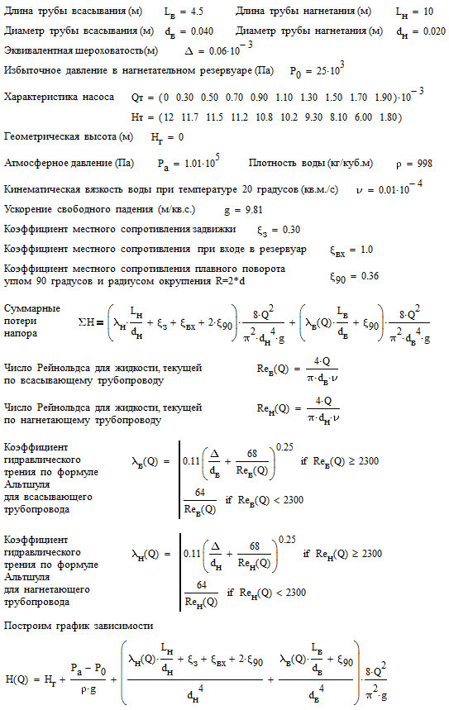

Задаемся несколькими значениями Q

$$\begin{aligned}Q=0,1⋅{\text{10}}^{−3}\overset{}{}\frac{м^{3}}{с} \\ {\text{Re}}_{В}=\frac{4⋅0,1⋅{\text{10}}^{−3}}{3,\text{14}⋅0,\text{04}⋅0,\text{01}⋅{\text{10}}^{−4}}=\text{3183}{}^{}{}^{}{}^{}{\text{Re}}_{Н}=\frac{4⋅0,1⋅{\text{10}}^{−3}}{3,\text{14}⋅0,\text{020}⋅0,\text{01}⋅{\text{10}}^{−4}}=\text{6366} \\ λ_{В}=0,\text{11}⋅{\left(\frac{0,\text{06}}{\text{40}}+\frac{\text{68}}{\text{3183}}\right)}^{0,\text{25}}=0,\text{0428}{}^{}{}^{}{}^{}λ_{Н}=0,\text{11}⋅{\left(\frac{0,\text{06}}{\text{20}}+\frac{\text{68}}{\text{6366}}\right)}^{0,\text{25}}=0,\text{0376} \\ H=0+\frac{1,\text{01}⋅{\text{10}}^{5}−\text{25}⋅{\text{10}}^{3}}{\text{998}⋅9,\text{81}}+\left(0,\text{0376}⋅\frac{\text{10}}{0,\text{020}}+0,\text{30}+1+2⋅0,\text{36}\right)⋅\frac{8⋅(0,1⋅{\text{10}}^{−3})^{2}}{9,\text{81}⋅3,{\text{14}}^{2}⋅0,{\text{020}}^{4}}+ \\ +\left(0,\text{0428}⋅\frac{4,5}{0,\text{040}}+0,\text{36}\right)⋅\frac{8⋅(0,1⋅{\text{10}}^{−3})^{2}}{9,\text{81}⋅3,{\text{14}}^{2}⋅0,{\text{040}}^{4}}=7,9\overset{}{}м \\ \\ Q=0,5⋅{\text{10}}^{−3}\overset{}{}\frac{м^{3}}{с} \\ {\text{Re}}_{В}=\frac{4⋅0,5⋅{\text{10}}^{−3}}{3,\text{14}⋅0,\text{04}⋅0,\text{01}⋅{\text{10}}^{−4}}=\text{15915}{}^{}{}^{}{}^{}{\text{Re}}_{Н}=\frac{4⋅0,5⋅{\text{10}}^{−3}}{3,\text{14}⋅0,\text{020}⋅0,\text{01}⋅{\text{10}}^{−4}}=\text{31831} \\ λ_{В}=0,\text{11}⋅{\left(\frac{0,\text{06}}{\text{40}}+\frac{\text{68}}{\text{15915}}\right)}^{0,\text{25}}=0,\text{0303}{}^{}{}^{}{}^{}λ_{Н}=0,\text{11}⋅{\left(\frac{0,\text{06}}{\text{20}}+\frac{\text{68}}{\text{31831}}\right)}^{0,\text{25}}=0,\text{0294} \\ H=0+\frac{1,\text{01}⋅{\text{10}}^{5}−\text{25}⋅{\text{10}}^{3}}{\text{998}⋅9,\text{81}}+\left(0,\text{0294}⋅\frac{\text{10}}{0,\text{020}}+0,\text{30}+1+2⋅0,\text{36}\right)⋅\frac{8⋅(0,5⋅{\text{10}}^{−3})^{2}}{9,\text{81}⋅3,{\text{14}}^{2}⋅0,{\text{020}}^{4}}+ \\ +\left(0,\text{0303}⋅\frac{4,5}{0,\text{040}}+0,\text{36}\right)⋅\frac{8⋅(0,5⋅{\text{10}}^{−3})^{2}}{9,\text{81}⋅3,{\text{14}}^{2}⋅0,{\text{040}}^{4}}=\text{10},0\overset{}{}м \\ \\ Q=0,9⋅{\text{10}}^{−3}\overset{}{}\frac{м^{3}}{с} \\ {\text{Re}}_{В}=\frac{4⋅0,9⋅{\text{10}}^{−3}}{3,\text{14}⋅0,\text{04}⋅0,\text{01}⋅{\text{10}}^{−4}}=\text{28648}{}^{}{}^{}{}^{}{\text{Re}}_{Н}=\frac{4⋅0,9⋅{\text{10}}^{−3}}{3,\text{14}⋅0,\text{020}⋅0,\text{01}⋅{\text{10}}^{−4}}=\text{57296} \\ λ_{В}=0,\text{11}⋅{\left(\frac{0,\text{06}}{\text{40}}+\frac{\text{68}}{\text{28648}}\right)}^{0,\text{25}}=0,\text{0274}{}^{}{}^{}{}^{}λ_{Н}=0,\text{11}⋅{\left(\frac{0,\text{06}}{\text{20}}+\frac{\text{68}}{\text{57296}}\right)}^{0,\text{25}}=0,\text{0280} \\ H=0+\frac{1,\text{01}⋅{\text{10}}^{5}−\text{25}⋅{\text{10}}^{3}}{\text{998}⋅9,\text{81}}+\left(0,\text{0280}⋅\frac{\text{10}}{0,\text{020}}+0,\text{30}+1+2⋅0,\text{36}\right)⋅\frac{8⋅(0,9⋅{\text{10}}^{−3})^{2}}{9,\text{81}⋅3,{\text{14}}^{2}⋅0,{\text{020}}^{4}}+ \\ +\left(0,\text{0274}⋅\frac{4,5}{0,\text{040}}+0,\text{36}\right)⋅\frac{8⋅(0,9⋅{\text{10}}^{−3})^{2}}{9,\text{81}⋅3,{\text{14}}^{2}⋅0,{\text{040}}^{4}}=\text{14},6\overset{}{}м\end{aligned}$$

