Miss Valeriia Sergienko

I received the new version of your dissertation. I have reviewed it carefully, and I also let my colleague to read it. Today we have discussed it and exchange opinions between us. We think your dissertation does not meet the requirements of Master of Engineering Dissertation of Shanghai Jiao Tong University, and it will not be approved by the academic committee of Shanghai Jiao Tong University. So we think you need to revise your dissertation thoroughly. Below I will describe what the problems are for your dissertation. You can take it for reference.

- The problems abstract
Abstract is the “face” of your dissertation. The most experts view it carefully. We think you have to rewrite it thoroughly.
The first part of the abstract (the first paragraph) is to introduce the background and requirements of your dissertation, it is better to point out what biggest problem is in current situation, then describes the theme and main content of the dissertation, and briefly describe the significance and necessity of the dissertation. Usually 100-200 words.
The second part of the abstract you should describe what the kind of technologies or methods you created or selected, especially the new techniques, methods and algorithms that you created for specific problems. Usually there are 3 or 4 items. Each technique or method item should generally use one paragraph to describe the technical characteristic with the problem to be solved.
The third part of the abstract is to describe the research conclusion of your dissertation, usually describing the results of your simulation or evaluation.
- The structure of the dissertation
The structure of the dissertation is very important for the expert of academic committee to examine your dissertation. The structure of your dissertation is not good. The main problems are as follow.
- Contents structure of the dissertation
The hierarchical design of the directory structure should be consistent for all chapters, except for the last chapter. This dissertation adopts the three-level directory structure, as follow. But some of chapters have three-level directory structure, some have tow-level directory structure, and some have one. It is better to balance all chapters of the dissertation to adopt the same directory structure.
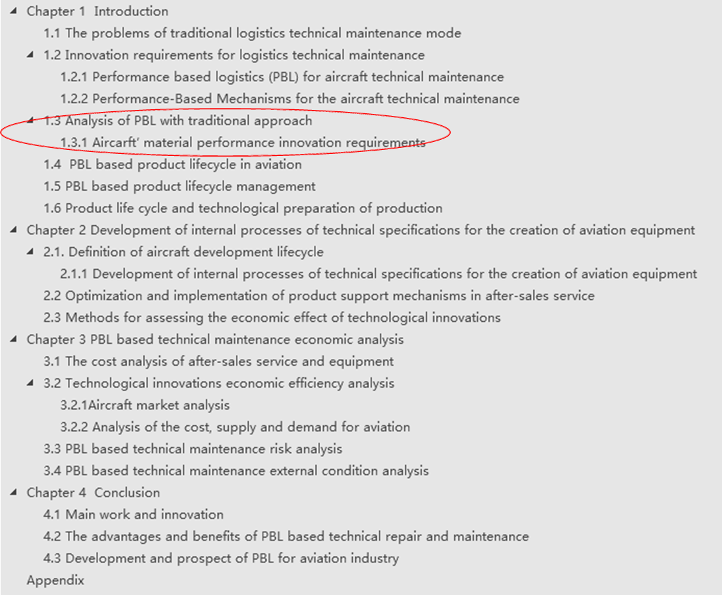
- The number of sections in a chapter or number of subsections in a sections
The number of sections in a chapter or number of subsections in a sections should be greater than one. If there only one section in a chapter or one subsection in a section, it not necessary to define the section or the subsection. It is shown by the red circle in the figure above.
- The number structure of the dissertation
The number structure of the dissertation should be as follow:
Chapter 1 XXXX —— chapter name
  - XXXX —— section name
1.1.1 XXXX —— Subsection name
1) XXXX —— Topic name
1. XXXX —— Subtopic name
• XXXX —— Items

- The introduction or description of each chapter
For each chapter, the first paragraph, before the section, should generally describe the main themes and contents of this chapter, and these are discussed in detail in the following sections. It is the same for each of sections.
- The introduction diagram of dissertation writing organizational structure
At the end of first chapter, it is better to give a introduction diagram of dissertation writing organizational structure, which describe the main the name with theme and relationship between them. An example is as follows:
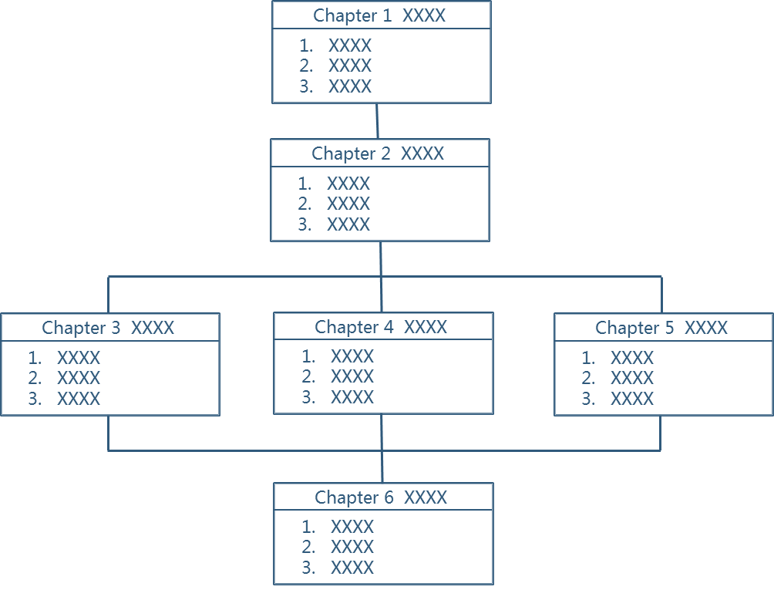
- The new techniques, methods and algorithms
The new techniques, methods and algorithms that you created should describe clearly for the specific problems your dissertation faced, and you also have to give assessments about correctness and effectiveness.
- The technical innovation of the dissertation
In the last chapter, it is better for you to describe the technical innovation of the dissertation, and provide an analysis of advantages and limits.

