Dissertation Submitted to Shanghai Jiao Tong University for the Degree of Master

PBL Based Technical Repair And Maintenance In Development Of Aircraft

Candidate： | Valeriia Sergienko
Student ID: | 119413990003
Supervisor： | Prof. Guoqing Wang
Assistant Supervisor: | Prof.
Academic Degree Applied for： | Master of Engineering
Speciality： | PLM
Affiliation： | School of Aeronautics and Astronautics
Date of Defence： | Feb, 2022
Degree-Conferring-Institution： | Shanghai Jiao Tong University

Academic Dissertation Original Declaration
of Shanghai Jiao Tong University

I hereby declare: the academic dissertation 《System of technical maintenance and repair based on the principles of PBL (Performance Based Logistics) in the development of aircraft》 I sent, is the result of my independent research under the guidance of my supervisor. This paper does not contain any published or written work of other individual or groups, except what has been noted in this paper. The individuals and groups who have made important contributions to the research of this paper have been clearly indicated in the paper. I am fully aware of the legal consequences of this statement.
Dissertation author sign：

date：

Academic Dissertation Copyright Authorization
of Shanghai Jiao Tong University

The author of this dissertation fully understands the regulations of the university about the retention or use of this dissertation, agrees that the university could retain and submit the copy or the electronic version of the dissertation to the relevant departments or institutions, and allows the dissertation can be consulted and borrowed. The author authorizes Shanghai Jiao Tong University to put the entire or part contents into the relevant database for retrieval, and to preserve and compile this dissertation by photocopying, reducing or scanning.
secrecy□, the authorization applies after year.
The dissertation belongs to
No secret .
(please type “√” in the box above)

Dissertation author sign: Supervisor sign:

Date: Date:

PBL Based Technical Repair And Maintenance In Development Of Aircraft

Abstract

With the traditional model of after-sales service of aviation equipment a service company providing a full range of services, or specializing in a certain set of them, builds its logistics, focusing on the task of full readiness to provide the necessary work at any time on request customers. Since the receipt of such applications, their specifics and volumes in the traditional if the models are not predicted, the per-former creates a stock of all the necessary parts, materials and equipment to be ready to perform all the declared types of work.
In such economic conditions, service companies face numerous challenges non-productive costs that cannot be avoided technologically:
1) Diversion of financial resources for the purchase and storage of parts, materials and equipment that may remain unclaimed in the main activity in the for a long time due to the lack of orders to carry out work with them use;
2) Delays in the completion of individual orders due to a lack of one or the other equipment, parts, materials, if the need for them for the execution of a specific the order is higher than the standard inventory volume set in the company;
3) Technological, moral and physical obsolescence of stocks, a long time un-claimed, which leads to an uncompetitive low the level of execution of orders using them or to direct losses when accepting them decisions to eliminate such obsolete stocks.
Thus, service companies under the traditional model are responsible for unproductive losses in the logistics system, since its organization is built without ability to predict the nature and structure of market demand for work and services.
When switching to the model of service support based on the Performance Based principle
Logistics (hereinafter referred to as PBL) service companies receive undeniable advantages in the field of logistics and personnel planning. Application of such a logistics system based on the life cycle of at civil aviation, allows service companies to rebuild the entire system organization of order fulfillment with a focus on achieving the set targets serviceability and safety.
A fundamental difference from the traditional system in terms of organization of work the goal of service companies is to select targets for business planning.
The model is based on achieving and maintaining performance indicators foreign economic activity of enterprises, that is, the final result for the customer
Final result - serviceability, reliability, cost of housing and utilities, downtime at the airplane, timelinesses.

Keywords: logistics chain; after-sales stage of the aircraft life cycle; PBL (Performance Based Logistics).

基于PBL（基于性能的物流）原理的飞机开发技术维护和维修系统

摘 要

本文提出了一个模型的框图，用于评估飞机生命周期售后阶段技术创新的效果，该模型基于考虑飞机系统技术和运营维护指标的数量变化，即评估物流售后服务的优化结果对飞机技术和运营完善的影响,
考虑到飞机生产和运营阶段所取得的效果，提出了航空公司交易对手互动，工作流程和内部工作附加程序的新流程。 从工作组织的角度来看，与传统系统的根本区别在于，服务公司的目的是为业务规划选择目标。
该模型基于实现和维护企业对外经济活动的绩效指标，即客户的最终结果。

关键词：物流链；飞机生命周期的售后阶段；PBL。

Content

I
Abstract I
基于PBL（基于性能的物流）原理的飞机开发技术维护和维修- I
摘 要 I
1.1 Introduction 1
1.2 Innovations in repair and aftersales maintenance. 1
1.2.1 System of logistic support for the operation of the airline's aircraft on the principles of PBL 2
1.2.2 Performance-Based Mechanisms 3
1.2.3 Compare traditional and performance-based contract 3
1.3 Analysis of material solutions as elements of innovation PBL concepts 4
1.3.1 Aircarft’ material performance innovation requirements……………………...6
1.4 Product lifecycle in aviation 7
1.5 Product lifecycle management 9
1.6 Product life cycle and technological preparation of production. 10
Development of internal processes of technical specifications for the creation of aviation equipment…………………………………………………………………...24
2.1 Definition of aircraft development lifecycle 27
2.1.1 Development of internal processes of technical specifications for the creation of aviation equipment……………………………………………………………….…….28

2.2 Optimization and implementation of product support mechanisms in after-sales service 29
2.3 Methods for assessing the economic effect of technological innovations 31
3.1 Aviation the cost of after-sales service and equipment cost 36
3.2 The connection between technological innovations implementation and economic efficiency indicators 40
3.2.1 Aircraft market analysis 42
3.2.2 Analysis of the cost, supply and demand for aviation equipment 44

3.3 Assessment of the economic effect of technological innovations 50
3.4 PBL based technical maintenance external condition analysis………………...52
4.1 Main work and innovation 57
4.2 The consequences of the technology innovation’s economic effect 60
4.3 Follow up research 61
Appendix 65
68

Catalog of Figure

Fig.1-1 The essence of operational excellence is on common functions such as design, supply chain, procurement, procurement and production and interaction with time indicators and cost costs. 4
Fig.1-2 Comparison of the traditional model and the new proposed model of PBL services. A graph of dependence and benefits in terms of value. 6
Fig.1-3 Hierarchy of PBL indicators with a description of each level 15
Fig.1-4 Interactions between the obligations of the two parties involved. Dependence of actions. 16
Fig.1-5 Table with the evaluation method on the scale of importance. Percentages by degree of importance. 17
Fig.2-1 Formulas for calculating the necessary coefficients and data for comparative analysis 24
Fig.3-1 The graph of the global dynamics of aviation fuel prices in the value dependence of the dollar and the gallon 36
Fig.3-2 The dynamics of global air traffic and dependence on political events in the world 36
Fig.3-3 Financial stability of the airline industry.Dark blue - XAL (Airline Index on the American Stock Exchange) and light blue - S&P 500 (Stock Index 500 largest US companies) 37
Fig.4-1 The main PBL principle. 49

Catalog of Table

Table 1-1 Table 3-Rating and remuneration Calculation contractor under contract FY 04-08. 20

Chapter 1 Introduction

In the scientific work, a critical analysis of aircraft maintenance as a system for maintaining the airworthiness of aviation equipment is carried out, the characteristics of the technical operation of civil aviation, maintenance programs, structures of technical operation processes, methods and strategies for maintaining the airworthiness of civil aviation equipment are considered. A description is given the developed mathematical model of the processes of transition of the state of aircraft, quality management processes of technical operation of aviation equipment. The process of technical operation of aircraft and flight safety is analyzed, the tasks of ensuring the quality of maintenance and flight safety are considered.

1.1 The problems of traditional logistics technical maintenance mode

The coronavirus pandemic is still having the biggest impact on logistics. The second most important, perhaps, should be considered the global energy crisis. Most notable was the "container crisis" in Asian and Chinese ports, which dramatically increased shipping costs and created uncertainty for business over delivery times.
In such economic conditions, service companies face numerous challenges non-productive costs that can not be avoided technologically:
1) Diversion of financial resources for the purchase and storage of parts, materials and equipment that may remain unclaimed in the main activity in the for a long time due to the lack of orders to carry out work with them use;
2) Delays in the completion of individual orders due to a lack of one or the other equipment, parts, materials, if the need for them for the execution of a specific the order is higher than the standard inventory volume set in the company;
3) Technological, moral and physical obsolescence of stocks, a long time un-claimed, which leads to an uncompetitive low the level of execution of orders using them or to direct losses when accepting them decisions to eliminate such obsolete stocks.
Thus, service companies under the traditional model are responsible for unproductive losses in the logistics system, since its organization is built without ability to predict the nature and structure of market demand for work and services.
When switching to the model of service support based on the Performance Based principle
Logistics (hereinafter referred to as PBL) service companies receive undeniable advantages in the field of logistics and personnel planning. Application of such a logistics system based on the life cycle of at civil aviation, allows service companies to rebuild the entire system organization of order fulfillment with a focus on achieving the set targets serviceability development of the maintenance process and safety.
A fundamental difference from the traditional system in terms of organization of work the goal of service companies is to select targets for business planning.
The model is based on achieving and maintaining performance indicators foreign economic activity of enterprises, that is, the final result for the customer

1.2 Innovation requirements for logistics technical maintenance
Technological innovations are the final result of innovative activity, embodied in the form of a new or improved product or service introduced on the market, a new or improved process or method of production (transfer) of services used in practice. Technological innovations can be both those products, processes, services and methods that an organization develops for the first time, and those that it adopts from other organizations.
The concept of repair, as a rule, is applied to the repair of the structure, when something is riveted, airframe elements are replaced, doubler patches are put, some changes are made to the design. That is, it is a consequence of some kind of abnormal incident such as damage on the ground, corrosion, fatigue cracks, etc.
Maintenance is inherently preventive. Since the release of the aircraft and during operation, degradation processes are constantly going on, and the point is to find the consequences of these processes and eliminate them before they become a threat to safety. Strictly speaking, before you face a security problem, you will have to break through the fence of economic efficiency. That is, neglect of THAT primarily leads to financial losses.
The simplest example is the operation of wheels. Airplane wheels wear out in about a month. With normal wear, the wheel is sent to the manufacturer, and the tire is restored by welding rubber, and this can be done up to five times. But if you do not change the wheel in time, then it will not be taken for repair. That is, you can fly longer on a worn-out wheel, but then you have to throw it away, and it will be more expensive for yourself.
Various units either have their own resource and must be changed with a certain periodicity, or they are operated according to the condition. Operation by condition is divided into two types: with parameter control and to failure.
Operation by condition - certain parameters of the operation of this unit are controlled, and if they go beyond the boundaries, then it's time to change it. The control can be either by means of tests or built-in monitoring systems for electronic systems, or during various inspections or non-destructive testing for mechanical units and airframe. For example, during C-check maintenance, the aircraft is disassembled to the structures, and if corrosion or something else is detected outside the tolerances, then repairs are already being made.
Operation to failure, as a rule, concerns electronic equipment. Modern avionics systems often have self-monitoring systems, and in case of failure they issue a message, they say, go on without me. The failure is isolated, and due to duplicate systems, the aircraft can continue to be operated further. That is, the failure is not accompanied by any sparks, smoke or insanely working devices, just a message is displayed about the fault failure - switching to another system - we fly on. This approach made it possible to implement a policy of CHALK flights with malfunctions.

Performance based logistics (PBL) for aircraft technical maintenance
PBL is synonymous with performance-based life cycle product support, where outcomes are acquired through performance-based arrangements that deliver Warfighter requirements and incentivize product support providers to reduce costs through innovation. These arrangements are contracts with industry or intergovernmental agreements.
PBL Requirements:
- Preferably for PBL is an approach in which the final goals are formulated in the contract, and not specifically the detailed composition of products or specific services to service support.
- PBL has a fully integrated supplier cooperation.
- One integrator provider is responsible for the overall end result of all service support.
- The purchase and subsequent support of a specific IWT system in operation are combined into a single process under the management of a manager.
- Applicable both at the level of large complex systems and platforms, and at the level of individual subsystems.

Improving the efficiency of aircraft use by airlines is the most important means of increasing their competitiveness and profitability in the air transportation market. Competition between airlines is growing every year, the global integration of cargo and passenger transportation, according to statistics, is of paramount importance.
The creation of a logistics support system for the operation of airline aircraft based on the principles of PBL requires the integration of all participants in the logistics process. It is proposed to implement such integration on the basis of payment to all participants of the logistics process for the achieved values, the same for all key participants in the process, based on the fulfillment of the specified values of indicators.
Availability indicators and indicators of the speed of after-sales service of an aircraft have a significant impact on the efficiency of aircraft use. These indicators can be used as key indicators (KPIs) in the formation of a logistics support system for the operation of airline aircraft based on the principles of PBL (Performance Based Logistic).
When designing aviation equipment, the most important economic issue is to determine the integral effect of improving its technical and economic indicators or the effectiveness of additional investments associated with achieving a higher level of technical perfection of the aircraft design. The main conditions for improving the efficiency of the aircraft design are: reducing the weight of an empty aircraft, improving the aerodynamic qualities of the aircraft, increasing the service life and achieving maximum operational adaptability.
The goal is to shift responsibility for results to suppliers while reducing overall lifecycle costs. From the point of view of the aviation department, logistics contracts based on results can work, and their use is resumed.

Performance-Based Mechanisms for the aircraft technical maintenance
The essence of operational excellence is faster, more reliable and more inexpensive efficiency. If the organization has not yet implemented this culture, then it is likely that in all its programs, and not just in PBL, there is a decrease in profitability and a deterioration in customer relations. If an organization has departments that adhere to a culture of continuous improvement, it is extremely important to change incentives so that they apply to the entire organization, since most programs will be based on common functions such as design, supply chain, procurement, procurement and production.
PBL considerations should be part of the manufacturing/quality assurance (QA) process, as repair processes (included in PBL) are influenced by production assembly decisions.
The goal of PBL is to use performance-based mechanisms with an appropriate contract structure and incentives to motivate the desired PSP/PSP behavior.
The result is an agreement that provides the necessary capacity to conduct actions, positively affects the costs of operation and maintenance and satisfies the supplier's need for profitability.

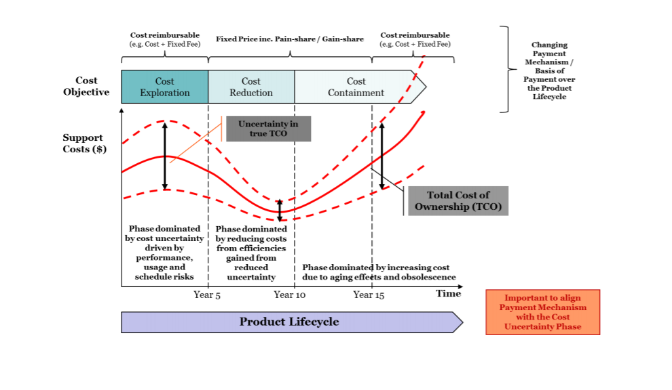
Figure 1.1 - The essence of operational excellence is on common functions

1.3 Analysis of traditional approach and PBL
The PBL strategy works by incentivizing desired outcomes across the product life cycle, from design through sustainment to retirement. Those individuals responsible for designing the system, crafting the strategy, and fulfilling the requirement must have an understanding of the business model and the perspectives of the airlines and the provider.
Under the traditional transactional product support model, where the airlines purchase parts or maintenance services from a commercial PSP (Contractor) when a repair is needed, the Contractor is not incentivized to reduce the need for repairs and repair parts. When equipment fails or is overhauled, the provider charges the Services for repair or replacement on a transaction-by-transaction basis. With transactional sustainment, the provider’s revenue and workload increase as equipment failures increase.
This model creates a fundamental product support misalignment for DoD; PBL arrangements address this misalignment. When commercial providers are paid for performance, not per transaction, their profits are directly impacted in a negative way by any additional costs they incur in delivering contractual requirements. In a PBL arrangement, a commercial provider is incentivized to reduce both the number of repairs and the cost of the parts and labor used in the repair process. Commercial providers are incentivized to reduce system downtime in PBL arrangements because the contract specifies it or their profit is increased by reducing their cost.
Public providers respond to a different set of incentives than commercial industry. While commercial industry is driven by profit, return on Invested Capital (ROIC), and a guaranteed revenue stream, public providers are driven by increased workload and additional labor at the depots. However, since Program
Offices (PO) also like to see a decrease in required repairs (i.e., work), the incentives must be established to satisfy both of these goals. Monetary incentives for shop performance may be used; however, the funds must come from the organic Command as the OEM Product Support Integrator (PSI) is prohibited from bonuses or other monetary incentives to the public PSP as part of a Public Private Partnership (PPP). Industry is Driven by Profit, Return on Invested Capital, Long-Term Revenue Stream, and Risk.
When the PSI or PSP is a commercial business, it is important to understand the factors that influence and motivate its behavior. Industry, accountable to shareholders, competes to provide goods and services in the marketplace, balancing business risks and the potential for profit with providing a sound return on investment to shareholders. Since a strong business relationship is one of the foundational elements of successful performance-based arrangements, it is important to understand how industry works from a corporate and individual perspective. This understanding will facilitate the development of incentives that will best motivate the necessary behaviors for desired performance outcomes.

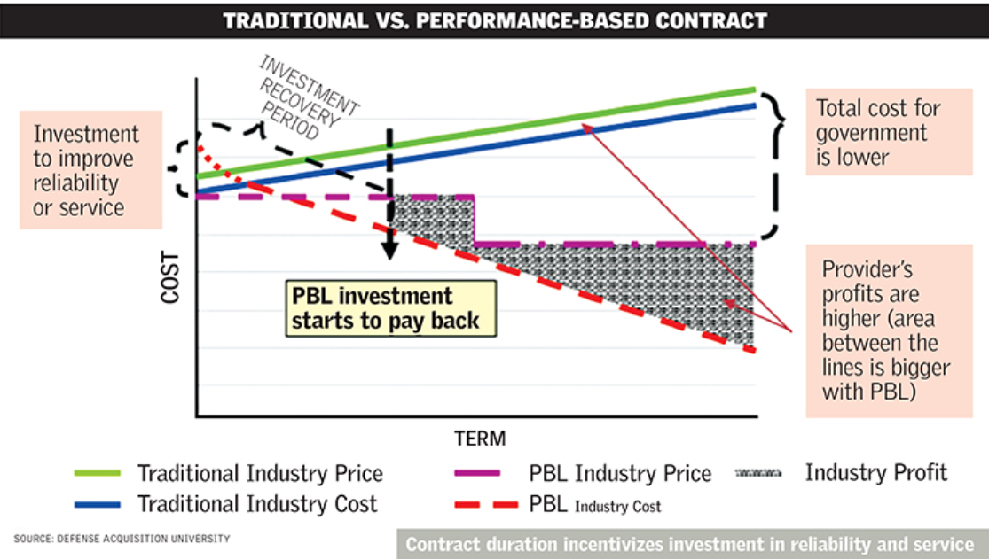

Figure 1.2 - Comparison of the traditional model and the new proposed model of PBL

The essence of operational excellence is delivering value faster, more reliably and at lower cost. If an organization does not have this culture already embedded, then it’s likely that all its programs — not just PBL — are seeing erosion of margin and customer relationships. If there are pockets of an organization that embrace a culture of continuous improvement, it is critical to change incentives so that it drives this across the entire organization as most programs will draw on shared functions such as engineering, supply chain, sourcing, procurement and manufacturing.

1.3.1 Aircarft’ material performance innovation requirements
The Materiel Solution Analysis phase provides the first significant opportunity to influence the supportability and affordability of weapon systems by balancing Warfighter requirements and desired operational capabilities with support and cost considerations. The Analysis of Alternatives (AoA) is completed at this time, which includes a comparison of the life cycle support approaches and costs. Suitability attributes (reflected in metrics such as Materiel Availability, Reliability, O&S cost, and other sustainment metrics) that are required to support the Warfighter should be evaluated in requirements trade-offs, along with performance characteristics (such as speed, range, and lethality for hardware and speed, agility and scalability for software). A failure to do so can result in a solution that creates unaffordable demands for resources during operations and sustainment.
The main factors reflecting the PBL concept:

• PBL Key Considerations
• Key Considerations That Support PBL Strategies and Arrangements
•Work with the Warfighter to establish sustainment requirements that are specific and measurable at program initiation.
• Identify and quantify O&S cost and readiness drivers early, and pursue opportunities to mitigate via system design and sustainment alternatives.
• Influence design for reliability, maintainability, prognostics and diagnostics, and special requirements for hardware (e.g., corrosion control), plus modularity, reusability, and testability for software.
Promote standardized (common) systems, components, spare parts, and support equipment. This enables the greatest flexibility and competition for PBL arrangements in sustainment.
• Produce a product support intellectual property strategy, including ownership needs as part of the acquisition strategy being developed. A decision. This enables multiple provider and system/subsystem options for PBL. • Promote standard and stable manufacturing/factory floor processes that could be used in the depot, as well as production activities.
• Promote structured, consistent processes for software development and sustainment activities based on standard maturity models. This enables the greatest flexibility and competition for PBL support solutions.
• Ensure the broad product support strategy requirements are aligned with the Warfighter’s requirements.
• Search within and outside of Service for existing support solutions that will satisfy requirements and reduce support costs.

1.4 PBL based product lifecycle in aviation
PBL is responsible for lifecycle management and is responsible for the implementation, management and supervision of all activities related to the development, production, maintenance and disposal of the system throughout its lifecycle.
It is also responsible for developing an appropriate support strategy to achieve effective and affordable operational readiness in accordance with the Warfighter resources allocated for this purpose.
PBL is a strategy aimed at affordable and effective satisfaction of requirements (for example, reliability, availability) and reduction of operating and support costs
The product support business model defines the hierarchical structure and methodology by which planning, development, implementation, management and execution of product support for a component, subsystem or platform will be carried out during the lifecycle.
A properly designed PBL mechanism aligns the goals of the supplier and the government through the proper application of incentives.
The optimal approach is to take into account support capabilities and lifecycle costs at the beginning of the program (or earlier). This inclusion ensures that the attributes of the system have been designed in such a way as to minimize the need for logistical resources, reducing operating costs. It also ensures that the acquisition strategy and Lifecycle Maintenance Plan will take into account the technical and product support data needed to encourage competition and other supply sources during maintenance, while maintaining downward pressure on the cost of support.
As the program moves from development to deployment and life support, temporary support mechanisms are being created for contractors and based on the results of work to mitigate the risk of uncertainty and collect demand data for follow-up activities.
As a program or product moves from development to sustainable use, actual costs are collected and risks are reduced using cost-plus incentive mechanisms, as failure modes are determined and demand stabilizes. After stabilization, costs are further reduced by stimulating the improvement of processes and products.
Finally, as a system, subsystem or component approaches recycling, the emphasis is on containing costs associated with obsolescence, product wear, loss of sources of production/repair, etc.

The aerospace industry has always been far ahead of other industries in terms of introducing the latest technologies. They were the first to implement CAD when it was born in the 1960s. It has become critically important for them to implement the latest technologies in order to avoid difficulties with aircraft, various government and spatial regulatory requirements, long service life, strict operational requirements and, of course the same rules and security requirements. The use of advanced technologies for design, engineering, manufacturing, planning, modeling and all other aspects of the supply chain, including all the players involved, are becoming a matter of survival for aerospace industry players. With so many players infiltrating the airspace, it's also a matter of survival of the fittest.
In addition, given the fact that there are several premises and external networks that need to be managed, as well as to optimize outdated applications, the aerospace industry market is not only a hope, but also, to put it mildly, extremely complex, and this, in turn, has led to the introduction of PLM solutions. This helps them to enter the market faster, reduce costs and increase revenues.

1.5 PBL based product lifecycle management
(Here should add a describe the PBL management and methods for the product lifecycle progress)
The product life cycle (product life cycle) is a set of processes performed from the moment when the needs of society for certain products are identified to the moment when these needs are met and the product is disposed of. Taking into account the stages of the life cycle allows you to reduce the costs of product refinement or even prevent a possible catastrophe due to the action of "unforeseen" circumstances, rationally plan activities for the creation and maintenance of products.
The stage of the product life cycle is a conditionally allocated part of it, which is characterized by the specifics of the work performed at this stage and the final results.
The product life cycle includes: idea and marketing, design and development of technological requirements, product development, logistics, preparation and development of production processes, production, control of testing, packaging and storage, sale and distribution of products, installation and operation, technical assistance and maintenance, disposal of products. Production and technical cycle and technological preparation of production. The most important stages of the housing and communal services, at which the quality of the product is largely formed, are the stages of the Chamber of Commerce and production, which are usually combined into a production and technological cycle (PTC). Technological is any decision made and implemented in the PTC, relating directly to the definition or change of the state of the object of production and aimed at ensuring the output of products. Technological solutions serve as the basis for the development of design and technological measures and relevant documentation at the CCI, sent for execution and implementation into production. The main functions of the CCI at the enterprise level are
- ensuring the manufacturability of product designs;
- selection and preparation of workpieces;
- TP development;
- design of technological equipment;
- control and management of TP.
Input data for the CCI system form: working design documentation for the product and the directive billet, the volume of product output, information support.
When using computer-aided design systems for product structures (CAD), information about the product and its elements can be imported by the CCI system in the most convenient forms for use. In particular, instead of assembly drawings and part drawings, geometric and technological models of the product and its elements obtained in CAD are used. For example, solid-state models developed using graphical software packages (Compass, AutoCAD, etc.)
The information support of the CCI can be divided into invariant to the functions of the CCI and functionally oriented.

1.6 Product life cycle and technological preparation of production
As you know, the product life cycle is a process consisting of a number of stages and stages at which specific tasks are solved in order to create and use (consume) products.
The life cycle of aviation equipment may include the following main stages:
- Technical specification for design;
- Design;
- Construction and testing of prototypes;
- Development of technical documentation for serial production;
- Serial production and delivery to the customer;
- Operation and modernization of it during operation;
- Disposal, from the working deadline;
All stages and stages of the product life cycle are reflected in the design and technological documentation. In relation to the product life cycle, information contained in the product life cycle is also used, as well as planning, financial accounting and other documentation related to accounting, storage of goods and its purchase, and sale, etc. Classifiers of technical and economic information are used as the basis of information support and logistical support in both processes. The design documentation includes:
−specifications;
− drawings of structures;
− circuits (electrical, hydraulic, optical, etc.);
− technical conditions;
− forms, passports, labels;
− operation and repair manual;
− installation, start-up and adjustment instructions;
− educational and technical posters, etc.
The technological documentation includes:
− route and operational maps;
− various technological statements;
− maps of technological processes, etc.
The most important process is data collection. Data collection to describe the process of providing logistics services and aircraft maintenance begins with the development of a data collection plan.
The data collection plan will list the data needed to conduct a product support assessment. Part of this initial stage is understanding what "good" data looks like. If possible, the collected data should be associated with the event. In addition, data should be collected in the smallest possible form; avoid totals or pre-calculated indicators that make it difficult to conduct a new analysis and/or use other assumptions or calculations.
At the stage of data collection, the data should be presented in the most concise form. This allows data analysts to draw their own conclusions based on the data and the source data of the site, if there are questions about the assessment/conclusions.
Technical specification for design
The formation of the goals for which the aircraft is used to achieve, the justification for the need for a new development requires analysis and prediction of changes in the external environment – natural, i.e. in nature, and artificial, i.e. created by human hands – and the consequences (environmental, political, technical) that the development of the project will lead to, aircraft production and its functioning.
This work is carried out jointly by the organizations of the customer and the developer. As a result of this work (sometimes referred to as external "design"), the required flight performance characteristics (hereinafter LTX), technological, operational and other requirements for the aircraft are determined, criteria (indicators) for the effectiveness of the aircraft performance of the task are selected and the technical specification for the aircraft project is formed.
There is no approved form for drawing up the terms of reference, and it is determined by agreement between the developer and the customer. But in general, this document should contain the following information:
1. Purpose of the designed system.
2. Its characteristics, which are often set within the boundaries - no more or no less.
3. Feasibility study. It should be indicated whether it is advisable to create an object and how much it will cost.
4. Terms of implementation. If the object is complex, then its implementation is divided into stages, indicating the completion dates for each stage.
5. The cost of implementation.
Also, other information may be entered in the terms of reference, which the customer considers necessary to enter or. For example, the construction of a prototype, the order of admission, evaluation criteria, requirements for the composition and design of the project, etc.
In general, the development of the terms of reference includes the following steps:
1. Collecting initial information about the actual state of the object or what exists in this area.
2. Formalization of requirements for the engineering system. The necessary technical characteristics that must be achieved are fixed on paper.
3. Checking the possibility of achieving the required characteristics. At this stage, an examination is carried out on the correctness of the Customer's requirements to the current GOST standards, regulations, SNiP, etc. If necessary, the technical characteristics and other requirements of the Customer are adjusted.
4. Approval of the terms of reference with the Customer.
Designing
Designing aircraft structures is a complex process. In the process of work, all the necessary stages of designing aviation infrastructure products are observed:
1. Calculations of the future product are made taking into account the maximum workloads, load capacity, installation features and much more.
2. preliminary design. At the preliminary design stage, several aircraft concepts are being worked out with a degree of detail sufficient to objectively assess the advantages and disadvantages of each of them. At the same time, a compromise between the very contradictory requirements of the terms of reference is achieved on the basis of more objective modeling results of the aircraft, its LTX, operational, economic characteristics.
3. preliminary design;
4. operational design;
The conditionality of such a separation is determined by the depth of study of all aircraft systems.
The design and construction of objects of the aerospace industry belong to the sphere of activity of specialized design bureaus. In addition to designing a new product, their tasks include a description (modeling) of the stages of the life cycle of a real product from the beginning of its production to the end of operation and disposal.
At this stage of project development, many of its stages are directive in nature, since when designing a new product in the design bureau, it is difficult to implement the design of operational technological processes for a serial enterprise.
At the stage of finishing the prototype in the design bureau, it is not always possible to develop documentation suitable for the operation of the product. Therefore, for example, the technological information reflected in the relevant documentation will be far from perfect. It implies further cooperation with other project participants to correct this information.
The information about the new product is transmitted by the design bureau to the serial enterprise, which is the beginning of technological preparation of production for it.
The life cycle of each product instance for any organization of serial mechanical engineering begins with the production cycle – a period of time during which raw materials, materials and components turn into finished products, which provides the company with profit.
At the beginning of the production cycle, each product instance is assigned a production number, which can be conditionally considered the beginning of the production stage, i.e. the first stage of the product instance life cycle.
The testing process precedes the transfer of the product into operation, the beginning of which is the moment when the serial number is assigned to it.
When forming the concept and justifying the feasibility of creating a product, a description of the functioning of a new product during its operation is carried out, which is reflected in the terms of reference. The stage is performed by the design bureau.
When conducting theoretical and experimental research, in addition to developing the design of the future product, research is carried out on the principles and ways of creating a new product at the "Production" stage, the characteristics of the product are specified at the "Operation" stage, which is reflected in the documentation of the research stage (R&D). The stage is performed by the design bureau.
When performing the stage of experimental design work, design and technological documentation (CD, etc.), a prototype of the product are developed, its manufacture is carried out, preliminary and acceptance tests of the prototype are carried out, CD and SO on are finalized for the organization of production, the testing stage, the operation stage and individual fragments of the disposal stage, which is reflected in the implementation of the experimental- design work. The stage is performed by the design bureau.
During the technological preparation of production, the CD and SO on are specified, taking into account the type of production and the structure of the manufacturer. The stage is carried out by manufacturers and the design bureau, but most of it is carried out by the manufacturer.

PBL mechanisms should be considered under the following circumstances:
The data collection plan does not have to be detailed or complex, but it must be comprehensive. The complexity will depend on the characteristics of the program, as well as on the stage of the logistics management based on the performance of the life cycle (PBL). It can be as simple as a spreadsheet or a two-page sketch. The data collection plan should include a data source to establish accountability and improve the accuracy and traceability of the collected data for any necessary follow-up. Table 9 below, based on the process of restoring state F to A, is an example of a sample data collection diagram. The data highlighted in the bottom line will help PSM IPT in analyzing the current product support strategy.
Data collection also includes interview with appropriate stakeholders and an analysis of the product support policy and other supporting documentation. The PSMIPT should ensure that all data is accurate, timing, and relevant to the Alternatives being accessed. Information has Been Gathered Perform a reconciliation of obtained documents, prioritize/remove documents accordingly, and make additional requests for data as necessary Extract/Summarize Key Details Summarize the key information for each document and interview to facilitate analysis.
• Process Step Description
• Review
• Performance
• Requirements for
• Current State
If performance requirements exist, review the requirements and the current state of the program (e.g., metrics, sustainment costs) relative to the requirements. If performance requirements are absent, provide initial performance requirements as part of the recommendation.
Review Phase Analysis
• Review the analysis from Phase 2 and insights generated in
Phase 3 regarding the state of the current product support strategy.
• Demonstrate the benefits and disadvantages based on the findings.
Create a Recommendation
• Generate a product support assessment recommendation and present those to the Decision Authority (PM, PSM, etc.).
• Obtain a decision from the Decision Authority on the development and evaluation of product support alternatives.
After the stage of collecting information, there comes an equally important stage of analyzing the collected information. Study of the reliability of data and the possibility of their application to create optimization actions for aircraft maintenance.
Review Phase
Analysis Review the analysis from Phase 2 and insights generated in
Phase 3 regarding the state of the current product support strategy.
Demonstrate the benefits and disadvantages based on the findings.
Create a Recommendation
Generate a product support assessment recommendation and present those to the Decision Authority (PM, PSM, etc.).
Obtain a decision from the Decision Authority on the development and evaluation of product support alternatives
Here we take a closer look at the analysis model and the collision with other problems of the optimization process and the planning of after-sales service activities.
Here, for clarity, we have modeled the problem and proposed ways to solve it, taking into account the 1st stage, which was described above.

Table 1-1 The simulated problem and the proposed ways
Process Step | Description of the Process Step
Review Performance Requirements for Current State | If performance requirements exist, review the requirements and the current state of the program (e.g., metrics, sustainment costs) relative to the requirements.  • If performance requirements are absent, provide initial performance requirements as part of the recommendation.
Review Phase 2 Analysis | Review the analysis from Phase 2 and insights generated in Phase 3 regarding the state of the current product support strategy. • Demonstrate the benefits and disadvantages based on the findings.
Create a Recommendation | Generate a product support assessment recommendation(s) and present those to the Decision Authority (PM, PSM, etc.). • Obtain a decision from the Decision Authority on the development and evaluation of product support alternatives

Conclusion of the step number 4.
The end of this step will conclude with a “Go/No-Go” recommendation for continued analysis based upon the potential benefit from a change in sustainment strategy, coupled with the feasibility of a PBL arrangement. The PMO should review the opportunities in cost savings and readiness improvements that a PBL strategy would provide and should explore potential alternatives.

Concepts in Action: Generic Subsystem Use Case
The PSM identified the necessary information using a data collection plan and conducted interviews with key stakeholders. The PSM interviewed representatives from the PMO, maintenance organization, supply support division, field-level support units, and the requirements community. Using the data collected, an analysis was conducted producing key insights to share with the IPT. Based on the analysis and insights, the PSM was able to develop an understanding of the performance of the current product support strategy.
Phase consists of a top-level assessment to determine the extent

Understanding of the performance of the current product:
- This enables the greatest flexibility and competition for PBL arrangements in sustainment.
- Produce a product support intellectual property strategy, including ownership needs as part of
- the acquisition strategy being developed for a Milestone A decision. This enables multiple
- provider and system/subsystem options for PBL.
- Promote standard and stable manufacturing/factory floor processes that could be used in the
- Promote standard and stable manufacturing/factory floor processes that could be used.

This phase consists of a top-level assessment to determine the extent to which further analysis and review is required.
The PMO should work with stakeholders to determine material flow relationships, cycle times, labor requirements, and other process elements using process maps.
The process map will help the team visualize the entire supply chain and will enable the PSM IPT to find high-level opportunities to improve the product support strategy. The process map should include the specific activities and activity owners involved in the supply chain, including supply support, maintenance, repair, and overhaul or other IPS elements as appropriate.
If an existing process map does not exist, execute one with key stakeholders. Even if a detailed process map has already been documented, it is beneficial for the stakeholders to meet in order to review and validate it. Insights for Success A process map – following an “F condition asset” to an “A condition asset” – is a useful tool for qualitatively baselining the current status. Stakeholders from diverse organizations should be present during the process mapping exercise.
There is details the work required to complete the Data Analysis phase.
Activity Description Evaluate Data Collected Relative to Other Factors Assess the data collected to determine if a reduction in cost or increase in readiness may be possible through the introduction of a performance-based arrangement. Ensure access to technical data is included in the top-level assessment, as a change in sustainment strategy will be impacted by restrictions (or a lack thereof).
Analyze Feasibility Perform a feasibility check for the likelihood of PBL implementation. Analyze Timing From the data collected and interviews performed, decide if the program is ready to transition to a new strategy at this time or in the future. Estimate Cost Savings and Performance Improvements Determine if significant costs savings and/or readiness improvements can be achieved through a change in the PSA. Data Analysis Activities Performance Based Logistics (PBL) Guidebook Utilizing the data collected in Phase 1, the PSM IPT should seek to answer the below questions with data-driven and evidence-based responses.
PBL metrics hierarchy
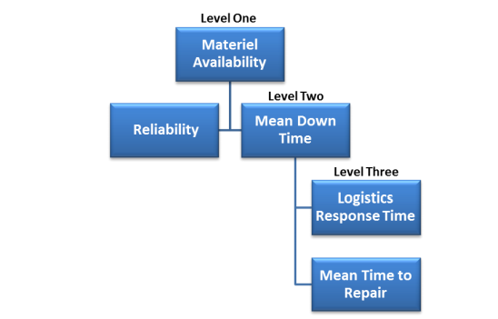
Decomposing Metrics by Level One of the most important considerations for selecting metrics is understanding how they link and contribute to top-level performance outcomes and each other. Therefore, in addition to understanding the relationship of metrics to the span of PSI/PSP control, it is also useful to decompose metrics to understand how they can be used to reinforce and complement each other. A breakdown of a PBL metrics hierarchy is as follows:
Fig.1-3 Hierarchy of PBL indicators with a description of each level

• Level 1 metrics are the performance goal or attribute for the PBL arrangement. For instance, Level 1 metrics can be AO and AM at the system level or supply chain delivery reliability at the subsystem or component level. Level 1 metrics will vary according to the focus of the PBL arrangement.
• Level 2 metrics support Level 1 metrics. The relationship helps to identify the root cause(s) of the performance gap for a Level 1 metric. If the Level 1 metrics are AO and AM, Reliability and Mean Down Time (MDT) would be considered realistic Level 2 metrics.
• Level 3 metrics support Level 2 metrics. For a Level 2 metric, such as MDT, Logistics Response Time (LRT), and Mean Time to Repair (MTTR) are examples of Level 3 metrics.
The economic efficiency of decisions taken in this area is determined by the ratio of the costs incurred for their implementation and the results obtained .
According to the theory of inventive problem solving, it is considered effective a solution that gives 100% compliance of the result with the specified parameters, which they are necessary for the customer, with minimal cost to achieve it (ideally –at zero cost) [Podkatilin].
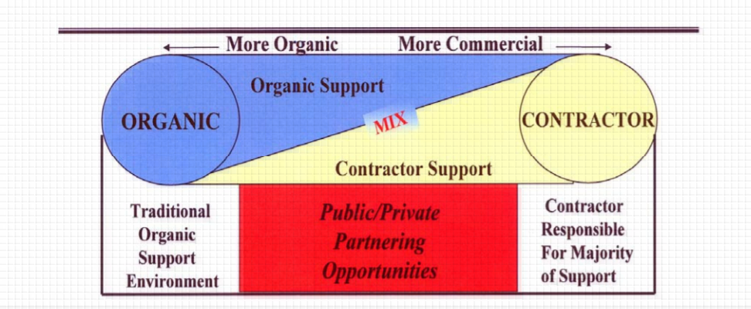
Fig.1-4 Interactions between the obligations of the two parties involved

Once all scores have been collected, each alternative receives a weighted-benefit score by summing the criterion’s weight multiplied by its average stakeholder rating. Figure 4 depicts the method for calculating the weighted-benefit scores.

𝑊𝑒𝑖𝑔ℎ𝑡𝑒𝑑 − 𝐵𝑒𝑛𝑒𝑓𝑖𝑡 𝑆𝑐𝑜𝑟𝑒 (𝐴𝑙𝑡 𝑋) =
(𝐶𝑟𝑖𝑡𝑒𝑟𝑖𝑜𝑛 1 𝑤𝑒𝑖𝑔ℎ𝑡) ∗ (𝐶𝑟𝑖𝑡𝑒𝑟𝑖𝑜𝑛 1 𝑠𝑐𝑜𝑟𝑒) + (𝐶𝑟𝑖𝑡𝑒𝑟𝑖𝑜𝑛 2 𝑤𝑒𝑖𝑔ℎ𝑡) ∗ (𝐶𝑟𝑖𝑡𝑒𝑟𝑖𝑜𝑛 2 𝑠𝑐𝑜𝑟𝑒)
+ (𝐶𝑟𝑖𝑡𝑒𝑟𝑖𝑜𝑛 3 𝑤𝑒𝑖𝑔ℎ𝑡) ∗ (𝐶𝑟𝑖𝑡𝑒𝑟𝑖𝑜𝑛 3 𝑠𝑐𝑜𝑟𝑒)

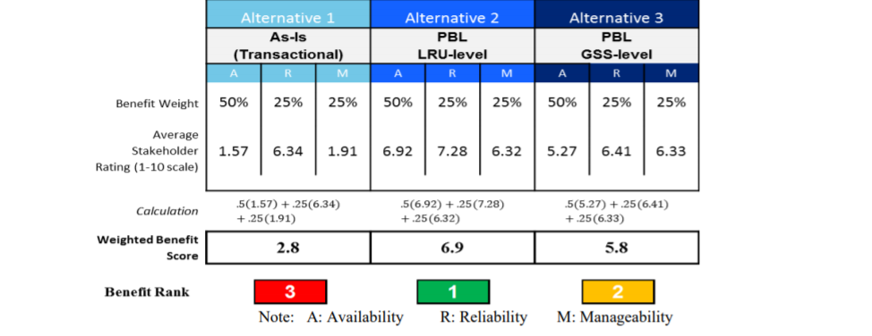
Fig.1-5 Table with the evaluation method on the scale of importance
In the Generic Subsystem example, Alternative 2 has the highest weighted-benefit score,indicating it is the most attractive alternative in the benefit analysis. Both Alternatives 2 and 3offer benefits well exceeding Alternative 1. This benefit score will be incorporated into the overarching Utility Score for each alternative at the conclusion of this step.
With this in mind, the PBL model performance condition can be written as follows:

lim Results → 100%
lim Expenditure → 0

where Results – the results achieved during the execution of the service contract escort;
Expenditure – expenses under the contract for service support.
If the results of the contractor's activities are achieved as specified in the contract, if the performance parameters are at the level of 100%, the performer receives 100% of the payment by agreement. If the actual results achieved are below the established standards, however, the amount of money paid remains within acceptable deviations decreases in direct proportion. When actual indicators deviate from the targets for limits of acceptable limits, a progressive coefficient of level reduction is introduced remuneration paid. Finally, if the performer for several the Customer does not reach the minimum acceptable level of performance indicators in General, it has the right to terminate payments and demand compensation for losses incurred losses in accordance with the established procedure .
This payment scheme for PBL contracts creates a high level of interest the contractor's success in achieving the performance criteria set by the customer when minimum own expenses.
In order to analyze the economic efficiency of our proposed model, we apply such a technique for building algorithms for solving inventive problems as decomposition of the studied phenomenon: let's analyze the effectiveness of the model on specific examples of its application. The examples below are a sample of successful ones PBL programs.
Let's look at the basic terms of PBL support contracts. Under the terms
FY 99-06 contract for fiscal year 1999, LMSW depot in Palmdale, state
California, commits to providing PBL support for 52 aircraft in the 49th fighter wing
the wing at Holloman air force base.[4]
Financial profile of the contract:
- cost plus incentive fee with bonus payment;
- remuneration for the full scope of work (3%);
- early completion fee (7%);
- promotion from the amount of us air force expenses (50%).
The value of the FY 99-06 contract was us $ 223 million per year in 1999 and increased to Us $ 234 million per year in fiscal year 2006, for a total of the entire period.
the service cost was us $ 1.97 billion [10].
Requirements for modification, integration and security for 52 aircraft in the
Economics and management of a national economy 95
The effectiveness of the strategy performance based logistics (the f-117 fleet included:
- development of a support system;
- management of subcontractors;
- integration of the system and subsystems;
- configuration management;
- material flow management;
- storage / transportation;
- direct service support;
- reporting to the US air force.
The effectiveness of this contract from the customer's point of view can be written as follows expression:
lim Results = 100% (matching the specified parameters)
lim Expenditure = us $ 1.97 billion + 98% premium
Next, let's look at the terms of another contract for PBL support.
The FY 04-08 contract was awarded in fiscal year 2004 to Boeing Corporation, for
maintenance of the C-17 Globemaster Sustainability partnership, operating under the worldwide [11].
The contract profile included the following main conditions:
− setting fixed service prices for five years in advance;
− FY 04-08 contract value of us $ 4.9 billion;
− programme management;
- logistics support;
− material flow management;
- engineering innovations;
- engine maintenance;
- attracting additional partners necessary for the performance of contractual obligations.
The performance of this contract was evaluated according to a different set of criteria specified in the table 3.

Table 3-Rating and remuneration Calculation contractor
PBL contract execution parameters | Minimum  metric standard | Actually achieved  value
Percentage of work completed within 48 hours after the end of their implementation period | 80% within 48 hours | 88%, average delivery time:  25 hours
Percentage of requests for equipment repairs, accepted for execution immediately | 82% | 86%
Percentage of requests for provision  consumables accepted for use  execution immediately | 67% | 86%
Percentage available for use  aircraft | 70% | 72%  81 units at VN  supported in  constant state  availability from the General  quantities of 114 units

These estimated parameters indicate full compliance performed works according to the final technical criteria set by the customer.
According to this contract, the service company performed current repairs within the framework of established deadlines, the duration of which was determined based on the share of equipment, which should be on full alert at all times. In the process of such work the performer constantly focuses on performance targets and measures reaction time to the customer's requests, which requires constant direct access to accurate, up-to-date technical data, logistics and configuration data for updating tasks for planning work and analyzing the service performed.[6]
Therefore, performers are interested in introducing integrated MRO into production and world-class PLM systems to perform product modification and service support support, maintenance, and saving the history of all adjustments and operations [1].
Thus, the experience gained in the implementation of the contracts reviewed using the PBL system has shown advantages when performing maintenance programs for the specified model.
For example, awards received by the Boeing Corporation for technical support based on the performance of the C-17 Globemaster over the past 8 years, they amounted to us $ 4.9 billion. Based on the results of this program in the US air force there was an increase in the number of fleets of 180 aircraft. Their service produced in the PBL system, executed by the developer and simultaneously by the manufacturer aircraft, which provides a higher level of responsibility and guarantees from possible risks, as well as a higher level of performance in support.

Chapter 2 Development of internal processes of technical specifications for the creation of aviation equipment

Currently, in industry and transport, depending on the nature of production and other conditions, various forms of organization of the production process are used, such as in-line, in-line-node (in-line-bench), group, individual, brigade, brigade-node, etc. All of them are characterized by a certain form of labor organization that ensures high productivity with high quality. But the production process of aircraft maintenance has characteristic features: a large number of operations performed and a significant labor intensity of each operation; the technical condition of aviation equipment, which depends on both the timing and operating conditions: even with the same flight, aircraft may require different labor costs for their maintenance due to additional work to eliminate defects.
The main Methods: The fixed method is characterized by the fact that a certain set of works during maintenance or all maintenance of the aircraft is performed by individual specialists who are not part of the team. At the same time, the contractor has to perform both basic maintenance work on the airframe, power plants, chassis, controls, etc., and auxiliary work related to the preparation of the workplace, and simple operations that do not require high qualifications.
The fixed method is used, as a rule, in the maintenance of special-purpose aircraft at operational airfields, where it is impractical to send a large number of support personnel. The specialization of the performers of the work with this method is limited. The same method is used to perform operational maintenance of aircraft with piston engines, routine repairs of all types of aircraft, defecation, manufacture and repair of spare parts, tools and accessories.
The brigade method, which is very common in operational maintenance, provides for full maintenance of the aircraft, engines and special equipment by one complex team staffed with specialists of different specialties and qualifications, which allows for wide use of the specialization of performers both by types of equipment and by types of aircraft.
An even higher level of specialization is achieved when organizing maintenance according to the zone method, in which the aircraft is serviced by several teams specialized in various zones (nodes) of the aircraft.
The number of teams and specialists in the teams is selected depending on the scope of work in such a way that all maintenance work on the aircraft begins and ends with all teams at the same time. The members of each team specialize in performing individual operations, but each specialist must be able to perform all the operations assigned to the team. The zone method makes it possible to use qualified specialists more efficiently, which contributes to an increase in labor productivity. Work on this method can be organized for any type of maintenance, but it is especially advisable to use it for periodic maintenance that has sufficient volume and repeatability of work.
The aviation engineering service faces the task of further improving maintenance methods in order to reduce the calendar and actual downtime of aircraft for maintenance and repair, which for some types of aircraft reach 20-30% of the total calendar service life. Calendar downtime refers to the time from the landing of the aircraft to the end of its maintenance, and actual downtime refers to the net time from the beginning to the end of maintenance.
The solution of this problem will increase the intensity of the use of the aircraft fleet (flight) and the overall economic effect, which is possible only with the use of modern methods of mathematical analysis and calculation, which is the theory of queuing created in recent years. Among the existing and implemented methods of labor organization during maintenance is a step-by-step method of maintenance and a method of maintenance by condition.
The phased method of maintenance as a means of reducing the one-time calendar downtime of aircraft for maintenance has become widespread. It provides for the division of the most labor-intensive forms of maintenance into stages, the number and complexity of which is calculated for each ATB, depending on the operating conditions, the number of engineering and technical workers, the established organization of the production process and the specific features of a particular airline. For each of these stages, operational statements are developed that combine individual operations on nodes and systems with a less time-consuming form of maintenance. To do this, use the periods of operation of the aircraft within the upper and lower tolerances for labor-intensive form, as well as any forced downtime due to weather and other conditions.
For example, in order to eliminate the downtime of the aircraft at work on Form B with some time reserves, it can be performed in stages together with work on form A2, which will be carried out within a calendar tolerance of ± 2 days. It should be borne in mind that Form B is performed by one complex team of specialists, so the time spent on its implementation is quite large despite the predominance of inspection work. If the work on this form is carried out by a one-time method, then the downtime of the aircraft can reach one day, if they are divided into four stages and performed sequentially together with the work on the A2 form for four days of admission, then the aircraft will fly every day, which increases the decadal and monthly flight of the aircraft.
The economic effect of a product about technological innovations analysis is a base of conformity and validity. According to technological innovations economic effect analysis requirements, this chapter describes the definition of aircraft development lifecycle and methods for assessing the level of readiness of technologies and assessing the readiness of technologies, as well as the existing methods for assessing the economic effect of a product from the introduction of technological innovations in detail.
I used the parameters of the technical specification for the creation of aviation equipment Purpose of the aircraft, General requirements, Flight characteristics, Resource Characteristics, Crew Passenger, cabin comfort, Aviation equipment, Power plant, Maintenance and repair system, Technical level characteristics, Marginal price.
Engineering and Production Development completes the detailed design of all necessary hardware and software, systematically eliminates or reduces any open risks, creates and tests prototypes or first products to verify compliance with capability requirements, and prepares for production or deployment.
This stage of Engineering and Production development includes the establishment of an initial product baseline for all configuration elements. One of the goals at the stage is to ensure that the integrated product support program develops a solution that meets the requirements of availability, availability of tangible assets and reliability of tangible assets, while using the capabilities of Should Cost 13 to reduce projected operating costs. It is necessary to find a compromise between the possibility of support and other design constraints (weight, size, bandwidth, etc.), which will lead to the development of the design within budget and schedule.
Product support models used for inventory planning, workforce planning, training, planning, etc. are updated with actual and estimated data as they become available at this stage of development. The success/problems of reliability growth are evaluated and adjustments are made to the solution to support the product, taking into account the projected demand for logistics resources. It is extremely important to conduct reliable testing to ensure that the reliability requirements are met.
With the development of design, the retail space for sustainable development solutions is narrowing, and the sustainable development strategy is becoming more perfect.
PBL considerations should be part of the manufacturing/quality assurance process, as repair processes (included in PBL) are influenced by production assembly decisions.
During the operational testing and OT evaluation stages, problems identified through various tests, demonstrations, and other evaluation methods are eliminated, and remediation plans are implemented.
As products are put on the market and logistics demand can be reasonably predicted, result-based mechanisms can be implemented.
At an early stage of this stage, short-term cost-type incentive measures are appropriate until sufficient cost data and technical data on failure modes and frequency, as well as reliability data combined with structural stability, are accumulated. This approach provides visibility of costs through the use of a contract with the possibility of cost recovery.
Long-term fixed-price agreements that encourage continuous improvement of processes and products at reduced costs are suitable with a reasonable ability to predict demand and assess risks and the impact of costs.
The cost of aircraft development and production.
The total standard cost of the aircraft, in millions of rubles, is calculated by the formula:
US_{dev=}6,26G_{CH}+27
Where GCH is the mass of an empty equipped aircraft, ton.

2.1. Definition of aircraft development lifecycle
The design of an aircraft (aircraft) and its components is a rather complex iterative process, the task of which is to select suitable combinations of design solutions that best meet the tasks and selected criteria.
The development of technical proposals (preliminary design, preliminary design) is a significant stage in the entire aircraft design process. This stage occupies a transitional position between the stage the creation of the technical specification (TOR) and the stage of preliminary design, at the stage of development of technical proposals (TP), the choice of parameters and characteristics of the newly designed aircraft is mainly determined. It is important that at the initial stages of design, using about 10% of labor costs, up to 80% of decisions are made with a lack or excess of information [5].
An important task in the development of TP is to create the appearance of the aircraft, study the layout of its components and equipment, while it is necessary in the shortest possible time to analyze the various variants of the circuits of the aircraft and its components, while avoiding significant errors. Modeling a large number of possible feasible options manually requires a lot of labor, and making changes to them requires significant time resources.

2.1.1 Development of internal processes of technical specifications for the creation of aviation equipment
When determining the appropriate financial mechanism to finance your PBL agreement, it is also important to consider the time frame involved in securing the necessary financial resources. The parallel variability of the budget environment is a complexity that can make allocating funds time-consuming and complex. In this regard, it is useful to start the process of defining a funding strategy and securing the necessary financial resources at an early stage in this process, in order to avoid any delays in implementation PBL agreement. The process map in Figure below is an example of a simple tool that can be used to demonstrate how the funding process fits into the implementation process of a product support alternative.
How PMS can benefit from understanding the industry's prospects:
Appropriate implementation period: The duration of the agreement, corresponding to the level of investment required, gives industry the opportunity to invest in the system to achieve future savings and offer a better price to the government. It offers an organic food supplier a business case for investing in infrastructure and improving the workforce. Opportunities that provide long-term sources of income and a stable workload are attractive to both commercial and organic food organizations, even though the benefits vary. This does not mean that if a multi-year base is not possible, then PBL agreements cannot be implemented. There are examples of successful PBL agreements with a one-year base and one-year options.
However, this POP will limit PSI or PSP's ability to invest in improvements.
The ability to generate and maintain profits: both organic and commercial suppliers strive to optimize the long-term health of the organization. In the case of a commercial supplier, this is achieved by generating and maintaining long-term revenues and profits, while an organic supplier is often motivated to maintain the workload, benefit from the use of existing Infrastructure, as well as to use and develop the experience of residents.
Partnerships with direct sales departments: managers can encourage these types of partnerships; they have it is proved that the service centers of maintenance ensure the efficiency and quality of products.
The technological process and other developed data for the implementation of the process in teams can be found in the supplement –appendix to the thesis.

2.2 Optimization and implementation of product support mechanisms in after-sales service
The comprehensive support program is a typical example of PBL, the customer pays for the readiness of aircraft equipment, and not specific spare parts and services. In accordance with this, the company is responsible for all work to maintain the readiness of the entire fleet of aircraft, including material and technical support and periodic forms of maintenance. The personnel is constantly present at the air bases and in close cooperation with the Air Force personnel ensures round-the-clock readiness of aircraft for departure.

Autonomous maintenance of equipment in good condition is the most important
principle of PBL. Its goal is to minimize efficiency losses that arise due to device failures, technological equipment shutdowns, defects, etc. For this, an increasing part of the necessary maintenance activities (cleaning, lubrication, technical inspection of devices) is simplified, standardized and gradually transferred to the field in the duties
of employees. As a result, the staff of the chief mechanic 's department On the one hand, they are relieved of their current routine activities, so that they get more time to develop and implement measures to improve the operation of equipment. On the other hand, the equipment can now be provided with the necessary maintenance, which previously, it could not be made available at all or in a timely manner due to lack of adequate resources.
Creation and improving Product Support Mechanisms.
The service center benefits by implementing advanced maintenance capabilities, and the commercial firm benefits by increasing profitability.
Proximity to the end user: due to frequent unfiltered access to customer information, equipment problems are more easily identified. This can significantly reduce the time required for maintenance and repair work, as well as reduce the number of inspections.
In addition to the indicators, the PMO may require the Contractor to provide additional data. The stages of technology readiness level 1 - technology readiness level 6 are carried out with budgetary funding and are the responsibility of research organizations. After completing tests of a workable prototype of the future system under simulated operating conditions, a task for a new sample is formed and a decision is made to create it. Further stages lie in the sphere of responsibility of the industry, and the financing of the work is carried out mainly using market instruments. In addition to a significant reduction in the risk of creating an aircraft, the technology readiness level technique, as expected, can be applied to other science-intensive sectors of the economy, providing support for the development and implementation of various innovative technologies.
PBL focuses on design in order to increase reliability and reduce logistics costs, as well as to ensure effective product support through performance-based logistics strategies.
It should take into account the possibility of support, lifecycle costs, performance and a comparable schedule when making software decisions. The planning of operation and maintenance, as well as the assessment of the total cost of ownership, should begin as early as possible. The ability to support, a key component of performance, should be considered throughout the entire life cycle of the system
PBL uses a performance-based acquisition strategy that is developed, refined and implemented during the acquisition of systems for new programs or as a result of performance evaluation and support alternatives. PBL can help optimize performance indicators and cost indicators through strategic implementation.
The essence of PBL is to buy performance instead of the traditional approach of buying individual parts or repairs. This is achieved through business relationships that are structured in such a way as to meet the operational needs of the fighter and coordinate support goals with the required work results and available resources. PBL support strategies combine responsibility for system support with one or more product support integrators (PSI), which manage sources of support, public and private, in the implementation of agreed performance results.
Goals of PBL indicators
1. Operational availability
2. Operational reliability
3. Cost per unit of use
4. Logistics footprint
5. Logistics response time.
Operational Availability (Ao) is the percentage of time a system is available to complete a mission, or the ability to maintain the pace of operations.
Operational reliability is an indicator of how successfully a system performs mission tasks (percentage of task completion by system). Depending on the system, the mission goal may be departure, tour, launch, destination reached, or another indicator specific to the service and system.
Unit costs are the total operating costs divided by the corresponding unit of measurement for a given system. Depending on the system, the unit of measurement may be the flight hour, steaming hour, launch, mile traveled, or another indicator specific to the service and the system.
The logistics footprint is the size of the government/contractor or the ‘presence’ of deployed logistics support needed to deploy, maintain and move the system.
Measurable items include inventory/equipment, personnel, premises, vehicles, and real estate.
Logistics response time is the period of time from sending a logistics demand signal to meeting this logistics demand. "Logistics demand" refers to systems, components, or resources, including labor, required for system logistics support.
PBL should support these desired results. The performance indicators will be adapted by the departments taking into account the specific definitions of the service and the unique circumstances of the PBL agreements.
One of the most important elements of the PBL strategy is the adaptation of indicators to the operational role of the system and ensuring synchronization of indicators with the responsibility of the support provider.
While objective indicators should form the main part of the evaluation of the PBL supplier's performance, some elements of the product support requirements can be more adequately assessed subjectively by warfighter and the PM team.
This approach provides some flexibility in adapting to potential unforeseen support costs.
For example, there may be different customer priorities that need to be balanced with overall objective performance indicators.

2.3 Methods for assessing the economic effect of technological innovations
Evaluation of the effectiveness of innovations is central to the process of justification and selection of possible investment options in the innovative business. The theory and practice of innovative calculations has in its arsenal a wide variety of methods and practical techniques for evaluating real projects.
At all stages of the implementation of an innovative project, much attention is paid to determining costs (investments) and results. The costs incurred by the participants of the innovation project are divided into initial (one-time, or capital-forming, investments), current and liquidation. Basic, world, forecast and estimated prices can be used for their assessment.
The basic prices are understood to be the prices that have developed in the national economy at a certain point in time tb. The base price for any products or resources is considered unchanged during the entire billing period. The measurement of the effectiveness of the project in basic prices is carried out, as a rule, at the stage of technical and economic studies of innovative and investment opportunities. At the stage of feasibility study (feasibility study) of an innovative project, it is mandatory to calculate the efficiency in forecast and estimated prices. The forecast price of a M (t) product or resource at the end of the T-th calculation step (for example, the T-th year) is determined by the formula.
Mt=vtn+vt-1n+…+vt-n+1n 3)
M(t)= R(t) *V(t) +R(t-1) *V (t-1)+…+R(t-n+1) *V (t-1) 4)

M-Average
V-Actual value
R-Weighting factor.

If the time series to be forecasted contains trend-like variations, you will achieve better results by using the weighted moving average model rather than the moving average model. The weighted moving average model weighs recent data more heavily than older data when determining the average, provided you have selected the weighting factors accordingly. Therefore, the system is able to react more quickly to a change in level.
The accuracy of this model depends largely on your choice of weighting factors. If the time series pattern changes, you must also adapt the weighting factors.
These approaches differ from each other mainly in relation to non-financial factors (in other words, not related to money). In the case of an economic assessment of the effectiveness of the application of technologies aimed at increasing the range and duration of an aircraft flight, the methods of economic analysis are of interest, first of all.
Since the Industrial Revolution, numerous economic models and equations have been developed to estimate ROI. One of the oldest approaches, which is quite versatile and easy to use, is the ROI method. This ratio can be used to assess the effectiveness of an investment or to compare several investment opportunities in terms of their effectiveness.
The formula for calculating ROI is simple and looks like this:
$ROI=\frac{P-C}{C}$ , | [8]
where: P - investment income, C - investment costs.
According to this formula, you should not make an investment if it has a negative ROI, and if this ratio is positive and there are other alternatives, you should choose an investment with a higher ROI.
Let's consider the evaluation methodology from the point of view of critical thinking, from here we will conduct a survey and identify the weak undisclosed sides of this issue.
What is the optimal contract type for a PBL effort?
Fixed-price contract variants are the preferred type because they provide the greatest incentive to the PSI and PSP to improve their products and processes and reduce their cost to perform. When the providers cost to deliver or the risk is difficult to determine, then a FPIF target contract with a ceiling price and a profit-sharing formula is appropriate. However, successful PBL arrangements have been implemented with CPIF contracts and may be the more appropriate arrangement when the risk cannot be reasonably quantified or the cost of transferring risk to the PSI or PSP is more than the Government will accept. The key to an effective PBL arrangement is using incentives to elicit the desired behavior/outcome from the PSI/PSP in spite of the guaranteed cost reimbursement.
What is the appropriate PBL contract length?
The PBL arrangement must be long enough for the provider to recover any investments made to improve their product and/or streamline their processes to meet the Government’s requirements. Complex subsystem OEMs (e.g., engine OEMs) want five- to seven-year contracts.
This PoP gives them time to identify issues impacting reliability or improve processes, design the fix, field the improved subsystem or implement the improved processes, and recover the investment.
Less complex subsystems and components or arrangements that require less investment to improve may have shorter arrangements.
However, no OEM will make investments that cannot be recovered during the PoP. One or two year contracts do not incentivize the PSP to invest in performance improvements that drive down costs.
What is the difference between multiyear and multiple-year contracts?
The primary characteristics of each contract type are included below.
Buys more than one year’s requirement without having to exercise options
Beyond one-year investments can be recovered if contract is terminated
Multiple Years:
- Contract written for multiple years
- Only first year is ‘guaranteed’
- No recovery of investments if contract is terminated
The PSP organization is motivated by improving its capability and capacity and ensuring a stable (or increasing) workload. The workforce is motivated to perform and insulate their facility from potential BRAC closures. Establishing PPPs with commercial industry and aligning the organic PSP metrics with those of the program has resulted in improved processes and additional capabilities in organic facilities. These improved processes and capabilities result in additional workload in organic facilities. The organic PSP then continues to improve its productivity to satisfy program metrics and receive more work. There are different challenges and constraints when incentivizing public PSPs, compared to their commercial counterparts. Regulations preclude commercial PSIs from giving bonuses for exceptional performance to the Government PSPs they may have under contract. Any bonuses or awards given to the members of the organic PSP must come from the Command’s authorized (and often limited) funds.
What should I do with the savings from PBL arrangements?
USD Acquisition, Technology, and Logistics, “components have the latitude to apply savings to their most pressing unfunded requirements or may reinvest this funding within the same programs to accelerate the acquisition, fund cost-reduction initiatives, or cover critical unfunded requirements».
Can these top-level life cycle sustainment outcome metrics be put on contract or should we use tailored lower-tier metrics?
Top-level sustainment outcome metrics and/or lower-tier metrics can be put on contract. One of the most critical elements of a PBL strategy is the tailoring of metrics to the operational role of the system and ensuring synchronization of the metrics with the scope of responsibility of the support provider. The platform level and specifics of the arrangement will dictate whether to use top-level outcome metrics, lower-tier metrics or both.
1. PBL arrangements fail to deliver advertised mission readiness and cost improvements. Compelling evidence has been generated by multiple studies to demonstrate cost and performance improvements through PBL arrangements. In many cases the savings were understated due to accounting only for savings directly related to the arrangement and not accounting for savings associated with positive secondary effects on the logistics infrastructure as well
2. PBL arrangements must be developed and managed with precision to achieve significant cost and performance improvements. Positive outcomes are not strictly linked to perfect execution of a PBL arrangement, but rather to the fact that even moderate adherence to PBL business model tenets can result in success. Success is dependent upon the Services gaining an understanding of both the PBL business strategy and what incentivizes Industry.
3. PBL and outsourcing are synonymous, negatively impacting Services’ ability to comply with Core and 50/50 mandates. PBL’s are structured as government only, government-industry partnerships and industry only arrangements. Defense Department financing and employee compensation practices make government only arrangements extremely challenging to develop and execute. On the other hand, PBLs that involve government-industry partnerships have proven to be very successful.
Partnerships where industry serves as the Product Support Integrator and some or all of the sustainment work is sub-contracted to a government depot via a Direct Sales Agreement creates government depot and workforce incentives that result in better warfighter outcomes, greater government maintenance depot workload and reduced Service budgets. Bottom line: PBLs may involve outsourcing. However, it most often does not and the government has complete control over how PBLs are structured – not industry. Moving to a PBL strategy provides the government leverage not available in transactional logistics arrangements to move work currently being done in commercial facilities into government depots. In a typical transactional sustainment arrangement where industry is performing the work in its commercial facilities, industry has no incentive to move work into government depots – in fact, it dis-incentivized to do so in negotiated margin contracts where any reduction in industry costs results in reduced revenue and reduced profit. Conversely, PBLs highly incentivize industry to take aggressive action to reduce its invested capital and perform sustainment work at the lowest cost facilities. Return on Invested Capital (ROIC) is a key motivator for industry since ROIC is one of the metrics for which Wall Street and the money markets reward commercial companies. Industry reduces invested capital by, among other actions.

Chapter 3 PBL based technical maintenance economic analysis

Improving the assessment of the economic effect on the life cycle of an aircraft is a key issue, how to reduce the cost of logistics maintenance of the aircraft.
This chapter provides an in-depth analysis of economic efficiency indicators, namely: an analysis of the aviation market in the segment of medium-haul aircraft, an analysis of the cost, supply and demand for aviation equipment, an analysis of macroeconomic conditions affecting the introduction of technological innovations in the logistics chain of service, and also shows the conceptual and functional relationship between the development of technological innovations with a block of indicators to assess the economic effect at the early stages of the aircraft lifecycle.
Section 3.3 describes a number of expected indicators in the economic analysis of technological innovations on the example of the successful use of the PBL concept in the US military industry.

3.1 After-sales service coast and equipment cost analysis
Today there is no doubt that contractual work is a kind of legal activity, in the aspect of corporate law it is considered as the legal activity of corporations, which includes the stages of conclusion and execution of contracts. It is worth agreeing that the process of contractual work has a sequence typical of managerial activities.
Contractual work acts as a kind of not only legal, but also managerial activity, therefore, it is the object of research in various doctrinal fields: law, economics, management.
Economic and managerial studies of contractual work can also enrich the legal understanding of the issue. The availability of a reliable tool at the disposal of designers for a reliable economic assessment of the cost of the life cycle of aviation equipment - including design, serial production and operation, including ground maintenance, repair and disposal, makes it possible to create a highly efficient competitive aviation equipment with high functional perfection and satisfying requirements of high efficiency, based on its design, taking into account the technical and operational parameters of the cost of lifecycle. An important role in this, especially at the stage of external design, is played by the formation of the main parameters of the technical specifications for design [23].
The general criterion indicator of the life cycle cost is calculated taking into account the time factor and the rules of financial mathematics [2], in this case, the discounting method is used – bringing multi-time costs to the initial point in time. Calculations are carried out at the beginning of the first year, the general formula has the form:
$C_{lc}=\sum_{t=0}^{T_{p-1}}{\sum{C_{pt}^{}*a_{t}^{}}}$, | [9]
with the volume of use of aviation equipment (transportation) equal to the expected needs Q = {Qjl}, that is, on the entire route network for all types of transportation, provided that all costs are minimized, where
i - lifecycle stage;
t - is the serial number of the year of the billing period, the first year is conditionally reset due to the fact that calculations are carried out at the beginning of the period;
T0 - the total duration of the lifecycle;
I0 - the number of lifecycle stages;
$C_{i}^{t}$- the total cost of the life cycle of an innovative product, taking into account the full release program, in monetary units;
$a_{t}^{}$ - is the discount coefficient.
The discount factor is determined by:

$$- α = 1( + ) ,$$
10]
The life cycle of an innovative product can be complete, incomplete or private. The full life cycle includes all stages of full duration and inter-cycle expectations. Accordingly, the costs represent the full amount of costs for the entire scope of work on creation, production, sale, consumption (operation) and recycling. An incomplete life cycle differs from a full one in duration, structure and volume characteristics. The private life cycle is reduced to separate stages of the full cycle, for example, development, manufacture, operation, disposal. Determining costs by stages of the life cycle of a new product requires compliance with the following conditions:
1) completeness of the calculation, i.e. cost accounting for all stages of the life cycle;
2) accounting for all resources consumed;
3) the use of a unified methodology for determining the cost
of the cycle stages and a unified classification of the composition and content of costs;
4) the use of cost calculation methods corresponding to the stages of the life cycle.
The methodology for calculating the life cycle cost of an innovative product created at an aircraft manufacturing enterprise is based on determining the costs of the product life cycle stages listed below.
1. Justification of product development.
2. Product development.
Both of these stages are combined under the general name of research and development work (R&D).
3. Production of the product.
4. Operation (application) of the product.
5. Overhaul of the product.
The overhaul stage includes, in addition to the factory repair of the product, its deep modernization. The total costs of the lifecycle are determined on the condition that in each year, a certain (demand-driven) volume of transportations, works, services is performed, which must be determined already at the stage of the technical specification, i.e. optimization of the parameters of technical specifications and (or) design is solved as a problem with restrictions: the volumes of traffic, works, services are formed by years, and the total (by years and technological structure) costs of the lifecycle of aviation equipment, taking into account all stages of its creation and use, are used as a minimized optimization criterion (subject to appropriate discounting).
Since the cost of a lifecycle is calculated for certain time periods, various aspects of the time factor are taken into account: inflation, uncertainties and risks.
Based on international experience, the cost of the lifecycle of science-intensive systems (including aviation systems) includes all costs incurred during the life cycle of the project associated with the creation and use of aviation equipment, which are associated with its acquisition (including the cost of developing production), technical and commercial operation for the intended purpose, maintenance of operational suitability (maintenance and repair), as well as final disposal [23].
For a more complete consideration of the issue of lifecycle cost, it is proposed to consider aspects of aircraft competitiveness and efficiency.
The most important indicator of the competitiveness of an aircraft is the assessment of the ratio between the performed transport work (the product of the payload and the average flight range) to the fuel consumption required for this. When designing aviation equipment, the most important economic issue is to determine the integral effect of improving its technical and economic indicators or the effectiveness of additional investments associated with achieving a higher level of technical perfection of the aircraft design. The main conditions for increasing the efficiency of the aircraft design are: reducing the mass of an empty aircraft, improving the aerodynamic qualities of the aircraft, increasing the service life and achieving maximum operational adaptability [3]. The efficiency of engines is characterized by a decrease in fuel consumption, engine weight and an increase in engine life.
The criterion for assessing the efficiency of civil aircraft is the reduced costs, which are based on the cost of a ton-kilometre C, which is calculated by the formula:
$$C=\frac{100P}{K_{com}*M_{com}*V_{flight}}$$ | [11]
where P is the cost of operating the aircraft, rubbles/hour;
Kcom - coefficient of payload;
Mcom - the mass of the payload, t.;
Vflight - cruising speed, km / h. The higher the payload, the cruising flight speed and the lower the operating costs for one flight hour, the lower the cost of transportation. Thus, the main parameters for the development of civil aircraft are:
increased commercial load;
increase in cruise flight speed;
reducing the cost of operating the aircraft.
The decrease in aircraft operating costs is primarily associated with a decrease in fuel consumption per flight hour, which is defined as:
$$G_{m}=\frac{mg}{A}*C_{p},$$ | [12]
where mg is the average value of the aircraft mass during the flight;
A is the average value of the aerodynamic quality for the flight;
Cp - average for the flight value of the specific hourly fuel consumption of the engine. Expression (12) indicates that a decrease in fuel consumption is associated with a decrease in the average flight mass of the aircraft (due to a decrease in the mass of an empty aircraft), with an increase in the aerodynamic quality of the aircraft and a decrease in the specific fuel consumption of the engine.
Achieving a higher level of technical excellence in these parameters may in some cases require the use of new, more innovative, but more expensive materials, the complexity of technology and an increase in the labor intensity of aircraft production, an increase in the volume of research, design and test work, which is ultimately associated with additional investments and an increase in the value of the aircraft in the early stages of the life cycle. In this case, it is important that the developer, manufacturer and customer are confident in return on investment [25].
The considered examples reveal the features of calculating the cost of the life cycle "without" and "taking into account" discounting, show that the process of discounting reduces the current and final cost of the life cycle, which is important for making managerial decisions when managing the cost of projects. The modern economy is characterized by the predominance of a cost-based approach to management when creating innovative products, this is primarily due to the need to ensure competitive advantages, including price, as well as the possibilities of cost analysis and cost management when making managerial decisions at the enterprise. However, innovative products are primarily, they are market-oriented, their implementation is associated with the expectations of obtaining different types of efficiency and different areas. Thus, the approach to assessing the price of an innovative product on the part of the consumer
it is also crucial in the creation and market implementation of innovation. With the market pricing method, the price is calculated in such a way that it reflects the achieved advantage of the product being developed for a number of operational parameters, as well as the prevailing market conditions. The market price of the product, which ensures competitiveness both in terms of "quality / price" and the recommended level of effect in operation, should be equal to the minimum of the competitive and recommended prices [3].
In this part, only the main practical approaches to the formation of the cost of an innovative product at an aircraft manufacturing enterprise are considered. The proposed concepts and calculation methodology can be used when conducting a feasibility study of the creation of innovative products at aviation enterprises, and can also serve as a methodological basis for conducting a feasibility study of innovative products and processes.

3.2 Technological innovations economic efficiency analysis

PBL-Centralized Maintenance System, provides efficient troubleshooting and allows continuous monitoring of failures and malfunctions in real time and automatic printing of fault reports, facilitates the identification of faulty components and minimizes unjustified replacement of component components.
1. Modern technologies are implemented wherever possible to reliably reduce scheduled maintenance tasks and simplify maintenance, reduce the labor intensity of operational personnel in man-hours.
A typical example is controlling an aircraft to fly by wire, which is simpler and easier than a conventional control system with about 50% less maintenance required.
2. Multi-functional line replaceable (MFLR), associated with high reliability of components also contribute to minimizing maintenance costs, dynamics of reducing airframe maintenance costs
For example, there are also world examples when it is economically more profitable to use this service model, in accordance with the MSG-1 maintenance program of the Boeing 747-100 aircraft, United Airlines spent 66,000 man-hours on basic structural checks before reaching the main interval of the first heavy inspection of this aircraft in 20,000 hours. Using traditional maintenance procedures, minor and less complex inspections of the DC-8 aircraft required more than 4000000 man-hours for basic structural inspections to achieve the same 20,000 hour structural inspection interval. Cost reductions of this scale are obviously important for any organization responsible for maintaining the serviceability of heavy aircraft [Michael Rovinskiy and others MSG-3/PHP&L Maintenance Steering Group-3 (MSG-3) - based] Maintenance and Performance-based Planning and Logistics .
The innovative potential is determined by the dynamic nature of the air transport maintenance market , the ability to transform into a new state in order to meet existing or newly emerging needs for vehicle maintenance . In essence, the innovation potential is characterized by the ability of the vehicle maintenance system to economic evolution, progress, improvement and qualitative change.
The innovation potential of a territory is the amount of resources that territorial entities are able to transform into a steady stream of competitive innovations. Therefore, the main resource elements of the innovation potential will be personnel, information, logistical, organizational and financial capabilities of territorial administrative units of innovative progress.
The human resource components of the innovation potential provide the development and intellectual support for the introduction of innovations and gives a high added value to the innovation service.
Financial opportunities provide effective formation for innovation and carry out a quantitative assessment of the investment attractiveness of the investments used.
The innovation process determines the sequence of actions of the innovation process, the transition from an idea to the creation of a possible innovation, ensuring the maintenance market under the influence of management influences. There are three stages of the innovative maintenance process: the first stage is scientific research, the second is design development, and the third is ensuring the life cycle of an innovative service.
Once alternatives are identified in sufficient detail to support the analysis, the next step is to quantify the relative costs, benefits and risks. The analysis of product support alternatives includes both financial and non-financial considerations, as well as quantifiable and non-quantitative elements. The analysis may also include an assessment of performance, reliability, maintainability, and support capability. Programs may attach different levels of importance to costs, benefits, and risks when using these factors in their decisions. Assigning numerical weights that emphasize or suppress the relative impact of costs, benefits, and risks on the analysis is one way in which the program can better shape the analysis to support decision-making.
To analyse alternatives, it is necessary to additionally determine the weight (proportional value assigned to a specific benefit), benefits and risks.
If it is determined that the lowest cost is the predominant criterion for decision-making, this can be included in the analysis by setting the cost weight to a high value. However, cost, benefits, risks and sensitivity should be components of any analysis of product support alternatives.

1 Aircraft market analysis
At the first stage, analysts aggregate national and international statistics, information from business and industry publications. Additionally, our own research was conducted: surveys of consumers or experts, observations of prices in retail and wholesale sales channels. The data sources for each review are presented in detail in its annotation.
At the second stage of the work, the data obtained is weighted and reduced to a single consistent array. At this stage, the data is rejected, which is presented to analysts as contradictory and less reliable. The selected data should to be in full correlation with each other in order to make a comprehensive assessment of the market possible. For example, demand should be equal to supply, taking into account production, imports and exports, sales and inventory.
Data on production, customs operations, sales are extracted from different sources and initially do not fully correspond to each other, which often requires additional calculations.
The third stage of the work is the construction of dynamic series - forecasting.
Primary forecasting is carried out by mathematical methods that have already been described in Chapter 3, the essence of which is reduced to the analysis of retrospective data for making a forecast. However, such an analysis can only set a general trend in stable markets with well-known long-term dynamics.
There are virtually no such stable markets in the Russian experience, which is why the effectiveness of mathematical analysis decreases.
To clarify the forecasts, the factors influencing the development of the market are analyzed. Part of the factors. It is defined quite rigidly and can be used with great confidence to predict production, imports and exports. An example of such a factor is state industry regulation. Often, the government's policy in the field of import regulation, investment in production and construction, subsidizing or, conversely, increasing the tax burden on the industry is known in advance. Using the accumulated experience about the impact of such changes on the industry, I tried to conduct an analysis.
The influence of other groups of factors is less pronounced or the factors contradict each other. Most often, such factors are associated with the dynamics of sales and consumption. Here we have to analyze a wider range of variables, often using benchmarks from neighboring markets where a similar situation occurred earlier, or from the markets of the same industries in other countries where there were similar cases.
For example, in all developing countries of the world, there is a similar dynamics of consumer behavior due to the emergence of new categories of goods, the development of online retail, the arrival of international corporations.
For a good example, we can consider the situation in the Asian and Russian aircraft construction market. Where at this stage of the analysis we can notice that the combined work on the project of a long-haul aircraft looks like a rather promising project and is promising trying to solve some global problems of air transportation demand and that is not unimportant already composes good competition for large companies like Boeing and Airbus.
Despite the fact that the Chinese plane is intended primarily for the domestic market, the emergence of a new player on the field seriously worried about such "monsters" as Boeing and Airbus. The fact is that there is a high probability that the prices of the Chinese COMAC will be dumped in the Central Asian market of aviation equipment. This is understandable, for the countries of this region is becoming more attractive to purchase aircraft from a Chinese partner than an alien in all respects and distant American or European consortium. It mixes politics, economics, and long-standing differences between Eastern and Western philosophy.
Russia has always (until recently) occupied the place of one of the leaders in the aircraft industry, but our, domestic aircraft MC-21 enters the transportation market as a beginner. Moreover, it has a "zero" position in this market, that is, the conquest of the market in the segment of short- and medium-haul transportation will have to be conquered completely anew. In this regard, many experts predict the unenviable fate of the MC-21 on the world aircraft sales market [26].

3.2.2 Analysis of the cost, supply and demand for aviation
Aviation fuel costs account for about a third of all direct operating costs associated
with the operation of the aircraft. This indicator has a direct impact on the commercial performance of air carriers and affects the tariff policy of transportation, thereby causing an increase or decrease in interest in air transportation on the part of the final consumer - passenger.
The air transportation market reacts quickly to all changes in the global political and socio-economic situation. The difficult situation in the Middle East and Central Africa, the economic crisis in the Eurozone, the sanctions policy against Russia - all this has a negative impact on air transportation in the region or around the world as a whole, slows down the pace of their development.
The largest share of air transportation is carried out by network airlines. As a rule, large network air carriers have a developed route network, well-established services, a powerful fleet of aircraft in a wide range of capacities. Regional and low-cost airlines perform an important function of passenger transportation development.
The directions of transportation between Europe and Asia, North America and Asia, Europe and Latin America, North America and Latin America are developing most intensively today. Also in demand domestic transportation in Asia and Latin America. In countries with developed economies, where air transportation has reached the highest rates in absolute terms, the volume of air transportation growth, due to changes in GDP, the transportation market on less capital-intensive routes is noticeably decreasing, and they participate in the formation of passenger traffic between large air hubs. A few years ago it was possible clearly highlight the decades-old specifics of the activities of most airlines. There were carriers focused on regional and local transportation, there were large network companies characterized by a clear fleet structure and tariff policy. In a number of markets, business relations between carriers have been formed, which determine the specifics of work and the area of responsibility. The dynamics of recent years against the background of increasing competition in the market demonstrates an increase in the share of combined airline business models. Many large network carriers are introducing elements of low-cost transportation, and competition for regional routes is growing.

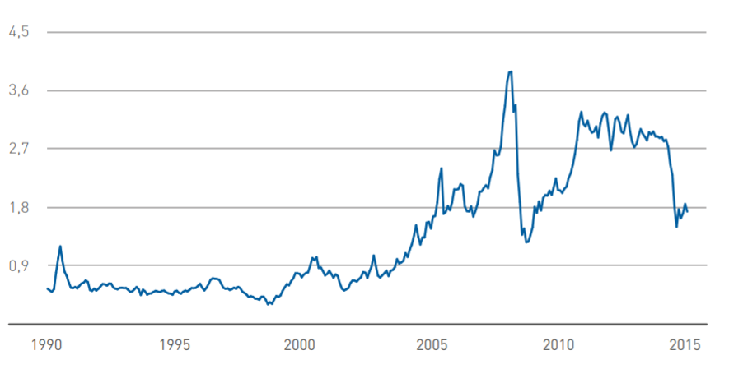
Fig.3-1 The graph of the global dynamics of aviation fuel prices
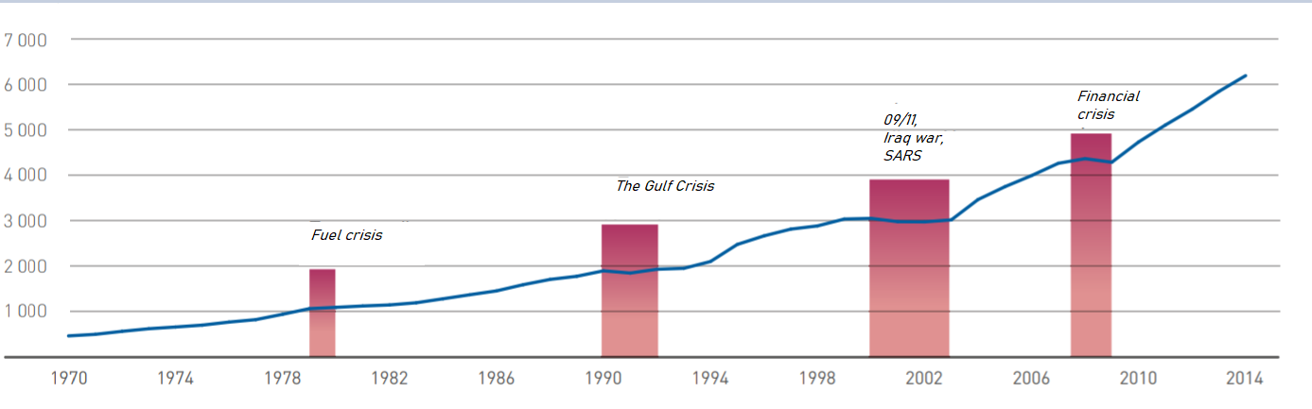
Fig.3-2 The global air traffic and dependence on political events in the world.

The economic and geopolitical conditions in which the global air transportation market exists today determine the trends of its development in the medium term. One of the main trends remains the liberalization of the global air transportation market. In the 2000s, the liberalization process intensified not only in Europe and the USA, but also in Asia, which led to an increase in the number of airlines on the market, tougher competition between them, and, as a result, to a decrease in ticket prices and an increase in passenger air transportation.
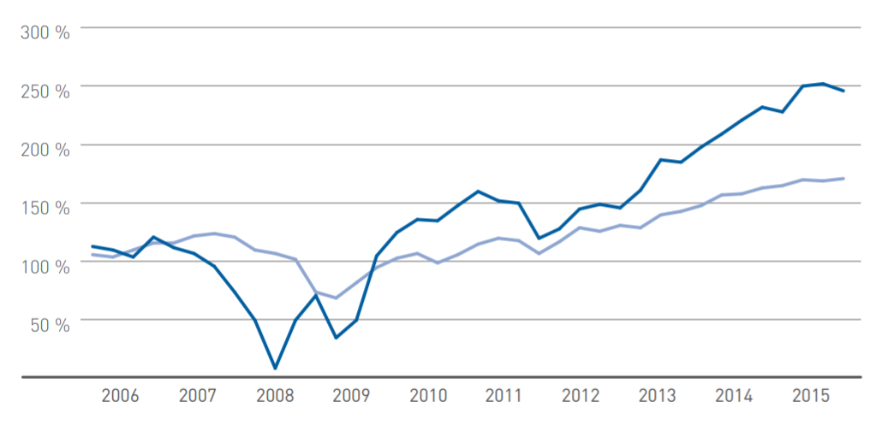
Against this background, an important trend is the globalization of aviation the market. Airlines are actively penetrating the markets of "not their" regions, the principle of "national" companies is being eroded, the process is being activated associations of the largest air carriers. Such examples are the unification of the largest national carriers of the United States, the acquisition by Lufthansa of many European airlines, the unification of a number of Russian players into the Aeroflot group, the active struggle of Middle Eastern carriers with the North American authorities to increase their role in the distribution of passenger traffic.
Fig.3-3 Financial stability of the airline industry.

Age more than 50% of PAS aircraft- The age structure of the fleet*of the Sazhir segment does not exceed 10 years old. Also, the world fleet is represented by a significant number of regional aircraft with a capacity of up to 60 chairs. However, aircraft with a capacity of up to 60 seats practically do not work in highly profitable directions, have fairly high
seat costs, and in a number of regions enter into direct competition with other modes of transport. The demand for aircraft with such a capacity has a cyclical form and significantly depends on the influence of external. A decrease in demand for air transportation or changes in the cost of jet fuel primarily affects this market segment.
The capital intensity of the narrow-body and wide-body segments significantly exceeds the performance of the segment with a capacity of up to 60 seats, although small narrow-body (with a capacity of 60-120 seats) and wide-body aircraft together make up no more than 30% of the current fleet. The fleet of wide-body aircraft has a fairly diverse age structure, but most major airlines prefer to operate a modern fleet. Age 49 % the fleet of wide-body aircraft does not exceed 10 years.
Thus, the global market is gradually becoming a single space for all playersod, GDP will grow by an average of 2.9%, and in the second by 2.7% per year. Growth over 20 years by 1.7 times.
It should be borne in mind that the rate of population growth in the world is slowing down. In the retrospective period (2001-2018), it amounted to 1.2% Now the population of the Earth is 7.6 billion. In 2038 it will be 9.1 billion. In 2018, approximately 4.3 billion passengers were transported; in 2038, about 10.4 billion.
The main measure of work in passenger traffic is the value of passenger turnover, measured in passenger-kilometres. Passenger turnover and GDP are interconnected and depend on the region, but everywhere passenger turnover is growing at a faster pace than GDP. As air travel develops, the lead is shrinking. In the retrospective period, the ratio between the rate of world passenger turnover and GDP was 1.9, in the first decade, it will decrease to 1.6, and in the second - 1.5. At the same time, in general, the passenger turnover will increase 2.4 times over 20 years (from 8.3 to 19.5 trillion passenger kilometres).
Air mobility (pkm / person) is increasing all the time, but the rate of its growth is decreasing. In the period 2001-2018 - 4.5%. In the first decade of the forecast period, they will decrease to 3.7% per year, and in the second decade - to 3.3%.
Narrow-body aircraft remain by far the most popular in the air transportation market, as they currently account for 52% of passenger traffic. The share of wide-body (WB) aircraft accounts for 44%. An important feature of the development of world transportation is the trend of an increase in the share of UV and a decrease in the share of WB aircraft (59% and 38% are expected in 2038, respectively).
The total share of traffic on regional aircraft in the world decreased from 8.3% in 2001 to 4.4% in 2018 and will continue to decline to 3.0% by 2038. The decline in the share of regional traffic and traffic on the WB is in no way equivalent to a reduction in the volume of these traffic.
In total, the commercial passenger fleet now has about 28 thousand vehicles. The largest share belongs to NB aircraft (single-aisle aircraft with a capacity of more than 110 seats) - 59%. Then there are WB aircrafts, their share is 17%. Regional aircraft in the world are 23% (9.5% of regional turboprop and 13.8% of regional jet aircraft).
The average calendar life of aircraft in the passenger commercial fleet at the beginning of 2019 was 11.1 years.
According to the average calendar service life, the most "old" are regional turboprop aircraft (16.4 years), followed by regional jet (12.3), then narrow-body (10.2) and the youngest are wide-body aircraft (10.1).
The distribution of the aircraft fleet by the average calendar service life within individual aircraft classes shows that long-haul aircraft are characterized by a reduction in their share as the age of the group increases.
It is expected that in 2038, the world park will remain approximately 10.5 thousand. Aircraft of the modern passenger fleet, that is, 38%. Most of all will remain NB aircrafts - about 7 thousand (42% of the current), least of all - regional turboprop and regional jet, 1 thousand each (27% and 39%), of the current WB in the ranks will be 1.5 thousand (32%).
The total demand for commercial passenger aircraft in 2019-2038 is estimated by us at 44.3 thousand or $ 6 351 billion in the catalogue prices of 2019. Of these, 13.4 thousand have already been ordered. Aircraft (30% of the estimated demand).
From the forecasts of the distribution of work between aircraft classes, it follows that narrow-body long-haul aircraft will be the most in demand. It is expected that the global demand for them will amount to approximately 31 thousand units in quantity and $ 3,736 billion in value terms, which is equivalent to 70% and 59%, respectively. 34% of the demand for NB aircrafts is already covered by existing orders. Thus, the free market is estimated at approximately 20,640 units.
If we talk about the distribution of demand for new NB aircraft by capacity groups, then the clear leader here is the group of 166-200 seats (20.5 thous. aircrafts), which accounts for 66% of the demand in the UV BC segment. 34% of the demand in the group will be satisfied by the existing orders, the free market - 13,550 aircraft or $ 1,625 billion.
In the group with a capacity of 201+ seats, orders cover 43% of the expected demand, and the demand itself is 3 times less than in the group 166-200 (23% of all NB). The free market for this group is estimated at 3,640 aircraft.
The demand for aircraft with a capacity of 135-165 and 111-134 is noticeably lower than in the groups listed above.
In the class of WB aircraft, the total world demand is estimated at about 7,550 aircraft, and the free market at about 5,610 aircraft (74%). The total demand in the group with a capacity of up to 300 seats (this group includes CR929-500 / 600) is 3,560 aircraft, not occupied by orders - 2,830 aircraft (21% coverage). In the 301+ capacity group (which includes CR929-700), the total demand is slightly higher - 3,990, but the uncontracted demand is less - 2,780 (30% coverage).
The total demand for regional jet aircraft is 3,610 aircraft, the free market is 2,830 (79%). The greatest demand will be in the group with a capacity of 61-90 seats (2,000 aircraft), but of which 1,370 (68%) are in North America. In the 91-110 group (to which the Superjet 100 belongs), the total demand is less (1,380 aircraft), but the group itself is also smaller in terms of the capacity range (delta is 20 seats, and in the 61-90 group it is 30 seats). In the group with a capacity of 30-60 seats, the demand is extremely low (about 230 aircraft).
The total demand for regional turboprop aircraft for 20 years will amount to 2,120 aircraft, of which 14% are covered by orders. The 61+ capacity group is more attractive as it accounts for 74% of the expected demand in quantity and 80% in value terms.
Russian civil aviation has already achieved results and is demonstrating double-digit growth rates in traffic. Our share in the global passenger turnover is 3.5%, and in the world population is 1.9%. Air mobility in Russia is 1.8 times the world average. Higher only in the Middle East (2.7), Europe (2.8) and North America (4.7). Note that these results do not seem unusual against the background of historical facts. At the time of the collapse of the USSR in 1991, Aeroflot was the largest airline in the world. In the same year, the share of the Russian Federation in terms of population was 2.7%, and in air transportation 8.1%, air mobility was 3 times higher than the world average. But then the crisis broke out. By 2000, the passenger turnover of Russian airlines decreased 2.8 times compared to 1991, and the global share decreased to 1.8% (the share in the population decreased to 2.4%, air mobility dropped to 0.7 of the world average). However, since 2001, the traffic of Russian airlines began to grow again and growth continued until 2014 with an average annual rate of 11.4%.
In the ICAO rating for passenger turnover performed in 2018, Russian airlines took the 7th position (after the USA, China, UAE, Great Britain, Germany and Canada). In terms of cargo turnover, it is also in 7th place.
The growth rate of GDP in the Russian Federation in the next 20 years is projected at 1.7%. The growth rates of passenger turnover in the forecast period will amount to 4.7% and will be higher than the world average (4.4%). By the end of the forecast period, the estimated air mobility of the population in relation to the world average will increase to 2.3, since here, in addition, the growth in the world population and the reduction in the Russian Federation will affect.
In total, the commercial passenger fleet of Russia now has 1,026 aircraft, the average calendar service life of aircraft in the fleet at the beginning of 2019 was 14.3, which is noticeably higher than the world average (11.1). The most "elderly" is the regional turboprop class (33.5 years) and its group of 30-60 seats (96 aircrafts with an average age of 39.4 years), since there are 76 An-24 in it, with the average calendar service life from 40 to 48 years. Moreover, 60 of them have the “In Service” status. In 2038, 326 aircraft will remain on the wing.
The demand for new aircraft is estimated at approximately 1,470 aircraft worth $ 182 billion, which is equivalent to a share of 3.3% of world demand in quantitative terms and 2.9% in value terms. 527 aircraft were ordered (36% of the quantitative demand). In the NB aircraft class, the expected demand will be 1,040 aircraft, of which 43% have already been ordered. At the same time, 59% of the projected demand has already been ordered in the NB 166-200 group, but there is still a demand potential for 260 aircraft. The second most popular group will be NB 201+. It is possible to purchase 210 liners here, 180 (86%) are not covered by firm orders. In the segment of regional jet aircraft, the delivery of about 200 aircraft is expected, 135 of which will be in the group with a capacity of 91-110 seats. Note that this is 10% of the world quantitative demand. Of the 135 aircraft, 32 have already been ordered. The demand for WB aircraft is forecasted in the amount of 140 aircraft, 45% of them (63 units) belong to the group of up to 300 seats. Orders covered 36% of the estimated demand for WB aircraft. The demand for turboprop aircraft is estimated at 94 aircraft. There are no firm orders yet [26].

3.3 PBL based technical maintenance risk analysis
Airline safety managers would like to have a simple and reliable tool for quantifying and predicting risk when flying with an airline.
The ICAO Safety Management Manual describes three safety management strategies: The reactive (response) method reacts to aviation events that have already occurred; The preventive method actively identifies hazards by analysing the activities of the organization; The predictive (warning) method analyses the characteristics of the system in its forthcoming production activities.

Depending on the intended aspect, the concept of flight safety may have different interpretations, for example:
- zero level of aviation accidents or serious incidents is a widely held opinion among passengers;
- the absence of hazard factors, i.e. such factors that cause or may cause damage;
- attitude of employees of aviation organizations to unsafe actions or conditions;
- avoiding errors;
- compliance with regulations.
Regardless of interpretation, they are based on one common premise - the possibility of absolute control. Zero level of accidents, absence of risk factors, etc. imply that it is possible (through the introduced system or measures) to put under control in the aviation operational context all variables that can lead to negative or damaging consequences. However, although the elimination of accidents and/or serious incidents and the achievement of absolute control are undoubtedly very desirable tasks, in an open and dynamic operational context they are unattainable. Hazard factors are integral components of the aviation operational context. Failures and operational errors will occur in aviation, despite the most effective and carefully designed measures applied to prevent them. No human activity or system created by him is guaranteed against the complete absence of hazard factors and operational errors.
Therefore, safety is a concept that should include relative rather than absolute concepts, which is why, in an inherently safe system, the presence of flight safety risk factors arising as a consequence of hazard factors in the operational context should be allowed. The main issue is still control, but control is relative, not absolute. As long as safety risks and operational errors are reasonably controlled, an open and dynamic system such as a commercial civil aviation system is considered safe. In other words, flight safety risk factors and operational errors that are under reasonable control are permissible in an inherently safe system.

Safety is increasingly viewed as a result of the management of certain organizational processes aimed at keeping under control the risk factors for flight safety that arise as a consequence of hazard factors in the operational context. Thus, for the purposes of this guide, safety means the following:
Safety. A condition in which the possibility of causing damage to persons or property is reduced to an acceptable level and maintained at this or a lower level through a continuous process of identifying hazard factors and managing flight safety risk factors.
Analytical risk expresses the frequency of the implementation of hazards in
relation to their possible number. In general:
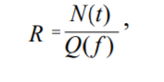
Where:
R is the risk;
N is a quantitative indicator of the number of undesirable events per unit of time t;
Q is the number of objects exposed to a certain risk factor а f.
The concept of "risk" includes another aspect – it is a quantitative characteristic of the action of hazards formed by a specific human activity.

3.4 PBL based technical maintenance external condition analysis
The main factors determining the demand for new aircraft are the development of air transportation and the disposal or replacement of the existing fleet. The demand for passenger air transportation, in turn, depends on many factors, but, first of all, on the size and rate of development of the gross domestic product (GDP), population and the level of development of the air transportation industry and alternative modes of transport.
Industry enterprises develop (as a rule, in cooperation with foreign companies) a number of promising civil aircraft and aircraft engines. First of all, this is a Russian regional aircraft (Russian regional aircraft, rzhu) of the Sukhoi joint-stock holding corporation with the participation of such companies as Boeing (USA), Alenia Aeronautica (Italy), as well as the SaM146 aircraft engine designed for installation on this aircraft, created within the framework of the alliance between the French company Snecma on Moteur and the Russian JSC NPO Saturn. The promising ones include the short- and medium-haul MS-21 aircraft (Yakovlev Design Bureau, Ilyushin Design Bureau and Tupolev Design Bureau) and PS-12 aircraft engines intended for installation on this aircraft (under development).
Perm Design Bureau and D-436T12 (created by the Ukrainian enterprise Motor - Sich in cooperation with a number of Russian enterprises).
The amount of costs for the development and development of mass production of new aircraft and aircraft engines is usually several billion dollars, therefore, for the project to pay off, it is necessary to implement at least several hundred or even thousands of products. Thus, the developers of the MC-21 family of aircraft predict sales only in the Russian market from 2012 to 2025. at the level of 230-410 copies, [4-5], and up to 300 aircraft of this type are expected to be exported during the specified period (about 3% of the projected company's total demand of the world's airlines for short- and medium-haul aircraft in the period up to 2025). The creators of the IEL aircraft expect to sell at least 800-1000 copies from 2008 to 2023 (more than 2/3 of them for export), with the total capacity of the world market of regional aircraft approximately 5.0-5.5 thousand units. At the same time, it should be recognized that demand forecasts for them vary significantly even among cooperation partners, not to mention competitors, airline representatives, and independent economists.
Due to the high cost of R&D, a reliable forecast of future demand volumes is necessary before the start of full-scale project development. Forecasting the demand for promising products of the aviation industry is complicated by its long-term nature: the pre-production stages of the life cycle of aircraft (R& D, technological preparation of production) take 5-10 years, and the period of serial production can last 20 years or more. If the forecast of sales volumes is not justified, the market failure of the project can cause not only the ruin of enterprises, losses for the state budget, but also the loss of scientific, technical and personnel potential of the industry, negative social consequences. Therefore, improving the methods of forecasting demand for aviation industry products is an urgent and complex scientific task.
In [6], some methodological problems of forecasting demand for aviation industry products are considered. In particular, it shows that in unstable economic conditions, a reliable forecast of demand for aircraft in a competitive market is possible only by selecting groups of rationally acting potential customers. This point of view is shared by some other researchers (see, for example, [5]). In turn, such a choice is determined by the economic efficiency of products offered by competing manufacturers. Those customers for whom the economic efficiency of the products of this enterprise is higher than the efficiency of competitors' products will make up a lot of likely customers of the enterprise. At the same time, the demand of airlines for aircraft and aircraft engines consists mainly of three purchases necessary: to replace aircraft that have exhausted their resource; to increase the carrying capacity (in order to more fully meet the growing demand for air transportation); to replace obsolete (although, perhaps, not fully exhausted their resource) aircraft with new generation products.
The specifics of the current situation in both Russian and global civil aviation are such that it is the third of the listed components of demand for aircraft that prevails, which is due to a significant excess of carrying capacity. In the early 1990s, due to a sharp decline in the purchasing power of most of the population in Russia, there was a multiple decrease in the volume of air traffic compared to the pre-reform level. A large number of serviceable aircraft were decommissioned. Thus, in 2004, the operated fleet of aircraft in Russian civil aviation was only 54%
The registered number [7]. At the same time, the intensity of aircraft operation, expressed by the average annual flight time per aircraft, is 1.5-2.0 times lower in Russia than abroad (1500-2000 flight hours per year compared with 3000-4500 in leading foreign airlines). By the beginning of 2006, the pre-crisis volume of traffic has not yet been restored, although the recovery growth has been observed since the early 2000s. Thus, the carrying capacity and resource of the existing fleet of aircraft are far from being exhausted. A similar situation is observed abroad, where (after the tragic events in the USA on 11.09.2001) hundreds of serviceable aircraft were put into temporary storage. The desire of Russian airlines to renew the fleet of aircraft observed in recent years is mainly caused by its moral aging (low fuel efficiency, non-compliance with new environmental standards, etc.), and not by the development of its resource. Thus, according to the source [7], only 42% of 700 decommissioned in 1991-2003. mainline and regional passenger aircraft have exhausted their resource, 14% of 440 cargo aircraft, 22% of 1,180 helicopters.
Thus, in the next few years, the most important factor determining the demand for new aircraft and aircraft engines on both the Russian and global markets will remain the desire of airlines to qualitatively upgrade the fleet of aircraft, to equip it with more modern and efficient aircraft. Therefore, in the economic analysis of innovations on their basis, there are several options for determining the indicator of the effectiveness of the introduction of innovations E, which can be represented as:
$$E=\frac{L}{(K_{IC}+K_{CC})},$$ | [13]
where L is the economic result of the innovation for the billing period;
K_{IC} - innovation costs;
K_{CC} - investment (capital) costs.
$$E_{CC}=\frac{L}{K_{CC}},$$ |  | [14]
$$E_{IC}=\frac{C_{P}}{K_{IC}},$$ | [15]
where C_{P} is the market price of the innovation.
In turn, the economic effect of the innovations U_{IC} can be written as:
$$U_{IC}=C_{P}-K_{IC},$$ | [16]
$$U_{IC}=L-K_{CC},$$ | [17]
In cases where it is necessary to compare innovations in terms of their profitability, ranking can be carried out using the profitability coefficient K_{P}:
$$K_{P}=\frac{S_{ð}}{S_{p}},$$ | [18]
where Sð - the sum of the reduced income;
Sp - the sum of the reduced cash costs.
The given cash incomes are the future profits from the innovation, which are added not in the absolute amounts that are expected in the future, but adjusted for the discount coefficient (different for each future year) [37].
The technical and economic level of aircraft engine production after the introduction of technological innovations can be characterized through the indicator of unit reduced costs K:
$$K=\frac{(C_{P}+E_{IC}F)}{N_{E}},$$ | [19]
where C is the cost of production of an aircraft engine;
Е_{IC} - standard efficiency coefficient (0.1–0.12);
F is the average annual cost of fixed assets;
N_{E} is the number of aircraft engines produced per year.
Thus, the economic analysis of technological innovations consists of defining a number of expected indicators that can be systematized into three groups:
The first group of indicators characterizes the expected economic results from the introduction of technological innovations (C_{P}, L).
The second group of indicators characterizes the expected innovation and investment costs associated with the introduction of technological innovations (K_{IC}, K_{CC}).
The third group of indicators characterizes the effectiveness of the introduction of technological innovations (E, E_{CC}, E_{IC}, K_{P}, K).
The problem of assessing innovations can be divided into two independent tasks: assessing the consequences (positive and negative) of the implementation of a particular direction of development and measuring the corresponding costs of their implementation. The choice of directions will be carried out by comparing alternative projects, which is carried out in two main directions: social assessments and economic (monetary) measurements [38].
Thus, the third chapter proposes a model of the conceptual and functional relationship between the development of technological innovations with a block of indicators for assessing the economic effect at the early stages of the aircraft life cycle. This model reveals the essence of assessing the economic effect of technological innovations at various stages of the aircraft life cycle and is based on quantitative changes in the technical and operational systems of the aircraft.
An in-depth analysis of economic efficiency indicators was also carried out, namely: an analysis of the aviation equipment market in the medium-haul aircraft segment, an analysis of the cost, supply and demand for aviation equipment, three methods of flight safety management were considered, an analysis of macroeconomic conditions affecting the implementation of technological innovations was carried out.
Section 3.3 describes a number of expected indicators in the economic analysis of technological innovations using the example of an aircraft engine. It is proposed to consider such a breakthrough product, which, appearing on the market, may cause a voluntary refusal in its favor, at least some operating organizations from using their existing aircraft, despite the fact that the latter has not yet exhausted its resource.
Of course, this is a very strict criterion. Nevertheless, it has a logical justification and, as will be shown below, does not contradict the data on the change of generations of aircraft.
If the formulated criterion is not met, airlines will prefer to continue to operate the existing fleet, and only as its resource is developed to acquire new products. Even if the preference is given to the products of domestic enterprises, it is obvious that the demand for it per unit of time will be significantly less, since of the three components of demand for aircraft listed above, only two remain in force (replacement of equipment that has exhausted its resource and expansion of the fleet), i.e. not the most significant at present. In the absence of radical advantages over the products of the previous generation, the purchase of new aircraft will be mainly postponed by airlines for the future, which will create two competitive threats.
Firstly, during the years for which the purchase of new aircraft (and engines) has been postponed, competing manufacturers are likely to offer new samples by the time their old products are written off. At the same time, it should be remembered that foreign competitors have significant financial resources for R&D, since they already receive significant revenue from the sale and maintenance of their products.
Secondly, by exploiting competitors' products, airlines strengthen ties with their manufacturers and repair companies, which causes the effects of mutual learning (during operation and after-sales service) and, as a result, enhance the locking effect.
So, it is proposed to consider a breakthrough product that (at least in certain market segments) is able to overcome the blocking effect. Using the conventions introduced earlier, we will build a simplified model of making a decision on the write-off of old-generation aircraft with a remaining resource. Let's assume for simplicity that the owner of an old-generation aircraft can take one of two alternative solutions. Either the old product is operated until the resource is fully exhausted, and only then it is replaced by a new generation product, or it is written off and replaced immediately when a new generation of aircraft appears on the market.

Chapter 4 Conclusion
A critical analysis of the current state and trends in aircraft maintenance management shows the following shortcomings of the existing system for maintaining the airworthiness of civil aviation aircraft, both in the Russian market and in the Asian market.
Departmental structure of the aircraft maintenance economy, virtually devoid of any economic or commercial relations between various enterprises, high labor intensity of maintenance; low productivity of technical personnel, poor organization of the maintenance process maintenance, insufficient quality of aircraft maintenance, the impact of the maintenance process itself on flight safety, the impact of the human factor on labor results. Hence the goals and objectives of further research. First of all, it is necessary to consider and propose a more perfect structure of the organization of maintenance from the standpoint of lean manufacturing, optimize its structure, and start with technical and economic indicators to consider the indicators of the maintenance process, excluding costly indicators, aiming at improving the economic mechanism, to consider the indicators of civil aviation transport activity, aiming at aircraft maintenance work, to perform aviation transport work on air transportation by air transport, to consider disparate indicators of manufacturability, maintainability, controllability, indicators of aircraft technical condition management to introduce, instead, introduce comprehensive performance indicators. Consider quality and risk indicators, introduce comprehensive reliability, safety indicators and indicators of timely performance of maintenance work. In connection with the translation of design and working documentation into figures and the increase in the share of modern processing complexes in production, it is necessary to consider a digital modification of the organization of production of technical operation of air transport and its components.

4.1 Main work and innovation
Summing up, we can say that the work considers well-known techniques that allow implementing generally accepted approaches to assessing the economic effect of the introduction of technological innovations at the stages of the aircraft life cycle by applying standard concepts for assessing the economic effect of the introduction of innovations.
Given the iterative process of executing a successful PBL arrangement, it is important to exercise consistent reporting, communicate regularly with key stakeholders and assess the performance of the arrangement at routine, designated times. Figure below summarizes best practices related to managing PBL contracts.
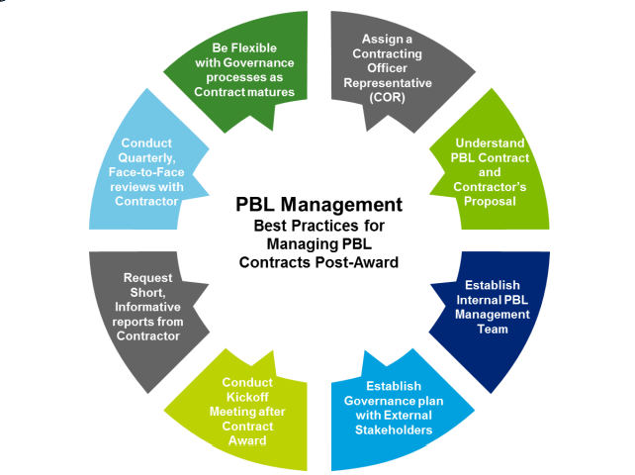
Fig.4-1 The main PBL principle

The master's study also looks at the theoretical basic principles of the study of the difficulty of assessing the financial result from the introduction of scientific and technical innovations at the stages of the current cycle of the aircraft unit, including the presentation of the essence of scientific and technical innovations, the difference between the judgments "innovation" and "innovation". Presented in detail: the current turnover of provisions, the boundaries of the current cycle of provisions, as well as the management of the current cycle of the product. The process of developing new technologies is almost always associated with the uncertainty of obtaining a successful result. This situation is especially typical for radical technologies with an intermittent development cycle. To reduce the degree of the technical and economic risk of creating technological innovations, the technology readiness level system can be recommended for use, and the return on investment can be assessed using well-known economic indicators, among which one of the most common is the indicator of net discounted income. These approaches, undoubtedly, are useful tools for managing investment and innovation projects and assessing their effectiveness, especially at later stages of the innovation process, for example, at the stage of manufacturing finished products. However, they lose their relevance at the early stages of the innovation process when developing radical discontinuous innovations, since in this case, there is an increased degree of uncertainty and it usually becomes impossible to give even an approximate forecast for the future regarding the success of creating an innovative product and draw up a plan for its implementation and commercialization. Therefore, in many respects, the degree of continuity of the process of its development will have a great influence on the ability to give an economic assessment of the effectiveness of creating high technologies. At the same time, the predictive methods used, the correct choice of strategy, risk assessment, technological routing, and technical and economic modelling are of great importance and value for the developer.
Summarizing the above, a model is proposed that presents the conceptual and functional relationship between the development of technological innovations with a block of indicators for assessing the economic effect at the early stages of the aircraft life cycle. This model reveals the essence of assessing the economic effect of technological innovations at various stages of the aircraft life cycle and is based on quantitative changes in the technical and operational systems of the aircraft. The model provides for the optimal (acceptable, acceptable or, in a negative sense, unacceptable, non-optimal) parameters of the technical and operational perfection of the aircraft within the technically achievable ranges. The model is built on the basis of a set of functional-cost (parametric) dependencies and includes taking into account the input (original) data - the requirements established in the technical specification for design, with the possibility of further clarification and coordination. The technical specification requirements for input establish the requirements for the basic (external) performance of aviation equipment and its technical and operational level.
In the third chapter, an in-depth analysis of economic efficiency indicators is carried out, namely: an analysis of the aviation market in the medium-haul aircraft segment, an analysis of the cost, supply and demand for aviation equipment. Three methods of flight safety management are considered, an analysis of macroeconomic conditions affecting the implementation of technological innovations is carried out.

4.2 The advantages and benefits of PBL based technical repair and maintenance
Innovations have a complex impact on both quantitative and qualitative parameters of economic growth. The impact of innovation on the pace of economic growth is manifested as a consequence of an increase in labor productivity and capital.
The high quality of economic growth presupposes the predominance of an innovative factor in its structure, which is reflected in the form of new goods, services, technologies, forms of organization, management methods, changes in the quality of labor.
The growth achieved at the expense of raw materials differs significantly from that which occurs on the basis of innovation.
The solution to the problem of the quality of economic growth is possible in 3 directions: economic, social and environmental. The economic direction includes two component blocks: factorial and structural.
When using the proposed innovative product, which is described in the master's thesis. We can finish off the totality of solving the set logistical problems in all 3 directions.
The economic direction will be developed in the direction of saving costs for logistics services. The social direction wins not only in the direction of creating new personnel, but also in the direction of reducing unnecessary personnel. Since the method of contacting intermediaries for certain logistics services will be applied. The ecological direction also wins, since we not only save fuel, kerasin, etc. And we also intentionally make less waste in the entire logical chain.
Innovation, being a direct growth factor, can revive demand in the long term. For Russia and China , the main domestic demand for aviation services in general is .In competition with other aviation giants, it is crucial to increase the competitiveness of goods and services, and this is possible only thanks to various innovations.
Performance-based mechanisms provide the industry with flexibility in determining how to provide quality services and performance results to its government partners with an acceptable level of profit and risk. In the context of PBL agreements, the industry will "compete" within its own organization
to reduce costs and increase profits, and will typically do so by:
• Process optimization, thereby reducing inefficiency and associated costs to meet
logistics demand
• Improving product quality (e.g. reliability), thereby reducing overall demand and
costs to achieve the desired performance
Both approaches, with the right structure and management, will lead to a reduction in support costs, the economy for
Ministry of Defense, improving support capabilities for the Warfighter and increasing profits for the supplier.

4.3 Development and prospect of PBL for aviation industry
The problem of assessing innovations can be divided into two independent tasks: assessing the consequences (positive and negative) of the implementation of a particular direction of development and measuring the corresponding costs of their implementation. The choice of directions will be carried out by comparing alternative projects, which is carried out in two main directions: social assessments and economic (monetary) measurements
Process improvement is a structured or continuous improvement of production processes. The four-step method described in TQM, which ensures the effectiveness of improving business processes, consists of: selecting processes; preparing for improvements; analyzing and redesigning processes; implementing improvements.
The term Total Performance Maintenance is universal efficient maintenance." At the same time, the term universal refers not only to productive and economical maintenance, but also to the entire complete system of effective maintenance of equipment during its service life, as well as to the inclusion of each individual employee and various departments in the process through the involvement of individual operators in maintenance. Moreover, the application requires a trusted platform module, certain obligations on the part of the management of the enterprise. The management concept of Total Performance Maintenance (TPM) is the universal care of production equipment - aimed at improving the efficiency of maintenance. The method of universal maintenance of equipment is based on the stabilization and continuous improvement of maintenance processes, a system of preventive maintenance, work on the principle of "zero defects" and systematic elimination of all sources of losses.
The advantage of the process approach is the continuity of management, which it provides at the junction of individual processes within their system, as well as their combination and interaction. When applied in a quality management system, this approach emphasizes the importance of: 1) understanding and meeting requirements; 2) the need to consider processes from the point of view of the value they add; 3) achieving the planned results of the processes and ensuring their effectiveness; 4) continuous improvement of processes based on objective measurement.

References

- Denisov Y., Klubova M., Milshina Y. et al. Vehicles and systems: new technologies of aircraft construction. - 2016. - No. 9 (Higher School of Economics) / [Electronic resource].
Access mode: URL: https://issek.hse.ru/trendletter/news/192541548.html
- [Brovkin A.V. Vasilenko A.A. Stoimostnoy podkhod k upravleniyu kompaniyami / A.V. Brovkin A.A. Vasilenko [The cost approach to the management of companies / A.V. Brovkin A.A. Vasilenko]. Ekonomika i predprinimatel'stvo – Economy and Entrepreneurship, 2017, no. 5-2 (82-2), pp. 404-410.
- Brovkin A.V. Vzaimnoye strakhovaniye – istoriya zarozhdeniya i mirovogo razvitiya, kak aktual'nyy nauchno-prakticheskiy opyt dlya razvitiya nekommercheskikh finansovykh otnosheniy v Rossii / A.V. Brovkin [Mutual insurance is the story of the birth and world development, as actual scientific and practical experience for the development of noncommercial financial relations in Russia / A.V. Brovkin]. Rossiyskoye predprinimatel'stvo – Russian Entrepreneurship,2017, Tom 18, no. 20, pp. 3019-3030.
- Podkatilin, A.V. Problemy razvitiya TRIZ / A.V. Podkatilin [Elektronnyy resurs]. – Zagl. s ekrana. – Rezhim dostupa:
- [Problems of development of TRIZ / A.V. Podkatilin [Electronic resource]. - Title from the screen. - Access mode] http://www.metodolog.ru/01116/01116.html.
- Eremin M.Yu. (2019) Effektivnost' primeneniya strategii performance based logistics priosushchestvlenii servisnogo soprovozhdeniya voyennoy aviatsionnoy tekhniki [The effectiveness of the strategy performance based logistics in the implementation of service support of military aircraft]. Ekonomika: vchera, segodnya, zavtra [Economics: Yesterday, Today and Tomorrow], 9(1А), pp. 90-100.
- Potanina YU. M. Razrabotka sistemy pokazateley otsenki deyatel'nosti stoimostno-oriyentirovannykh kompaniy [Development of a system of indicators for evaluating the activities of value-oriented companies]. Bukhgalterskiy uchet, statistika i audit: vyzovy vremeni : Sbornik nauchnykh statey / Moskovskiy gosudarstvennyy institut mezhdunarodnykh otnosheniy (universitet) Ministerstva inostrannykh del Rossiyskoy Federatsii; Kafedra ucheta, statistiki i audita [Accounting, statistics and audit: challenges of time: Collection of scientific articles / Moscow State Institute of International Relations (University) of the Ministry of Foreign Affairs of the Russian Federation; Department of Accounting, Statistics and Audit]. Moscow: MGIMO-Universitet, 2017, pp. 196-213.
- Potanina YU.M. Analiz pokazateley finansovoy ustoychivosti i otsenka veroyatnosti bankrotstva kompaniy [Elektronnyy resurs] [Analysis of financial stability indicators and assessment of the probability of bankruptcy of companies [Electronic resource]]. Menedzhment i kontrolling v usloviyakh nestabil'nosti rynkov i vneshnikh ugroz : Sbornik nauchnykh trudov IV Mezhdunarodnoy nauchno-prakticheskoy konferentsii po kontrollingu (Ryazan'-Moskva, 8-9 oktyabrya 2015 g.) / NP «Ob"yedineniye kontrollerov» ; pod nauch. red. S.G.Fal'ko [Management and Controlling in the Conditions of Market Instability and External Threats: Collection of Scientific Works of the IV International Scientific and Practical Conference on Controlling (Ryazan-Moscow, October 8-9, 2015) / NP "Combining Controllers"; under the scientific ed. S. Propulsion Falco]. Moscow, 2015.
- Khorin A.N., Brovkin A.V. Klyuchevyye indikatory otcheta ob ustoychivom razvitii organizatsii / Khorin A.N., Brovkin | A.V. [Key indicators of the organization's sustainable development report / Khorin A.N., Brovkin A.V.].
- Teoreticheskaya i prikladnaya ekonomika – Theoretical and applied economics, 2018, no. 1, pp. 1-12.
- Chumakova O.V. Kontsessionnyye soglasheniya i soglasheniya gosudarstvenno-chastnogo partnerstva, munitsi pal'nochastnogo partnerstva kak pravovyye formy developmenta infrastrukturnykh ob"yektov [Concession agreements and agreements of public-private partnership, municipal-private partnership as legal forms of development of infrastructure facilities]. Ekonomika i predprinimatel'stvo – Economy and Entrepreneurship, 2017, no. 2-1 (79), pp. 1129-1135.
- Chumakova O.V. Rossiyskoye zakonodatel'stvo ob investitsionno-stroitel'noy deyatel'nosti: osnovnyye cherty i tendentsii razvitiya [Russian legislation on investment and construction activities: the main features and development trends]. Ekonomika i predprinimatel'stvo – Economy and Entrepreneurship, 2017, no. 2-1 (79), pp. 1170-1173.
- LSAR – The missing link for performance-based logistics [Elektronnyy resurs]. –
- https://www.plm.automation.siemens.com/zh_cn/Images/lsar%20wp%20W%201_tcm78-5601.pdf.
- Performance Based Lifecycle Support [Elektronnyy resurs]. – Zagl. s ekrana. – Rezhim dostupa [Performance Based
- Lifecycle Support [Electronic resource]. - Title from the screen. - Access mode]: https://www.sdcexec.com/
- warehousing/event/10722458/performance-based-lifecycle-suppor
- Methodological recommendations for evaluating the effectiveness of investment projects: Second edition / Official publication of 21.06.99 - M.: Economics, 2000.
- Product Support: A Program Manager’s Guide to Buying Performance, published in November 2001,
- “The PBL Guide.” USA/ 2001

Appendix

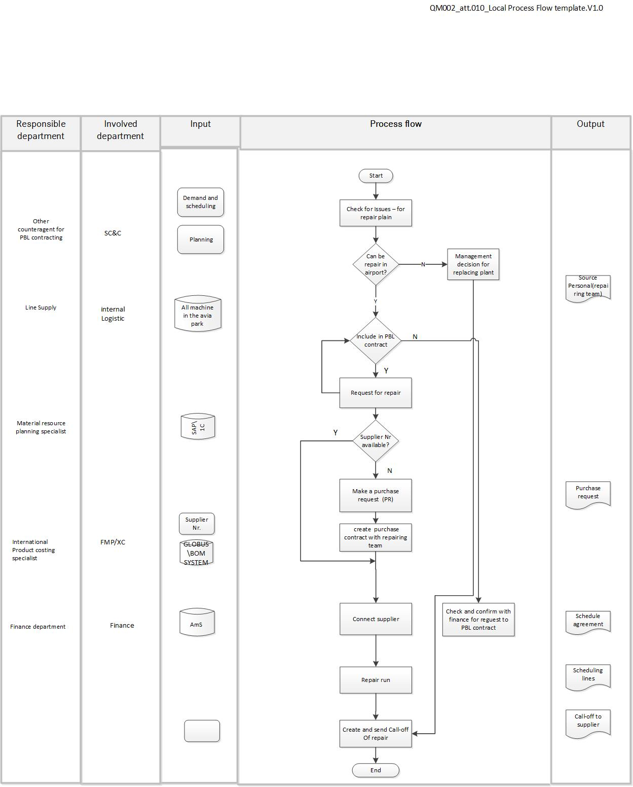

The concept of the streaming process and organizational structure, interaction in PBL logistics services has been developed.

Acknowledgements

I express my great gratitude to my supervisor, my teacher Nikolai Laznikov, my Chinese professor Guoqing Wang. Without them, this work simply could not exist. I also say thank you to all my classmates and the university SJTU.

Papers published or accepted during the master's degree

[1] Adomavichyute M.E., Sergienko V.I., Yazovskih A.L, Laznikov N.M., 19th International Conference “Aviation and Cosmonautics” (AviaSpace-2021)
№ 4, 252-254 p. Development of MRO system based on Performance-Based Logistics in aircraft design

