Academic Dissertation Original Declaration
of Shanghai Jiao Tong University

I hereby declare: the academic dissertation 《System of technical maintenance and repair based on the principles of PBL (Performance Based Logistics) in the development of aircraft》 I sent, is the result of my independent research under the guidance of my supervisor. This paper does not contain any published or written work of other individual or groups, except what has been noted in this paper. The individuals and groups who have made important contributions to the research of this paper have been clearly indicated in the paper. I am fully aware of the legal consequences of this statement.
Dissertation author sign：

date：

Academic Dissertation Copyright Authorization
of Shanghai Jiao Tong University

The author of this dissertation fully understands the regulations of the university about the retention or use of this dissertation, agrees that the university could retain and submit the copy or the electronic version of the dissertation to the relevant departments or institutions, and allows the dissertation can be consulted and borrowed. The author authorizes Shanghai Jiao Tong University to put the entire or part contents into the relevant database for retrieval, and to preserve and compile this dissertation by photocopying, reducing or scanning.
secrecy□, the authorization applies after year.
The dissertation belongs to
No secret .
(please type “√” in the box above)

Dissertation author sign: Supervisor sign:

Date: Date:

PBL Based Technical Repair And Maintenance In Development Of Aircraft

Abstract

The most important link of the unified world transport system and one of the main and main components of the transport infrastructure of modern civilization is air transport.
Recently, the volume of international traffic carried out by Russian airlines has greatly increased, but at the same time, on the other hand, the intensity of air traffic on international routes that pass through Russia has significantly increased.
In connection with such conditions, new and important tasks are assigned to aviation and the aviation industry, which are primarily related not only to the construction of a modern regulatory system for the industry, but also to the complete improvement of regulatory support for the effective flight and technical operation of aircraft.
The system of technical operation of aviation equipment plays a major and special role in improving and accelerating the scientific and technological progress of aviation. The main goal of this system is not only full and basic support and preservation of the airworthiness of the aircraft throughout its life cycle, but also the creation of the necessary conditions for effective use for its intended purpose.
Experience shows that operating costs are one of the most regulated items of enterprise costs, and reducing operating costs ultimately increases productivity. The identification of assessments and management factors for the maintenance of the aircraft becomes particularly relevant and requires a comprehensive analysis. Research shows that for many large and complex products and their systems, maintenance accounts for 65% to 75% of the main costs for the entire period of their life cycle. Thus, the role of maintainability, maintenance and reliability is becoming increasingly important.
These conditions simply oblige airlines not only to develop, but also to implement new and improved measures to improve the efficiency and profitability of using the fleet of aircraft, but also to include new and improved methods for managing all production processes of aircraft maintenance, as well as their forms for organizing maintenance and repair to fully ensure the necessary level of flight safety, while reducing the labor costs and downtime of aircraft for maintenance and repair.
Maintenance of aircraft is an integral part of the operation of aircraft and includes the organization and execution of works defined by the program of technical operation, as well as the elimination of failures and malfunctions identified in flight and during maintenance of aircraft, carrying out improvements, performing one-time inspections, routine repairs, replacement of components, etc.
At present, effective technical operation of aviation equipment is no longer possible without scientific research, the use of modern strategies and programs for maintenance and repair, methods of managing the efficiency of production processes, methods and means of diagnostics and control.
The scientific, theoretical and economic base of the technical operation of aviation equipment needs to be improved and developed. This requires, first of all, continuous improvement of professional training of specialists in the field of technical operation. These problems revealed the relevance of the research topic.
The relevance of the research topic is to identify problems during aircraft maintenance. Since the essence of maintenance problems is:
• Outdated contract model of technological maintenance of aircraft.
• Large overpayment when receiving services.
• Increased time for aircraft maintenance and document preparation.
The purpose of the master's research is to identify errors in the existing aircraft maintenance system, propose to eliminate bottlenecks, propose a new organizational structure with contractors and determine the economic efficiency of a new innovative system based on pbl principles, as well as change the operation of the after-sales service system.
In my work, the following tasks were also set:
• To study the theoretical foundations of the problem of assessing the economic effect of the introduction of an innovative PBL service system at the stages of the aircraft life cycle;
• To analyze methods and approaches in assessing the economic effect of the introduction of logistics technological innovations;
• To improve the model for assessing the economic effect of the introduction of innovations at the early stages of the aircraft life cycle.
The object of the study is the process of aircraft maintenance and repair both by traditional methods and on the principles of pbl.
The research methods are associated with a complete analysis of the costs of maintenance and operation of the aircraft; methods are proposed for calculating the savings on maintenance based on the concept of pbl. Methods for improving the technological maintenance of the aircraft, methods for reducing the supplier base are proposed. Also based on pbl.
The study proposes a model representing the conceptual and functional relationship between the development of technological innovations with a block of indicators for assessing the economic effect at the early stages of the aircraft life cycle.
This model reveals the essence of assessing the economic effect of technological innovations at various stages of the aircraft life cycle and is based on quantitative changes in the technical and operational systems of the aircraft.
The model provides optimal (acceptable, permissible or, in a negative sense, unacceptable, suboptimal) parameters of technical and operational perfection of the aircraft within technically achievable ranges. The model is built on the basis of a set of functional and cost (parametric) dependencies and includes consideration of input (source) data - the requirements set out in the technical specification for the design, with the possibility of further refinement and coordination.
The requirements of the technical specification for input data establish requirements for the basic (external) characteristics of aviation equipment and its technical and operational level.
The proposed model represents a conceptual and functional relationship between the development of technological innovations with a block of indicators for assessing the economic effect at the early stages of the aircraft life cycle.

Keywords: Logistics chain; after-sales stage of aircraft life cycle; PBL.

基于PBL（基于性能的物流）原理的飞机开发技术维护和维修系统

摘 要

本文提出了一个模型的框图，用于评估飞机生命周期售后阶段技术创新的效果，该模型基于考虑飞机系统技术和运营维护指标的数量变化，即评估物流售后服务的优化结果对飞机技术和运营完善的影响,
考虑到飞机生产和运营阶段所取得的效果，提出了航空公司交易对手互动，工作流程和内部工作附加程序的新流程。 从工作组织的角度来看，与传统系统的根本区别在于，服务公司的目的是为业务规划选择目标。
该模型基于实现和维护企业对外经济活动的绩效指标，即客户的最终结果。

关键词：物流链；飞机生命周期的售后阶段；PBL。

Content

I
Abstract I
基于PBL（基于性能的物流）原理的飞机开发技术维护和维修- I
摘 要 I
1.1 Introduction 1
1.2 Innovations in repair and aftersales maintenance. 2
1.2.1 System of logistic support for the operation of the airline's aircraft on the principles of PBL 3
1.2.2 Performance-Based Mechanisms 5
1.3 Analysis of material solutions as elements of innovation PBL concepts 6
1.4 Product lifecycle in aviation 8
1.5 Product lifecycle management 10
1.6 Product life cycle and technological preparation of production. 11
Development of internal processes of technical specifications for the creation of aviation equipment…………………………………………………………………...25
2.1 Definition of aircraft development lifecycle 28
2.2 Optimization and implementation of product support mechanisms in after-sales service 30
2.3 Methods for assessing the economic effect of technological innovations 32
3.1 Aviation the cost of after-sales service and equipment cost 36
3.2 The connection between technological innovations implementation and economic efficiency indicators 41
3.2.1 Aircraft market analysis 43
3.2.2 Analysis of the cost, supply and demand for aviation equipment 44
3.3 Assessment of the economic effect of technological innovations 50
3.4 PBL based technical maintenance external condition analysis………………...52
4.1 Main work and innovation 58
4.2 The consequences of the technology innovation’s economic effect 60
4.3 Follow up research 62
Appendix 68
71

Catalog of Figure

Fig.1-1 The essence of operational excellence is on common functions such as design, supply chain, procurement, procurement and production and interaction with time indicators and cost costs. 4
Fig.1-2 Comparison of the traditional model and the new proposed model of PBL services. A graph of dependence and benefits in terms of value. 6
Fig.1-3 Hierarchy of PBL indicators with a description of each level 15
Fig.1-4 Interactions between the obligations of the two parties involved. Dependence of actions. 16
Fig.1-5 Table with the evaluation method on the scale of importance. Percentages by degree of importance. 17
Fig.2-1 Formulas for calculating the necessary coefficients and data for comparative analysis 24
Fig.3-1 The graph of the global dynamics of aviation fuel prices in the value dependence of the dollar and the gallon 36
Fig.3-2 The dynamics of global air traffic and dependence on political events in the world 36
Fig.3-3 Financial stability of the airline industry.Dark blue - XAL (Airline Index on the American Stock Exchange) and light blue - S&P 500 (Stock Index 500 largest US companies) 37
Fig.4-1 The main PBL principle. 49

Catalog of Table

Table 1-1 Table 3-Rating and remuneration Calculation contractor under contract FY 04-08. 20

Chapter 1 Introduction

This chapter describes the developed mathematical model of the processes of transition of the state of the aircraft, the processes of quality management of technical operation of aviation equipment. The process of technical operation of the aircraft and flight safety is analyzed, the tasks of ensuring the quality of maintenance and flight safety are considered.

1.1 The problems of traditional logistics technical maintenance mode

Nowadays, after-sales service of aviation equipment, a service company provides a full range of services or a service company that specializes in a certain set of services, they build their logistics, focusing on the task of full readiness to provide all the necessary work at any time at the request of customers. It turns out that the service company creates a stock of all the necessary parts, materials and equipment to be ready to perform all the declared types of work. Which is very costly for the customer.
In such economic conditions, service companies face numerous challenges non-productive costs that can not be avoided technologically:
1. Diversion of financial resources for the purchase and storage of parts, materials and equipment that may remain unclaimed in the main activity in the for a long time due to the lack of orders to carry out work with them use;
2. Delays in the completion of individual orders due to a lack of one or the other equipment, parts, materials, if the need for them for the execution of a specific the order is higher than the standard inventory volume set in the company;
3. Technological, moral and physical obsolescence of stocks, a long time un-claimed, which leads to an uncompetitive low the level of execution of orders using them or to direct losses when accepting them decisions to eliminate such obsolete stocks.
It turns out that within the framework of the traditional model, service companies bear full responsibility for unproductive losses in the logistics system, since their organization is built without any ability to predict the nature and structure of market demand for work and types of services.
When switching to the model of service support based on the Performance Based principle
Logistics (hereinafter referred to as PBL) service companies receive undeniable advantages in the field of logistics and personnel planning. Application of such a logistics system based on the life cycle of at civil aviation, allows service companies to rebuild the entire system organization of order fulfillment with a focus on achieving the set targets serviceability development of the maintenance process and safety.
A fundamental difference from the traditional system in terms of organization of work the goal of service companies is to select targets for business planning.
The model is based on achieving and maintaining performance indicators foreign economic activity of enterprises, that is, the final result for the customer

1.2 Innovation requirements for logistics technical maintenance
Technological innovations are the final result of innovative activity, embodied in the form of a new or improved product or service introduced on the market, a new or improved process or method of production (transfer) of services used in practice. Technological innovations can be both those products, processes, services and methods that an organization develops for the first time, and those that it adopts from other organizations.
The concept of repair, as a rule, is applied to the repair of the structure, when something is riveted, airframe elements are replaced, doubler patches are put, some changes are made to the design. That is, it is a consequence of some kind of abnormal incident such as damage on the ground, corrosion, fatigue cracks, etc.
Maintenance is inherently preventive. Since the release of the aircraft and during operation, degradation processes are constantly going on, and the point is to find the consequences of these processes and eliminate them before they become a threat to safety. Strictly speaking, before you face a security problem, you will have to break through the fence of economic efficiency. That is, neglect of THAT primarily leads to financial losses.
The simplest example is the operation of wheels. Airplane wheels wear out in about a month. With normal wear, the wheel is sent to the manufacturer, and the tire is restored by welding rubber, and this can be done up to five times. But if you do not change the wheel in time, then it will not be taken for repair. That is, you can fly longer on a worn-out wheel, but then you have to throw it away, and it will be more expensive for yourself.
Various units either have their own resource and must be changed with a certain periodicity, or they are operated according to the condition. Operation by condition is divided into two types: with parameter control and to failure.
Operation by condition - certain parameters of the operation of this unit are controlled, and if they go beyond the boundaries, then it's time to change it. The control can be either by means of tests or built-in monitoring systems for electronic systems, or during various inspections or non-destructive testing for mechanical units and airframe. For example, during C-check maintenance, the aircraft is disassembled to the structures, and if corrosion or something else is detected outside the tolerances, then repairs are already being made.
Operation to failure, as a rule, concerns electronic equipment. Modern avionics systems often have self-monitoring systems, and in case of failure they issue a message, they say, go on without me. The failure is isolated, and due to duplicate systems, the aircraft can continue to be operated further. That is, the failure is not accompanied by any sparks, smoke or insanely working devices, just a message is displayed about the fault failure - switching to another system - we fly on. This approach made it possible to implement a policy of CHALK flights with malfunctions.
The PBL strategy works by stimulating desired outcomes throughout the product lifecycle, from design to operation and decommissioning. Those responsible for system design, strategy development and requirements fulfillment should have an understanding of the business model and prospects of the fighter and the supplier.
Under the traditional model of transactional product support, if the customer purchases spare parts or maintenance services with the assistance of a commercial technical support service (contractor) at the time of the need for repair, the contractor has no incentive to reduce the need for repair work and the use of spare parts.
When equipment fails or undergoes major repairs, the supplier charges for repair or replacement services on a case-by-case basis. When transactions are maintained, the vendor's revenue and workload increase as the number of hardware failures increases. PBL mechanisms and methods eliminate this discrepancy.
According to the PBL agreement, a commercial supplier acquires motivation to reduce the number of repairs, the cost of spare parts and the labor force used during the repair process. commercial suppliers are motivated to reduce the duration of system downtime under PBL agreements, since it is stipulated in the contract, and their revenues increase due to a decrease in their cost.

Performance based logistics (PBL) for aircraft technical maintenance
PBL is a logistics that is performance-based to improve aircraft maintenance and support all types of product throughout the aircraft lifecycle. In PBL, results are achieved through performance-based mechanisms that meet customer requirements and also encourage product support providers to reduce costs through various innovations.
PBL Requirements:
- Preferably for PBL is an approach in which the final goals are formulated in the contract, and not specifically the detailed composition of products or specific services to service support.
- PBL has a fully integrated supplier cooperation.
- One integrator provider is responsible for the overall end result of all service support.
- The purchase and subsequent support of a specific of armed military equipment system in operation are combined into a single process under the management of a manager.
- Applicable both at the level of large complex systems and platforms, and at the level of individual subsystems.
For airlines, when using various aircraft, the main factor is the increased efficiency of the use of aircraft, which plays a major role in raising competitiveness and profitability in the air transportation market.
Availability indicators and indicators of the speed of after-sales service of an aircraft have a significant impact on the efficiency of aircraft use. These indicators can be used as key indicators in the formation of a logistics support system for the operation of airline aircraft based on the principles of PBL.
When designing aviation equipment, the most important economic issue is to determine the integral effect of improving its technical and economic indicators or the effectiveness of additional investments associated with achieving a higher level of technical perfection of the aircraft design. The main conditions for improving the efficiency of the aircraft design are: reducing the weight of an empty aircraft, improving the aerodynamic qualities of the aircraft, increasing the service life and achieving maximum operational adaptability.
The goal is to shift responsibility for results to suppliers while reducing overall lifecycle costs. From the point of view of the aviation department, logistics contracts based on results can work, and their use is resumed.

Performance-Based Mechanisms for the aircraft technical maintenance
The essence of operational excellence is faster, more reliable and more inexpensive efficiency. If the organization has not yet implemented this culture, then it is likely that in all its programs, and not just in PBL, there is a decrease in profitability and a deterioration in customer relations. If an organization has departments that adhere to a culture of continuous improvement, it is extremely important to change incentives so that they apply to the entire organization, since most programs will be based on common functions such as design, supply chain, procurement, procurement and production.
PBL considerations should be part of the manufacturing/quality assurance (QA) process, as repair processes (included in PBL) are influenced by production assembly decisions.
The goal of PBL is to use performance-based mechanisms with an appropriate contract structure and incentives to motivate the desired PSP/PSP behavior.
The result is an agreement that provides the necessary capacity to conduct actions, positively affects the costs of operation and maintenance and satisfies the supplier's need for profitability.
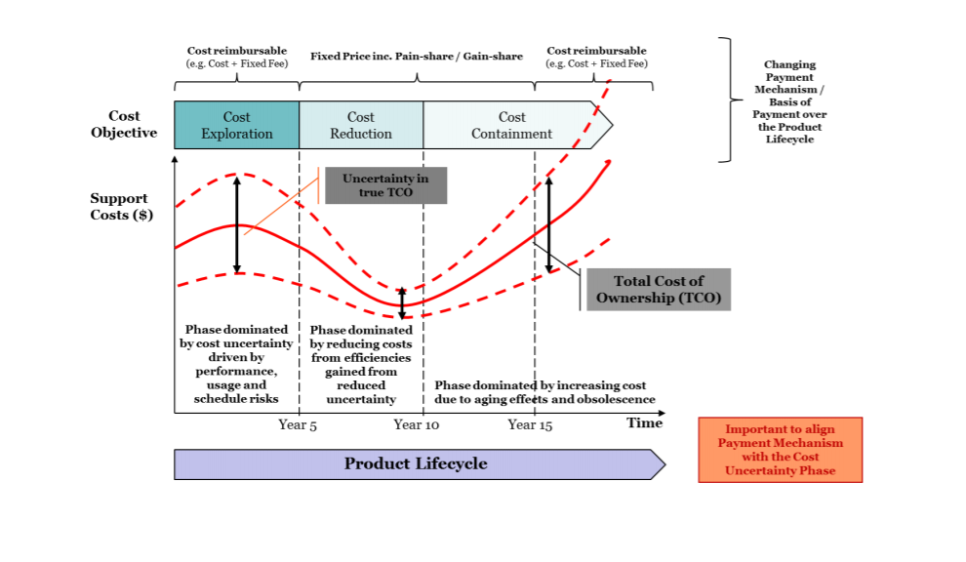
Figure 1.1 - The essence of operational excellence is on common functions

1.3 Analysis of PBL with traditional approach
The PBL strategy is to stimulate the achievement of desired results throughout the product lifecycle, from design to operation to decommissioning of the product. Persons who are responsible for the development of the system, or persons who are involved in the development of strategies and the implementation of requirements, must necessarily have an idea of the business model and prospects of airlines and all service providers.
If we compare the framework of transactional product support in the traditional model, it turns out that when airlines buy spare parts or maintenance services from a commercial contractor, or in cases where repairs are required, the contractor is not interested in reducing the need for repairs and spare parts.
That is, when any equipment fails or undergoes major repairs, the supplier charges for repair or replacement services on an individual basis. It turns out that, while maintaining transactions, the supplier's income and the entire workload will increase as the number of equipment failures increases.
Thus, the traditional model creates a fundamental discrepancy in product support for the customer, and PBL mechanisms eliminate this discrepancy. When paying for performance, points per transaction, it is to commercial suppliers. It turns out that their profits are negatively affected by any additional costs that they incur when fulfilling contractual requirements.
Under the PBL agreement, the commercial supplier receives an incentive to reduce both the number of repairs and the cost of parts and labor, or to reduce the downtime of the system that is used in the repair process. As part of the PBL agreements, this is stipulated directly in the contract, because the profit of suppliers increases by reducing the cost of repairs and maintenance.
Commercial value is focused on profit, a significant increase in investment capital and a guaranteed income stream. At the same time, suppliers who respond to a different set of incentives are in demand, they require increased workload and increased strength in warehouses. But they would also like to see the inevitability of repairs and repairs. There is a desire to create incentives to achieve this goal.
If necessary, various incentives can be used for the operation of the store; But do not take into account that the funds must start from the organic team, since the OEM product Support integrator (PSI) prohibits receiving bonuses or other important incentives for the public PSP within the framework of public-private content.
It is very important to understand the factors that are characteristic of the behavior and motivation of a commercial enterprise when an integrator supports OEM (PSI) products and offers suppliers. It turns out that participation, which includes significant accountability to shareholders, attracts attention to goods and services in the market, balancing business risks and bringing profit closer, provides shareholders with a good return on investment. Since solid affairs are relationships of legitimate elements of successful principles based on the position, it is important to understand how to work from a corporate and individual point of view. This understanding will meet the requirements of incentives, which must be justified by the need to achieve the desired results of work.

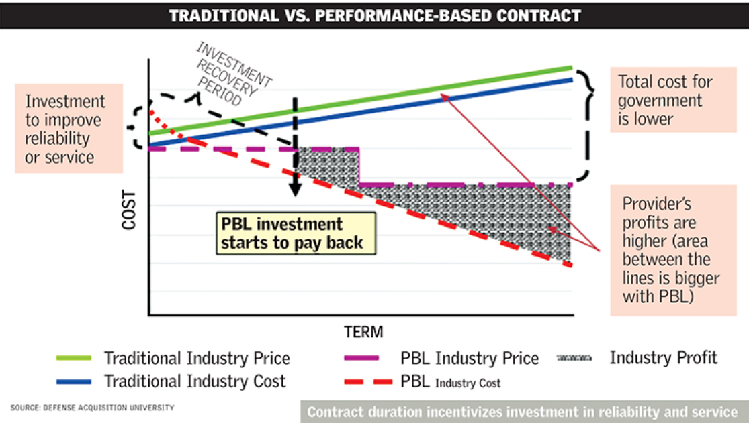

Figure 1.2 - Comparison of the traditional model and the new proposed model of PBL

The essence of operational excellence is delivering value faster, more reliably and at lower cost. If an organization does not have this culture already embedded, then it’s likely that all its programs — not just PBL — are seeing erosion of margin and customer relationships. If there are pockets of an organization that embrace a culture of continuous improvement, it is critical to change incentives so that it drives this across the entire organization as most programs will draw on shared functions such as engineering, supply chain, sourcing, procurement and manufacturing.

Aircarft’ material performance innovation requirements
The analysis of the logistics solution provides the very first opportunity to somehow influence the various support capabilities and availability of different technological systems, balancing the requirements for aircraft and the desired operational capabilities, taking into account support and costs. Currently, an Alternative Analysis (Aaa) has been completed, which includes a comparison of life cycle support methods and costs. It is necessary to assess the performance characteristics (reflected in such important indicators as the availability of material resources, reliability, operating costs and other life support indicators) necessary to provide a combat fighter when conditions are agreed together with performance specifications (such as speed, range and lethality for hardware and speed, maneuverability and scalability for software). Failure to comply with this condition may entail a decision that will create unaffordable resource requirements during operation and maintenance.
- The main factors reflecting the PBL concept:
• All the main and key considerations that support PBL strategies and agreements
• Work with the customer to establish the necessary requirements for ensuring the life of the aircraft, which are specific and measurable at the beginning of the program.
• Immediately identify and quantify all factors that affect costs, operation and availability at the earliest stage and use opportunities to mitigate the consequences through system development and alternative maintenance options.
• Influence the design, but from the point of view of reliability, maintainability, as well as participate in forecasting and diagnostics, directly influence the definition of special requirements for hardware (for example, corrosion control), as well as modularity, reusability and testability of software.
- Standardization of maintenance procedure
It is the promotion of standardized or common systems, components, spare parts and other auxiliary equipment that provides the greatest flexibility and competition to PBL mechanisms in the field of sustainable development.
• It is necessary to develop a product support strategy in the field of intellectual property, including all the needs for ownership, as this is part of the acquisition strategy being developed. Decision. This will allow you to use several options of suppliers and systems, or subsystems for PBL.
• Prompt production processes that are standard and stable and can be used in the warehouse as well as in production activities.
• It is also necessary to promote all structured and consistent software development processes, as well as its maintenance actions based on typical maturity models. all this ensures the greatest versatility and competitiveness of solutions in the field of PBL support.
• Make sure that the requirements for a broad product support strategy meet the requirements of Warfighter.
•Search within the service and on external resources for existing support solutions that meet the requirements and contribute to reducing support costs.

1.4 PBL based product lifecycle in aviation
PBL is responsible for lifecycle management and is responsible for the implementation, management and supervision of all activities related to the development, production, maintenance and disposal of the system throughout its lifecycle.
It is also responsible for developing an appropriate support strategy to achieve effective and affordable operational readiness in accordance with the Warfighter resources allocated for this purpose.
PBL is a strategy aimed at affordable and effective satisfaction of requirements (for example, reliability, availability) and reduction of operating and support costs
The product support business model defines the hierarchical structure and methodology by planning, development, implementation, management and execution of product support for a component, subsystem or platform that will be performed throughout the lifecycle.
A properly designed PBL mechanism aligns the goals of the supplier and the government through the proper application of incentives.
The optimal approach is to take into account support capabilities and lifecycle costs at the beginning of the program (or earlier). This inclusion ensures that the attributes of the system have been designed in such a way as to minimize the need for logistical resources, reducing operating costs. It also ensures that the acquisition strategy and Lifecycle Maintenance Plan will take into account the technical and product support data needed to encourage competition and other supply sources during maintenance, while maintaining downward pressure on the cost of support.
As the program moves from development to deployment and life support, temporary support mechanisms are being created for contractors and based on the results of work to mitigate the risk of uncertainty and collect demand data for follow-up activities.
As a program or product moves from development to sustainable use, actual costs are collected and risks are reduced using cost-plus incentive mechanisms, as failure modes are determined and demand stabilizes. After stabilization, costs are further reduced by stimulating the improvement of processes and products.
Finally, as a system, subsystem or component approaches recycling, the emphasis is on containing costs associated with obsolescence, product wear, loss of sources of production/repair, etc.
The aerospace industry has always been far ahead of other industries in terms of introducing the latest technologies. They were the first to implement CAD when it was born in the 1960s. It has become critically important for them to implement the latest technologies in order to avoid difficulties with aircraft, various government and spatial regulatory requirements, long service life, strict operational requirements and, of course the same rules and security requirements. The use of advanced technologies for design, engineering, manufacturing, planning, modeling and all other aspects of the supply chain, including all the players involved, are becoming a matter of survival for aerospace industry players. With so many players infiltrating the airspace, it's also a matter of survival of the fittest.
In addition, given the fact that there are several premises and external networks that need to be managed, as well as to optimize outdated applications, the aerospace industry market is not only a hope, but also, to put it mildly, extremely complex, and this, in turn, has led to the introduction of PLM solutions. This helps them to enter the market faster, reduce costs and increase revenues.

1.5 PBL based product lifecycle management
The product life cycle (product life cycle) is a set of processes performed from the moment when the needs of society for certain products are identified to the moment when these needs are met and the product is disposed of. Taking into account the stages of the life cycle allows you to reduce the costs of product refinement or even prevent a possible catastrophe due to the action of "unforeseen" circumstances, rationally plan activities for the creation and maintenance of products.
The stage of the product life cycle is a conditionally allocated part of it, which is characterized by the specifics of the work performed at this stage and the final results.
The product life cycle includes: idea and marketing, design and development of technological requirements, product development, logistics, preparation and development of production processes, production, control of testing, packaging and storage, sale and distribution of products, installation and operation, technical assistance and maintenance, disposal of products. Production and technical cycle and technological preparation of production. The most important stages of the housing and communal services, at which the quality of the product is largely formed, are the stages of the Chamber of Commerce and production, which are usually combined into a production and technological cycle (PTC). Technological is any decision made and implemented in the PTC, relating directly to the definition or change of the state of the object of production and aimed at ensuring the output of products. Technological solutions serve as the basis for the development of design and technological measures and relevant documentation at the CCI, sent for execution and implementation into production. The main functions of the CCI at the enterprise level are
- ensuring the manufacturability of product designs;
- selection and preparation of workpieces;
- TP development;
- design of technological equipment;
- control and management of TP.
Input data for the CCI system form: working design documentation for the product and the directive billet, the volume of product output, information support.
When using computer-aided design systems for product structures (CAD), information about the product and its elements can be imported by the CCI system in the most convenient forms for use. In particular, instead of assembly drawings and part drawings, geometric and technological models of the product and its elements obtained in CAD are used. For example, solid-state models developed using graphical software packages (Compass, AutoCAD, etc.)
The information support of the CCI can be divided into invariant to the functions of the CCI and functionally oriented.

1.6 Product life cycle and technological preparation of production
As you know, the product life cycle is a process consisting of a number of stages and stages at which specific tasks are solved in order to create and use (consume) products.
1) The consist of life cycle of aviation equipment
The life cycle of aviation equipment may include the following main stages:
- Technical specification for design;
- Design;
- Construction and testing of prototypes;
- Development of technical documentation for serial production;
- Serial production and delivery to the customer;
- Operation and modernization of it during operation;
- Disposal, from the working deadline;
2) The requirements of information of the product life cycle
All stages and stages of the product life cycle are reflected in the design and technological documentation. In relation to the product life cycle, information contained in the product life cycle is also used, as well as planning, financial accounting and other documentation related to accounting, storage of goods and its purchase, and sale, etc. Classifiers of technical and economic information are used as the basis of information support and logistical support in both processes. The design documentation includes:
• specifications;
• drawings of structures;
• circuits (electrical, hydraulic, optical, etc.);
• technical conditions;
• forms, passports, labels;
• operation and repair manual;
• installation, start-up and adjustment instructions;
• educational and technical posters, etc.
The technological documentation includes:
• route and operational maps;
• various technological statements;
• maps of technological processes, etc.
The most important process is data collection. Data collection to describe the process of providing logistics services and aircraft maintenance begins with the development of a data collection plan.
When implementing the data collection plan, all the data that is necessary for conducting a qualitative assessment of product support will be provided and listed. It is understanding what great data should look like that is part of the initial stage. If possible, the collected data should be associated with the event. In addition, data should be collected in the smallest possible form; avoid totals or pre-calculated indicators that make it difficult to conduct a new analysis and/or use other assumptions or calculations.
At the stage of data collection, the data should be presented in the most concise form. All these actions at the initial stage, allow data analysts to draw their own conclusions, which are based on specific data and the source data of the site, or if there are questions about the assessment or specific conclusions.
3) Technical specification for design
The formation of the goals for which the aircraft is used to achieve, the justification for the need for a new development requires analysis and prediction of changes in the external environment – natural, i.e. in nature, and artificial, i.e. created by human hands – and the consequences (environmental, political, technical) that the development of the project will lead to, aircraft production and its functioning.
This work is carried out jointly by the organizations of the customer and the developer. As a result of this work (sometimes referred to as external "design"), the required flight performance characteristics (hereinafter LTX), technological, operational and other requirements for the aircraft are determined, criteria (indicators) for the effectiveness of the aircraft performance of the task are selected and the technical specification for the aircraft project is formed.
4) The agreement documents between the developer and the customer
There is no approved form for drawing up the terms of reference, and it is determined by agreement between the developer and the customer. But in general, this document should contain the following information:
• Purpose of the designed system.
• Its characteristics, which are often set within the boundaries - no more or no less.
• Feasibility study. It should be indicated whether it is advisable to create an object and how much it will cost.
• Terms of implementation. If the object is complex, then its implementation is divided into stages, indicating the completion dates for each stage.
• The cost of implementation.
5) The operation requirements of PBL
Also, other information may be entered in the terms of reference, which the customer considers necessary to enter or. For example, the construction of a prototype, the order of admission, evaluation criteria, requirements for the composition and design of the project, etc.In general, the development of the terms of reference includes the following steps:
1. Collecting initial information about the actual state of the object or what exists in this area.
2. Formalization of requirements for the engineering system. The necessary technical characteristics that must be achieved are fixed on paper.
3. Checking the possibility of achieving the required characteristics. At this stage, an examination is carried out on the correctness of the Customer's requirements to the current GOST standards, regulations, SNiP, etc. If necessary, the technical characteristics and other requirements of the Customer are adjusted.
4. Approval of the terms of reference with the Customer.
6) The development design of aircraft for PBL
Designing aircraft structures is a complex process. In the process of work, all the necessary stages of designing aviation infrastructure products are observed:
• Calculations of the future product are made taking into account the maximum workloads, load capacity, installation features and much more.
• preliminary design. At the preliminary design stage, several aircraft concepts are being worked out with a degree of detail sufficient to objectively assess the advantages and disadvantages of each of them. At the same time, a compromise between the very contradictory requirements of the terms of reference is achieved on the basis of more objective modeling results of the aircraft, its LTX, operational, economic characteristics.
• preliminary design;
• operational design;
The conditionality of such a separation is determined by the depth of study of all aircraft systems.
The design and construction of objects of the aerospace industry belong to the sphere of activity of specialized design bureaus. In addition to designing a new product, their tasks include a description (modeling) of the stages of the life cycle of a real product from the beginning of its production to the end of operation and disposal.
At this stage of project development, many of its stages are directive in nature, since when designing a new product in the design bureau, it is difficult to implement the design of operational technological processes for a serial enterprise.
At the stage of finishing the prototype in the design bureau, it is not always possible to develop documentation suitable for the operation of the product. Therefore, for example, the technological information reflected in the relevant documentation will be far from perfect. It implies further cooperation with other project participants to correct this information.
The information about the new product is transmitted by the design bureau to the serial enterprise, which is the beginning of technological preparation of production for it.
The life cycle of each product instance for any organization of serial mechanical engineering begins with the production cycle – a period of time during which raw materials, materials and components turn into finished products, which provides the company with profit.
At the beginning of the production cycle, each product instance is assigned a production number, which can be conditionally considered the beginning of the production stage, i.e. the first stage of the product instance life cycle.
The testing process precedes the transfer of the product into operation, the beginning of which is the moment when the serial number is assigned to it.
When forming the concept and justifying the feasibility of creating a product, a description of the functioning of a new product during its operation is carried out, which is reflected in the terms of reference. The stage is performed by the design bureau.
When conducting theoretical and experimental research, in addition to developing the design of the future product, research is carried out on the principles and ways of creating a new product at the "Production" stage, the characteristics of the product are specified at the "Operation" stage, which is reflected in the documentation of the research stage (R&D). The stage is performed by the design bureau.
When performing the stage of experimental design work, design and technological documentation (CD, etc.), a prototype of the product are developed, its manufacture is carried out, preliminary and acceptance tests of the prototype are carried out, CD and SO on are finalized for the organization of production, the testing stage, the operation stage and individual fragments of the disposal stage, which is reflected in the implementation of the experimental- design work. The stage is performed by the design bureau.
During the technological preparation of production, the CD and SO on are specified, taking into account the type of production and the structure of the manufacturer. The stage is carried out by manufacturers and the design bureau, but most of it is carried out by the manufacturer.
7) The characteristaics of aircraft for PBL
PBL mechanisms should be considered under the following circumstances:
The data collection plan does not have to be detailed or complex, but it must be comprehensive. The complexity will depend on the characteristics of the program, as well as on the stage of the logistics management based on the performance of the life cycle (PBL). It can be as simple as a spreadsheet or a two-page sketch. Data sources should be included in the data collection plan in order to create accountability, as well as to increase the accuracy and ability to track the data collected in order to carry out any further required activities. Table 9 below, based on the process of restoring state F to A, is an example of a sample data collection diagram. The data highlighted in the bottom line will help PSM IPT in analyzing the current product support strategy.
Data collection also includes interview with appropriate stakeholders and an analysis of the product support policy and other supporting documentation. The PSMIPT should ensure that all data is accurate, timing, and relevant to the Alternatives being accessed.
The necessary information has been collected, it is necessary to verify the received documents, that is, prioritize, delete the documents accordingly and make additional requests for data as needed. Extract and summarize key details. Summarize all the key information for each document and interview to facilitate analysis.
• Make a description of the process stage
• Overview
• Performance
• Requirements
• Current State
If there are necessary performance requirements, review the requirements and the current state of the program (for example, indicators, maintenance costs) regarding the requirements. If there are no performance requirements, you need to specify the initial performance requirements as part of the recommendation.
Review Phase Analysis
• Review the analysis carried out in step 2 and the conclusions obtained in
Stage 3, concerning the status of the current product support strategy.
• Demonstrate all the advantages and disadvantages based on the results obtained. Create a recommendation
• Generate recommendations for evaluating product support and submit them to the decision-making body (PM, PSM, etc.).
• Get a decision from the decision-making body on the development and evaluation of alternatives to product support.
After the stage of collecting information, there comes an equally important stage of analyzing the collected information. Study of the reliability of data and the possibility of their application to create optimization actions for aircraft maintenance.
8) Review Phase
Review the results of the analysis performed in phase 2, as well as the information received in phase 3, regarding the current situation in the field of product support strategy. Show the advantages and disadvantages based on the conclusions drawn.
Write a recommendation, to form recommendations on the evaluation of technical support for the product and submit them for consideration by the decision- making body (PM, PSM, etc. ) . Get a response from the decision- making body regarding the process of developing and evaluating alternative product support.
Here we take a closer look at the analysis model and the collision with other problems of the optimization process and the planning of after-sales service activities.
Here, for clarity, we have modeled the problem and proposed ways to solve it, taking into account the 1st stage, which was described above.
Table 1-1 The simulated problem and the proposed ways
Process Step | Description of the Process Step
Performance requirements for the current state | If there are necessary performance requirements, examine the requirements and the current state of the program (for example, indicators, maintenance costs) in relation to these requirements.  If there are no performance requirements, you need to specify the initial performance requirements as part of the recommendation.
Phase 2 analysis | Phase 2 analysis Review the results of the analysis conducted in phase 2, as well as the indicators produced during Phase 3, regarding this state in the product support strategy.  • Highlight all the pros and cons completely, based on the results obtained.
Create a Recommendation | Create the necessary recommendations for evaluating product support and submit them to the decision-making body (PM, PM-PM, etc.).  • Get the necessary decision from the decision-making body on the development and evaluation of various alternatives to product support.

Conclusion of the step number 4.
At the end of this stage, a recommendation will be made to “continue/or not continue” the analysis, which is based on the potential benefits of changing the sustainable development strategy in combination with the feasibility of the PBL agreement. It is necessary to analyze all the possibilities that the PBL concept can provide, not only to save money, but also to increase any readiness, as well as to explore all potential alternatives.
9) PBL concepts in action: An example of using a universal subsystem.
PSM identified and collected all the necessary information using a data collection plan, then PSM conducted interviews with all key and interested parties. PSM conducted a survey among representatives of the Maintenance Management Team, the supply support department, field support units and the requirements community. And using all the collected data, an analysis was carried out, which allowed us to obtain all the key conclusions for exchange with IPT. Based on the analysis and insights, PAST was able to develop an understanding of the effectiveness of the current product support strategy.
The phase includes a top-level assessment in order to identify the degree of knowledge of the characteristics of the current product:
• In this way, maximum flexibility and competition is achieved for pbl mechanisms in the field of life support.
• Creating intellectual property strategies in support of a product that take into account ownership requirements, as part of an acquisition strategy that is being developed to make an important decision. * this function gives the right to choose different suppliers as well as systems/subsystems for PBL.
• Stimulate standard and stable production/factory processes that could be used in directly at the factory.

This stage consists of an assessment that will be given to determine the extent to which further analysis and revision is required.
Using process maps, the PMO must work with all stakeholders to determine not only the relationship between all the necessary material flows, but also to accurately determine the cycle time, to determine the requirements for labor and other necessary elements of the process.
The process map is a very important element that includes specific activities and the owners of these activities who are involved in the supply chain, also the process map includes all full supply support, all necessary data on maintenance, repair and overhaul, as well as other IPS elements, depending on various circumstances. The process map helps the company to present the entire supply chain process and enables PSM IPT to identify optimal opportunities in terms of improving product technical support strategies and operational troubleshooting.
If the existing process map does not exist, you need to create it with key stakeholders. Even if a detailed process map has already been documented, it will be useful for interested parties to meet in order to review and ultimately approve it. How to understand success in the state and acceptance of the process map – from “state F” to “state A" – is a useful tool for a qualitative and clear definition of the current state. All stakeholders from various organizations should be present during the mapping of the process., as it describes in detail the process and all the work that is necessary to complete the data analysis stage.
Description of the activity. Evaluate the collected data relative to other factors. Evaluate the collected data to determine whether cost reduction or increased availability is possible through the implementation of a results-based mechanism. Make sure that access to technical data is included in the top-level assessment, since restrictions (or lack thereof) will affect the change in the sustainable development strategy.
Feasibility study perform a practical check to identify the possibility of implementing PBL. It is necessary to analyze all the deadlines that are obtained on the basis of the collected data and interviews conducted, to decide whether the program is ready to switch to a new strategy at the present time or will be ready in the future. It is worth evaluating cost savings and productivity improvements. It is also necessary to determine whether significant cost savings and/or increased availability will be achieved by changing the PSA. A logistics guide that is based on the results of data analysis activities (PBL). Using the necessary data that is collected in Step 1, PSM IPT directly, must answer all the necessary questions with the help of the received and reliable data.
10) Degrees hierarchy of PBL indicators.
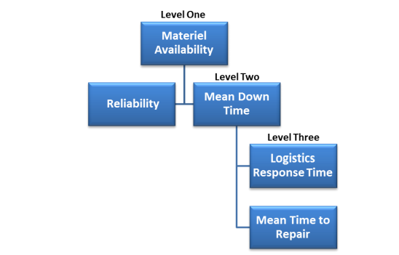
The decomposition of indicators by levels is one of the most important points when choosing indicators. It is the understanding of how they relate to each other and contribute to the results of work at the highest level. It is also necessary, in addition to understanding the relationship of metrics with the PSI/PSP control range, it will be useful to decompose metrics in order to understand how they can be used to enhance and complement each other. The breakdown of the hierarchy of PBL indicators is as follows:
Fig.1-3 Hierarchy of PBL indicators with a description of each level

• Level 1 characteristics are an indicator or a sign of performance for the PBL structure. The characteristics of the 1st level vary depending on the direction of the PBL agreement.
• The characteristics of the 2nd level correspond to the characteristics of the 1st level. this relationship helps to identify as accurately as possible the specific root cause or factors that cause the performance mismatch characteristic of level 1. However, if the indicators of the 1st level relate to the O and AM areas, then reliability and average downtime (MDT) are considered real characteristics of the 2nd level.
• The characteristics of the 3rd level affect the indicators of the 2nd level. Examples of Level 3 characteristics are Level 2 indicators, for example, MT, Logistics response time (LORD) and repair time (MTTR).
The economic efficiency of decisions taken in this area is determined by the ratio of the costs incurred for their implementation and the results obtained.

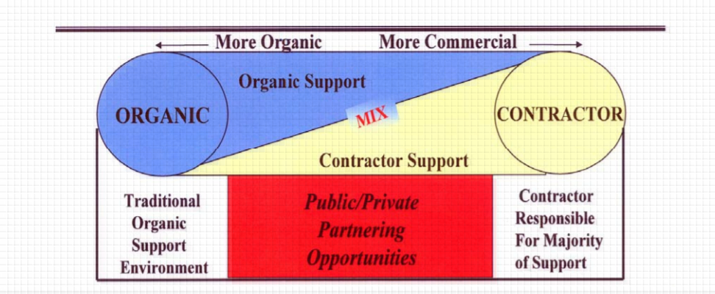
Fig.1-4 Interactions between the obligations of the two parties involved

When all the points are scored, any alternative acquires a weighted benefit score in the form of the cumulative weight of the criterion multiplied by its average rating of stakeholders. Figure 4 shows a method for calculating weighted benefit indicators.

𝑊𝑒𝑖𝑔ℎ𝑡𝑒𝑑 − 𝐵𝑒𝑛𝑒𝑓𝑖𝑡 𝑆𝑐𝑜𝑟𝑒 (𝐴𝑙𝑡 𝑋) =
(𝐶𝑟𝑖𝑡𝑒𝑟𝑖𝑜𝑛 1 𝑤𝑒𝑖𝑔ℎ𝑡) ∗ (𝐶𝑟𝑖𝑡𝑒𝑟𝑖𝑜𝑛 1 𝑠𝑐𝑜𝑟𝑒) + (𝐶𝑟𝑖𝑡𝑒𝑟𝑖𝑜𝑛 2 𝑤𝑒𝑖𝑔ℎ𝑡) ∗ (𝐶𝑟𝑖𝑡𝑒𝑟𝑖𝑜𝑛 2 𝑠𝑐𝑜𝑟𝑒)
+ (𝐶𝑟𝑖𝑡𝑒𝑟𝑖𝑜𝑛 3 𝑤𝑒𝑖𝑔ℎ𝑡) ∗ (𝐶𝑟𝑖𝑡𝑒𝑟𝑖𝑜𝑛 3 𝑠𝑐𝑜𝑟𝑒)

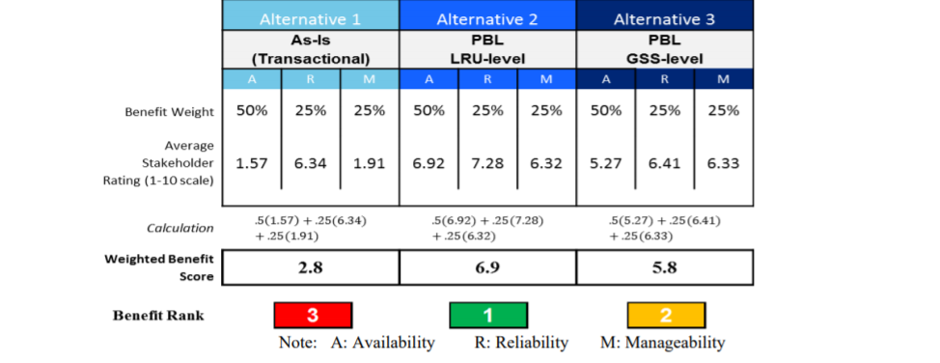
Fig.1-5 Table with the evaluation method on the scale of importance
In the example with the general subsystem, alternative 2 contains the highest weighted benefit indicator, indicating that it is the most attractive alternative in the benefit analysis. Options 2 and 3 provide advantages that are significantly superior to option 1. This utility indicator will be entered into the overall utility indicator for each alternative at the end of this stage.
With this in mind, the PBL model performance condition can be written as follows:
lim Results → 100%
lim Expenditure → 0
where Results – the results achieved during the execution of the service contract escort;
Expenditure – expenses under the contract for service support.
If the results of the contractor's activities are achieved as specified in the contract, if the performance parameters are at the level of 100%, the performer receives 100% of the payment by agreement. If the actual results achieved are below the established standards, however, the amount of money paid remains within acceptable deviations decreases in direct proportion. In case of discrepancy between the actually achieved indicators and the target indicators, within acceptable limits, a progressive scale of reduction in the level of remuneration paid is applied. Finally, if the performer for several the Customer does not reach the minimum acceptable level of performance indicators in General, it has the right to terminate payments and demand compensation for losses incurred losses in accordance with the established procedure.
Such a payment scheme under PBL contracts generates an increased level of interest of contractors in success and in meeting the performance criteria set by the customer, at the lowest own costs.
In order to analyze the economic efficiency of our proposed model, we will use such a method of creating algorithms for solving inventive tasks as decomposition of the studied phenomenon: we will analyze the effectiveness of the model by specific application examples.
Let's look at the basic terms of PBL support contracts. Under the terms
of the Fiscal Year 99-06 agreement for fiscal year 1999, LMSW warehouses in Palmdale, California, committed to provide PBL support for 54 aircraft of the 48th Fighter Wing located at Holloman Air Force Base. [4]
Financial profile under the contract:
•*Cost plus incentive contribution with bonus payment;
• Remuneration for the entire scope of work (3%); remuneration for early completion (7%); promotion-at the expense of expenses for the US Air Force (50%).
The value of the FY 99-06 contract was us $ 223 million per year in 1999 and increased to Us $ 234 million per year in fiscal year 2006, for a total of the entire period.
the service cost was us $ 1.97 billion [10].
Requirements for modification, integration and security for 52 aircraft in the Economics and management of a national economy 95
The effectiveness of the strategy performance based logistics (the f-117 fleet included:
- development of a support system;
- management of subcontractors;
- integration of the system and subsystems;
- configuration management;
- material flow management;
- storage / transportation;
- direct service support;
- reporting to the US air force.
The effectiveness of this contract on the part of the client can be expressed in the following expression:
lim Results = 100% (matching the specified parameters)
lim Expenditure = us $ 1.97 billion + 98% premium
Let's get acquainted with the terms of another PBL support contract.
The FY 04-08 contract was awarded in fiscal year 2004 to Boeing Corporation, for maintenance of the C-17 Globemaster Sustainability partnership, operating under the worldwide [11].
The contract profile included the following main conditions:
• setting fixed service prices for five years in advance;
• FY 04-08 contract value of us $ 4.9 billion;
• programme management;
• logistics support;
• material flow management;
• engineering innovations;
• engine maintenance;
• attracting additional partners necessary for the performance of contractual obligations.
The performance of this contract was evaluated according to a different set of criteria specified in the table 3.

Table 3-Rating and remuneration Calculation contractor
PBL contract execution parameters | Minimum  metric standard | Actually achieved  value
Percentage of work completed within 48 hours after the end of their implementation period | 80% within 48 hours | 88%, average delivery time:  25 hours
Percentage of requests for equipment repairs, accepted for execution immediately | 82% | 86%
Percentage of requests for provision  consumables accepted for use  execution immediately | 67% | 86%
Percentage available for use  aircraft | 70% | 72%  81 units at VN  supported in  constant state  availability from the General  quantities of 114 units

These estimated parameters indicate full compliance performed works according to the final technical criteria set by the customer.
In accordance with this contract, the service company performed routine repairs within the established deadlines, the duration of which was determined based on the proportion of equipment that should be constantly in full combat readiness. In the process of such work the performer constantly focuses on performance targets and measures reaction time to the customer's requests, which requires constant direct access to accurate, up-to-date technical data, logistics and configuration data for updating tasks for planning work and analyzing the service performed.[6]
Therefore, performers are interested in introducing integrated MRO into production and world-class PLM systems to perform product modification and service support support, maintenance, and saving the history of all adjustments and operations [1].
Thus, the accumulated experience in the implementation of the contracts under consideration through the use of the PBL system has demonstrated its advantages in the process of implementing maintenance programs for this model.
For example, awards received by the Boeing Corporation for technical support based on the performance of the C-17 Globemaster over the past 8 years, they amounted to us $ 4.9 billion. Based on the results of this program in the US air force there was an increase in the number of fleets of 180 aircraft. Their service produced in the PBL system, executed by the developer and simultaneously by the manufacturer aircraft, which provides a higher level of responsibility and guarantees from possible risks, as well as a higher level of performance in support.

Chapter 2 Development of internal processes of technical specifications for the creation of aviation equipment

This chapter fully examines the entire life cycle of an aircraft, describes in detail the development of technical specifications, the development of all internal processes that are needed when creating aircraft. The ways of optimization and ways of implementing various mechanisms of product support are provided in after-sales service. At the end of this chapter, two methods for assessing the economic effect of technological innovations are shown and considered.

Currently, in industry and transport, depending on the nature of production and other conditions, various forms of organization of the production process are used, such as in-line, in-line-node (in-line-bench), group, individual, brigade, brigade-node, etc. All of them are characterized by a certain form of labor organization that ensures high productivity with high quality. But the production process of aircraft maintenance has characteristic features: a large number of operations performed and a significant labor intensity of each operation; the technical condition of aviation equipment, which depends on both the timing and operating conditions: even with the same flight, aircraft may require different labor costs for their maintenance due to additional work to eliminate defects.
The main Methods: The fixed method is characterized by the fact that a certain set of works during maintenance or all maintenance of the aircraft is performed by individual specialists who are not part of the team. At the same time, the contractor has to perform both basic maintenance work on the airframe, power plants, chassis, controls, etc., and auxiliary work related to the preparation of the workplace, and simple operations that do not require high qualifications.
The fixed method is used, as a rule, in the maintenance of special-purpose aircraft at operational airfields, where it is impractical to send a large number of support personnel. The specialization of the performers of the work with this method is limited. The same method is used to perform operational maintenance of aircraft with piston engines, routine repairs of all types of aircraft, defecation, manufacture and repair of spare parts, tools and accessories.
The brigade method, which is very common in operational maintenance, provides for full maintenance of the aircraft, engines and special equipment by one complex team staffed with specialists of different specialties and qualifications, which allows for wide use of the specialization of performers both by types of equipment and by types of aircraft.
An even higher level of specialization is achieved when organizing maintenance according to the zone method, in which the aircraft is serviced by several teams specialized in various zones (nodes) of the aircraft.
The number of teams and specialists in the teams is selected depending on the scope of work in such a way that all maintenance work on the aircraft begins and ends with all teams at the same time. The members of each team specialize in performing individual operations, but each specialist must be able to perform all the operations assigned to the team. The zone method makes it possible to use qualified specialists more efficiently, which contributes to an increase in labor productivity. Work on this method can be organized for any type of maintenance, but it is especially advisable to use it for periodic maintenance that has sufficient volume and repeatability of work.
The aviation engineering service faces the task of further improving maintenance methods in order to reduce the calendar and actual downtime of aircraft for maintenance and repair, which for some types of aircraft reach 20-30% of the total calendar service life. Calendar downtime refers to the time from the landing of the aircraft to the end of its maintenance, and actual downtime refers to the net time from the beginning to the end of maintenance.
The solution of this problem will increase the intensity of the use of the aircraft fleet (flight) and the overall economic effect, which is possible only with the use of modern methods of mathematical analysis and calculation, which is the theory of queuing created in recent years. Among the existing and implemented methods of labor organization during maintenance is a step-by-step method of maintenance and a method of maintenance by condition.
The phased method of maintenance as a means of reducing the one-time calendar downtime of aircraft for maintenance has become widespread. It provides for the division of the most labor-intensive forms of maintenance into stages, the number and complexity of which is calculated for each ATB, depending on the operating conditions, the number of engineering and technical workers, the established organization of the production process and the specific features of a particular airline. For each of these stages, operational statements are developed that combine individual operations on nodes and systems with a less time-consuming form of maintenance. To do this, use the periods of operation of the aircraft within the upper and lower tolerances for labor-intensive form, as well as any forced downtime due to weather and other conditions.
For example, in order to eliminate the downtime of the aircraft at work on Form B with some time reserves, it can be performed in stages together with work on form A2, which will be carried out within a calendar tolerance of ± 2 days. It should be borne in mind that Form B is performed by one complex team of specialists, so the time spent on its implementation is quite large despite the predominance of inspection work. If the work on this form is carried out by a one-time method, then the downtime of the aircraft can reach one day, if they are divided into four stages and performed sequentially together with the work on the A2 form for four days of admission, then the aircraft will fly every day, which increases the decadal and monthly flight of the aircraft.
The economic effect of a product about technological innovations analysis is a base of conformity and validity. According to technological innovations economic effect analysis requirements, this chapter describes the definition of aircraft development lifecycle and methods for assessing the level of readiness of technologies and assessing the readiness of technologies, as well as the existing methods for assessing the economic effect of a product from the introduction of technological innovations in detail.
I used the parameters of the technical specification for the creation of aviation equipment Purpose of the aircraft, General requirements, Flight characteristics, Resource Characteristics, Crew Passenger, cabin comfort, Aviation equipment, Power plant, Maintenance and repair system, Technical level characteristics, Marginal price.
Engineering and Production Development completes the detailed design of all necessary hardware and software, systematically eliminates or reduces develops and tests prototypes or first products in order to confirm compliance with the requirements for capabilities, prepares them for production or deployment.
This stage of Engineering and Production development includes the establishment of an initial product baseline for all configuration elements. One of the goals at the stage is to ensure that the integrated product support program develops a solution that meets the requirements of availability, availability of tangible assets and reliability of tangible assets, while using the capabilities of Should Cost 13 to reduce projected operating costs. It is necessary to find a compromise between the possibility of support and other design constraints (weight, size, bandwidth, etc.), which will lead to the development of the design within budget and schedule.
Product support models that are used in inventory planning, workforce planning, training, planning, etc., are provided with up-to-date and calculated data at this stage of development in accordance with how they become available.
The success/problems of reliability growth are evaluated and adjustments are made to the solution to support the product, taking into account the projected demand for logistics resources. It is extremely important to conduct reliable testing to ensure that the reliability requirements are met.
With the development of design, the retail space for sustainable development solutions is narrowing, and the sustainable development strategy is becoming more perfect.
PBL considerations should be part of the manufacturing/quality assurance process, as repair processes (included in PBL) are influenced by production assembly decisions.
During the operational testing and OT evaluation stages, problems identified through various tests, demonstrations, and other evaluation methods are eliminated, and remediation plans are implemented.
As products are put on the market and logistics demand can be reasonably predicted, result-based mechanisms can be implemented.
At an early stage of this stage, short-term cost-type incentive measures are appropriate until sufficient cost data and technical data on failure modes and frequency, as well as reliability data combined with structural stability, are accumulated. This approach provides visibility of costs through the use of a contract with the possibility of cost recovery.
Long-term fixed-price agreements that encourage continuous improvement of processes and products at reduced costs are suitable with a reasonable ability to predict demand and assess risks and the impact of costs.
The cost of aircraft development and production.
The total standard cost of the aircraft, in millions of rubles, is calculated by the formula:
US_{dev=}6,26G_{CH}+27
Where GCH is the mass of an empty equipped aircraft, ton.

2.1. Definition of aircraft development lifecycle
The design of an aircraft (aircraft) and its components is a rather complex iterative process, the task of which is to select suitable combinations of design solutions that best meet the tasks and selected criteria.
The development of technical proposals (preliminary design, preliminary design) is a significant stage in the entire aircraft design process. This stage occupies a transitional position between the stage the creation of the technical specification (TOR) and the stage of preliminary design, at the stage of development of technical proposals (TP), the choice of parameters and characteristics of the newly designed aircraft is mainly determined. It is important that at the initial stages of design, using about 10% of labor costs, up to 80% of decisions are made with a lack or excess of information [5].
An important task in the development of TP is to create the appearance of the aircraft, study the layout of its components and equipment, while it is necessary in the shortest possible time to analyze the various variants of the circuits of the aircraft and its components, while avoiding significant errors. Modeling a large number of possible feasible options manually requires a lot of labor, and making changes to them requires significant time resources.

1)Development of internal processes of technical specifications for the creation of aviation equipment.

In the process of determining the appropriate financial mechanism for financing your PBL contract, it is also important to take into account the time interval associated with attracting the required monetary resources. Parallel fluctuations in budgetary conditions are a difficulty, because of which the assignment of funds takes a lot of time and is a difficult task. at this stage, it is advisable to start the process of determining financing strategies and providing the required material resources in order to avoid any delays in the implementation of the pbl agreement. The process diagram in the figure below is an example of the simplest tool that can be used to demonstrate how funding is integrated into the process of implementing alternative product support.
How PMS can benefit from understanding the industry's prospects:
Appropriate implementation period: The duration of the agreement, corresponding to the level of investment required, gives industry the opportunity to invest in the system to achieve future savings and offer a better price to the government. It offers an organic food supplier a business case for investing in infrastructure and improving the workforce. Opportunities that provide long-term sources of income and a stable workload are attractive to both commercial and organic food organizations, even though the benefits vary. This does not mean that if a multi-year base is not possible, then PBL agreements cannot be implemented. There are cases of successful conclusion of pbl agreements with a validity period of one year and with options for one year.
It is this decision that will limit the potential of PSI or PSP to invest in improvements.
The ability to generate and maintain profits: both organic and commercial suppliers strive to optimize the long-term health of the organization. In the case of a commercial supplier, this is achieved by generating and maintaining long-term revenues and profits, while an organic supplier is often motivated to maintain the workload, benefit from the use of existing Infrastructure, as well as to use and develop the experience of residents.
Partnerships with direct sales departments: managers can encourage these types of partnerships; they have it is proved that the service centers of maintenance ensure the efficiency and quality of products.
The technological process and other developed data for the implementation of the process in teams can be found in the supplement –appendix to the thesis.

2.2 Optimization and implementation of product support mechanisms in after-sales service
The comprehensive support program is a typical example of PBL, the customer pays for the readiness of aircraft equipment, and not specific spare parts and services. In accordance with this, the company is responsible for all work to maintain the readiness of the entire fleet of aircraft, including material and technical support and periodic forms of maintenance. The personnel are constantly present at the air bases and in close cooperation with the Air Force personnel ensures round-the-clock readiness of aircraft for departure.
The most significant principle of PBL is considered to be the autonomous support of equipment in all its serviceable states. The company's goal is to minimize the loss of efficiency caused by the breakdown of the device, downtime of technological installations, malfunctions, etc. To this end, the ever-increasing component of the required maintenance work (cleaning, lubrication, technical inspection of devices) has been rationalized, standardized and gradually transferred to field work in the duties of employees.
As a result, the staff of the chief mechanic 's department On the one hand, they are relieved of their current routine activities, so that they get more time to develop and implement measures to improve the operation of equipment. On the other hand, the equipment can now receive the necessary technical services, which previously could not be provided at all or on time due to insufficient resources.
Creation and improving Product Support Mechanisms. The service center benefits by implementing advanced maintenance capabilities, and the commercial firm benefits by increasing profitability.
Proximity to the end user: due to frequent unfiltered access to customer information, equipment problems are more easily identified. This can significantly reduce the time required for maintenance and repair work, as well as reduce the number of inspections.
In addition to the indicators, the PMO may require the Contractor to provide additional data. The stages of technology readiness level 1 - technology readiness level 6 are carried out with budgetary funding and are the responsibility of research organizations. After completing tests of a workable prototype of the future system under simulated operating conditions, a task for a new sample is formed and a decision is made to create it. Further stages lie in the sphere of responsibility of the industry, and the financing of the work is carried out mainly using market instruments. In addition to a significant reduction in the risk of creating an aircraft, the technology readiness level technique, as expected, can be applied to other science-intensive sectors of the economy, providing support for the development and implementation of various innovative technologies.
PBL focuses on design in order to increase reliability and reduce logistics costs, as well as to ensure effective product support through performance-based logistics strategies.
It should take into account the possibility of support, lifecycle costs, performance and a comparable schedule when making software decisions. The planning of operation and maintenance, as well as the assessment of the total cost of ownership, should begin as early as possible. Operability, which is one of the most important performance parameters, must be taken into account throughout the entire life cycle of the system
PBL applies an efficiency-oriented acquisition strategy that is developed, refined and implemented during the acquisition of systems under new programs or as a result of an analysis of the effectiveness and alternative methods of providing support. PBL can help optimize performance indicators and cost indicators through strategic implementation.
The main idea of PBL is to invest in improving performance, as opposed to the traditional approach of buying individual parts and repairing. This is achieved through business relationships that are structured in such a way as to meet the operational needs of the fighter and coordinate support goals with the required work results and available resources. As part of PBL support strategies, system support responsibilities are assigned to one or more Product Support Service (PCI) specialists, which ensures control of support sources, both public and private, in order to achieve consistent performance results.
The goals of PBL indicators should include as follows:
• Operational availability
• Operational reliability
• Cost per unit of use
• Logistics footprint
• Logistics response time.
Operational Availability (Ao) is the percentage of time a system is available to complete a mission, or the ability to maintain the pace of operations.
Operational reliability is an indicator of how successfully a system performs mission tasks (percentage of task completion by system). Depending on the system, the mission goal may be departure, tour, launch, destination reached, or another indicator specific to the service and system.
The specific weight of costs is the total operating costs, which are divided for the specified system into their corresponding units of units of measurement. Depending on the system, the unit of measurement may be the hour of flight, the speed of steam supply, launch, the number of miles travelled, or another indicator related to this service and system.
Logistics footprint - the amount of government management/contractor or ‘presence’ of organized logistics support that is needed for the deployment, maintenance and relocation of the system.
Measurable items include inventory/equipment, personnel, premises, vehicles, and real estate.
logistic response time is a period of time that elapses from the moment a signal is sent about a logistics need until this logistics need is met. The "need for logistics implementation" characterizes all systems, components and resources, including labor, needed to support the logistics of the system.
PBL should support these desired results. The performance indicators will be adapted by the departments taking into account the specific definitions of the service and the unique circumstances of the PBL agreements.
One of the most important elements of the PBL strategy is the adaptation of indicators to the operational role of the system and ensuring synchronization of indicators with the responsibility of the support provider.
While objective indicators should form the main part of the evaluation of the PBL supplier's performance, some elements of the product support requirements can be more adequately assessed subjectively by warfighter and the PM team.
This approach provides some flexibility in adapting to potential unforeseen support costs.

2.3 Methods for assessing the economic effect of technological innovations
Evaluation of the effectiveness of innovations is central to the process of justification and selection of possible investment options in the innovative business. The theory and practice of innovative calculations has in its arsenal a wide variety of methods and practical techniques for evaluating real projects.
At all stages of the implementation of an innovative project, much attention is paid to determining costs (investments) and results. The costs incurred by the participants of the innovation project are divided into initial (one-time, or capital-forming, investments), current and liquidation. Basic, world, forecast and estimated prices can be used for their assessment.
The basic prices are understood to be the prices that have developed in the national economy at a certain point in time tb. The base price for any products or resources is considered unchanged during the entire billing period. The measurement of the effectiveness of the project in basic prices is carried out, as a rule, at the stage of technical and economic studies of innovative and investment opportunities. At the stage of feasibility study (feasibility study) of an innovative project, it is mandatory to calculate the efficiency in forecast and estimated prices. The forecast price of a M (t) product or resource at the end of the T-th calculation step (for example, the T-th year) is determined by the formula.
$M\left(t\right)=\frac{v\left(t\right)}{n}+\frac{v\left(t-1\right)}{n}+…+\frac{v\left(t-n+1\right)}{n}$ 3)
M(t)= R(t) *V(t) +R(t-1) *V (t-1)+…+R(t-n+1) *V (t-1) 4)

M-Average
V-Actual value
R-Weighting factor.

If the time series to be forecasted contains trend-like variations, you will achieve better results by using the weighted moving average model rather than the moving average model. The weighted moving average model weighs recent data more heavily than older data when determining the average, provided you have selected the weighting factors accordingly. Therefore, the system is able to react more quickly to a change in level.
The accuracy of this model depends largely on your choice of weighting factors. If the time series pattern changes, you must also adapt the weighting factors.
These approaches differ from each other mainly in relation to non-financial factors (in other words, not related to money). In the economic assessment of the effectiveness of the use of technologies aimed at increasing the range and duration of an aircraft flight, methods of economic analysis are of interest, first of all.
Since the Industrial Revolution, numerous economic models and equations have been developed to estimate ROI. One of the oldest approaches, which is quite versatile and easy to use, is the ROI method. This ratio can be used to assess the effectiveness of an investment or to compare several investment opportunities in terms of their effectiveness.
The formula for calculating ROI is simple and looks like this:
$ROI=\frac{P-C}{C}$ , | [8]
where: P - investment income, C - investment costs.
According to this formula, you should not make an investment if it has a negative ROI, and if this ratio is positive and there are other alternatives, you should choose an investment with a higher ROI.
Let's consider the evaluation methodology from the point of view of critical thinking, from here we will conduct a survey and identify the weak undisclosed sides of this issue.
What is the optimal contract type for a PBL effort?
Fixed-price contract types are the most preferred, as they provide the greatest incentive for PSP and PSP partners to improve their products and processes and reduce their execution costs.
As a rule, this happens in cases where it is difficult for suppliers to set the cost of delivery or determine the risk, then a target FPIF contract with a maximum price and with a profit-sharing formula is appropriate. However, successful PBL mechanisms have been implemented with CPIF contracts, and they may become a more appropriate mechanism when risk cannot be reasonably quantified or the cost of transferring risk to PSI or PSP is higher than the government will agree. The source of an effective PBL mechanism is the use of incentives to obtain the desired actions/results from PSI/PSP, even though guaranteed.
What is the appropriate duration of the PBL contract?
The PBL agreement is necessary for a period sufficient for the supplier to be able to reimburse any investments made in promoting its product and/or rationalizing its processes in accordance with government requirements. Cost recovery.
This approach allows them to identify problems affecting reliability, or modernize processes, develop adjustments, implement an improved subsystem and recoup the invested funds.
Subsystems, components, or devices that require much less investment to improve may have shorter circuits.
But none of the manufacturers will make investments that cannot be recouped on time. Non-long-term contracts that are drawn up for one or two years do not show interest for PSPs to invest to increase their productivity, which leads to lower costs.
Below are all the main characteristics for each type of contract.
Acquires a need for more than one year without the need to use options Investments that are calculated for more than one year can be reimbursed in case of termination of the contract
Several years:
- Contract written for multiple years
- Only first year is ‘guaranteed’
- No recovery of investments if contract is terminated
PSP Agency is interested in increasing its capabilities and throughput, as well as in ensuring a constant and growing workload. All personnel are motivated to execute and isolate their facility from potential BRAC closures.
The implementation of PPP with commercial industry and the alignment of organic PSP indicators with program indicators leads to improved processes and additional opportunities at organic enterprises.
Improved processes and capabilities create an additional burden on organic enterprises. The organic PSP continues to improve its performance to match the program's performance and do more work.
When promoting state-owned PSPs, there are various problems and limitations compared to their commercial counterparts. The rules categorically prohibit commercial PSI from paying bonuses for exceptional work to state PSPs that they may have under contract. Any bonuses or bonuses given to Organic PSP members should be provided only from authorized (and often limited) Team funds.
Inclusion in the contract of Indicators of the results of maintaining the life cycle of the upper level and individual indicators of the lower level.
Data on the performance of the upper level and/or lower-level indicators may be included in the contract. One of the most significant elements of the PBL strategy is the adaptation of indicators to the operational role of the system and support for the synchronization of indicators with the responsibility of the support service provider.
The platform levels and the uniqueness of the agreement will determine whether top-level performance indicators and lower-level indicators or both should be applied.
1. PBL mechanisms do not provide declared mission readiness and cost increases. As a result of numerous studies, convincing evidence has been produced that demonstrates cost and productivity increases through PBL mechanisms. savings were often underestimated due to the fact that only savings directly related to the organization were taken into account, and savings also associated with positive secondary effects on the logistics infrastructure were not taken into account.
2. The PBL mechanism must necessarily be designed and precisely managed to ensure a significant increase in costs and productivity. good results are not only related to the flawless implementation of the PBL agreement, but rather to the fact that even a slight adherence to the principles of the PBL business model can lead to success. Success depends on the services understanding both the PBL business strategy and what is the incentive for the industry.
3. PBL and outsourcing are synonyms that negatively affect the ability of services to fulfill core mandates and 50/50 mandates. PBL are organized as government-only partnerships, government-industry partnerships, and industry-only agreements. The practice of financing the Ministry of Defense and paying compensation to personnel makes it extremely difficult to develop and execute only government agreements. If you look at the PBL from the other side, then the partnership between the government and industry has turned out to be very successful.
Partnerships in which industry acts as an integrator of product support, and some or all of the support work is subcontracted to a government warehouse through a direct sales agreement, lead to incentives for state warehouses and labor, resulting in increased results of hostilities, increased load of state maintenance warehouses and reduced maintenance budgets.
Bottom line: PBL can involve outsourcing. however, most often this does not happen, and it is the government that completely controls the PBL structure, not industry.
The transition to the PBL strategy gives the government leverage that is not available in transactional logistics mechanisms to transfer the work that is currently being performed at commercial facilities to state warehouses. In a standard transaction support agreement, in which industry carries out work at its commercial facilities, industry has no incentive to transfer work to government warehouses – in fact, it has no incentive to do so in accordance with agreed margin contracts, where any weakening of industry costs leads to a decrease in revenue and profit.
On the other hand, PBL significantly encourages industry to take aggressive measures to reduce invested capital and carry out maintenance work at facilities at the lowest cost. Return on Investment (ROIC) is a key factor in stimulating industry, since ROIC is one of the indicators for which Wall Street and money markets reward commercial companies. The industry reduces the invested capital, including through other actions.

Chapter 3 PBL based technical maintenance economic analysis

This chapter presents an in-depth analysis of economic efficiency indicators, namely: analysis of the aviation market in the segment of medium-haul aircraft, analysis of the cost, supply and demand for aviation equipment, analysis of macroeconomic conditions affecting the introduction of technological innovations in the logistics chain of service, and also shows the conceptual and functional relationship between the development of technological innovations with a block of indicators for assessment of the economic effect at the early stages of the aircraft life cycle.
Finally, this chapter describes a number of expected indicators in the economic analysis of technological innovations on the example of the successful use of the PBL concept in the US military industry.
Improving the assessment of the economic effect on the life cycle of an aircraft is a key issue, how to reduce the cost of logistics maintenance of an aircraft.

3.1 The cost analysis of after-sales service and equipment
One of the most important competitive characteristics of complex high–tech products is the cost of the product life cycle - the total costs associated with the product for its entire life cycle.
In the case of a high-tech product, the costs at the after-sales service stage, which are necessary in order to maintain these indicators in the field of safety, reliability and availability, contribute to a significant excess of the costs of its purchase.
It is the application of the PBL concept that will radically help solve these problems at a cost. The PBL concept is based on long-term service agreements with a clear division of powers and responsibilities between the parties.
Therefore, today there is no doubt that contractual work is a kind of legal activity, in the aspect of corporate law it is considered as the legal activity of corporations, which includes the stages of conclusion and execution of contracts. It is worth agreeing that the process of contractual work has a sequence typical of managerial activities.
Contractual work acts as a kind of not only legal, but also managerial activity, therefore, it is the object of research in various doctrinal fields: law, economics, management.
Economic and managerial studies of contractual work can also enrich the legal understanding of the issue. The availability of a reliable tool at the disposal of designers for a reliable economic assessment of the cost of the life cycle of aviation equipment - including design, serial production and operation, including ground maintenance, repair and disposal, makes it possible to create a highly efficient competitive aviation equipment with high functional perfection and satisfying requirements of high efficiency, based on its design, taking into account the technical and operational parameters of the cost of lifecycle. An important role in this, especially at the stage of external design, is played by the formation of the main parameters of the technical specifications for design [23].
The indicator of the general criterion of the life cycle cost is calculated taking into account the time factor and according to the rules of financial mathematics [2], while the discounting method is used – bringing the multi-time cost to the initial point in time.
Calculations are carried out at the beginning of the first year, the general formula has the form:
$C_{lc}=\sum_{t=0}^{T_{p-1}}{\sum{C_{pt}^{}*a_{t}^{}}}$, | [9]
with the volume of use of aviation equipment (transportation) equal to the expected needs Q = {Qjl}, that is, on the entire route network for all types of transportation, provided that all costs are minimized, where
i - lifecycle stage;
t - is the serial number of the year of the billing period, the first year is conditionally reset due to the fact that calculations are carried out at the beginning of the period;
T0 - the total duration of the lifecycle;
I0 - the number of lifecycle stages;
$C_{i}^{t}$- the total cost of the life cycle of an innovative product, taking into account the full release program, in monetary units;
$a_{t}^{}$ - is the discount coefficient.
The discount factor is determined by:
$-α=1^{\left(+\right)}$10]
The life cycle of an innovative product can be complete, incomplete or private. The full life cycle includes all stages of full duration and inter-cycle expectations. Consequently, expenses show the full amount of costs for the entire volume of work on creation, production, sale, consumption (operation) and processing. An incomplete life cycle differs from a full one in duration, structure and volume characteristics. Its own life cycle is reduced to certain stages of the entire cycle, for example, to development, production, operation, disposal. Determining costs by stages of the life cycle of a new product requires compliance with the following conditions:
1. completeness of the calculation, i.e. cost accounting for all stages of the life cycle;
2. accounting for all resources consumed;
3. the use of a unified methodology for determining the costof the cycle stages and a unified classification of the composition and content of costs;
4. the use of cost calculation methods corresponding to the stages of the life cycle.
The methodology for calculating the life cycle cost of an innovative product created at an aircraft manufacturing enterprise is based on determining the costs of the product life cycle stages listed below.
1. Justification of product development.
2. Product development.
3. Production of the product.
4. Operation (application) of the product.
5. Overhaul of the product.
1. and 2. iterms stages are combined under the general name of research and development work (R&D).
The overhaul stage includes, in addition to the factory repair of the product, its deep modernization. The total costs of the lifecycle are determined on the condition that in each year, a certain (demand-driven) volume of transportations, works, services is performed, which must be determined already at the stage of the technical specification, i.e. optimization of the parameters of technical specifications and (or) design is solved as a problem with restrictions: the volumes of traffic, works, services are formed by years, and the total (by years and technological structure) costs of the lifecycle of aviation equipment, taking into account all stages of its creation and use, are used as a minimized optimization criterion (subject to appropriate discounting).
Since the cost of a lifecycle is calculated for certain time periods, various aspects of the time factor are taken into account: inflation, uncertainties and risks.
Based on international practice, the costs of the life cycle of knowledge-intensive systems (including aviation systems) include all costs incurred during the life cycle of the project, related to the time of creation and operation of aviation equipment, and related to its purchase (including costs for development production), technical and commercial operation according to the purpose, ensuring serviceability (maintenance and repair), as well as subsequent disposal [23].
For a more complete consideration of the issue of lifecycle cost, it is proposed to consider aspects of aircraft competitiveness and efficiency.
The most important indicator of the competitiveness of an aircraft is the assessment of the ratio between the performed transport work (the product of the payload and the average flight range) to the fuel consumption required for this. When designing aviation equipment, the most important economic issue is to determine the integral effect of improving its technical and economic indicators or the effectiveness of additional investments associated with achieving a higher level of technical perfection of the aircraft design. The main conditions for increasing the efficiency of the aircraft design are: reducing the mass of an empty aircraft, improving the aerodynamic qualities of the aircraft, increasing the service life and achieving maximum operational adaptability [3]. The efficiency of engines is characterized by a decrease in fuel consumption, engine weight and an increase in engine life.
The criterion for assessing the efficiency of civil aircraft is the reduced costs, which are based on the cost of a ton-kilometre C, which is calculated by the formula:
$$C=\frac{100P}{K_{com}*M_{com}*V_{flight}}$$ | [11]
where P is the cost of operating the aircraft, rubbles/hour;
Kcom - coefficient of payload;
Mcom - the mass of the payload, t.;
Vflight - cruising speed, km / h. The higher the payload, the cruising flight speed and the lower the operating costs for one flight hour, the lower the cost of transportation. Thus, the main parameters for the development of civil aircraft are:
• increased commercial load;
• increase in cruise flight speed;
• reducing the cost of operating the aircraft.
The decrease in aircraft operating costs is primarily associated with a decrease in fuel consumption per flight hour, which is defined as:
$$G_{m}=\frac{mg}{A}*C_{p},$$ | [12]
where mg is the average value of the aircraft mass during the flight;
A is the average value of the aerodynamic quality for the flight;
Cp - average for the flight value of the specific hourly fuel consumption of the engine.
Expression (12) indicates that a decrease in fuel consumption is associated with a decrease in the average flight mass of the aircraft (due to a decrease in the mass of an empty aircraft), with an increase in the aerodynamic quality of the aircraft and a decrease in the specific fuel consumption of the engine.
Achieving a higher level of technical excellence in these parameters may in some cases require the use of new, more innovative, but more expensive materials, the complexity of technology and an increase in the labor intensity of aircraft production, an increase in the volume of research, design and test work, which is ultimately associated with additional investments and an increase in the value of the aircraft in the early stages of the life cycle. In this case, it is important that the developer, manufacturer and customer are confident in return on investment [25].
The considered examples reveal the features of calculating the cost of the life cycle "without" and "taking into account" discounting, show that the process of discounting reduces the current and final cost of the life cycle, which is important for making managerial decisions when managing the cost of projects. The modern economy is characterized by the predominance of a cost-based approach to management when creating innovative products, this is primarily due to the need to ensure competitive advantages, including price, as well as the possibilities of cost analysis and cost management when making managerial decisions at the enterprise. Nevertheless, innovative products are, in particular, market-oriented, their implementation is associated with expectations of obtaining different types of profitability and in different areas. This method allows you to estimate the price of an innovative product from the consumer side.
It is also crucial in the creation and market implementation of innovation. With the market pricing method, the price is calculated in such a way that it reflects the achieved advantage of the product being developed for a number of operational parameters, as well as the prevailing market conditions. The market price of the product, which ensures competitiveness both in terms of "quality / price" and the recommended level of effect in operation, should be equal to the minimum of the competitive and recommended prices [3].
In this part, only the main practical approaches to the formation of the cost of an innovative product at an aircraft manufacturing enterprise are considered. The proposed concepts and calculation methodology can be used when conducting a feasibility study of the creation of innovative products at aviation enterprises, and can also serve as a methodological basis for conducting a feasibility study of innovative products and processes.

3.2 Technological innovations economic efficiency analysis
The problem of aircraft maintenance is an outdated contract model and a large overpayment when receiving services, as well as an increase in the time of aircraft maintenance and preparation of documents.
Whereas the PBL concept is a centralized maintenance system, provides effective troubleshooting and allows continuous monitoring of failures and malfunctions in real time and automatic printing of fault reports, facilitates the identification of faulty components and minimizes unjustified replacement of component components.
1. The new technologies for reduce and simplify maintenance
Modern technologies are implemented wherever possible to reliably reduce scheduled maintenance tasks and simplify maintenance, reduce the labor intensity of operational personnel in man-hours.
A typical example is controlling an aircraft to fly by wire, which is simpler and easier than a conventional control system with about 50% less maintenance required.
2. Multi-functional line replacements
Multi-functional line replaceable (MFLR), associated with high reliability of components also contribute to minimizing maintenance costs, dynamics of reducing airframe maintenance costs
For example, there are also world examples when it is economically more profitable to use this service model, in accordance with the MSG-1 maintenance program of the Boeing 747-100 aircraft, United Airlines spent 66,000 man-hours on basic structural checks before reaching the main interval of the first heavy inspection of this aircraft in 20,000 hours. Using traditional maintenance procedures, it took more than 3,900,000 man-hours to carry out small and not so complex inspections of the DC-8 aircraft to carry out a basic design check, which made it possible to achieve the same 20,000-hour design check interval. Cost reductions of this scale are obviously important for any organization responsible for maintaining the serviceability of heavy aircraft [Michael Rovinskiy and others MSG-3/PHP&L Maintenance Steering Group-3 (MSG-3) - based] Maintenance and Performance-based Planning and Logistics.
The innovative potential is determined by the dynamic nature of the air transport maintenance market, the ability to transform into a new state in order to meet existing or newly emerging needs for vehicle maintenance. In essence, the innovation potential is characterized by the ability of the vehicle maintenance system to economic evolution, progress, improvement and qualitative change.
The innovation potential of a territory is the amount of resources that territorial entities are able to transform into a steady stream of competitive innovations. In this regard, the main elements of the resource innovation potential are personnel, information, logistical, organizational and financial capabilities of territorial administrative units for innovative progress.
The components of human resources of innovative potential provide development and intellectual support in the process of innovation implementation and also provide a high level of additional value of innovative services.
Financial opportunities provide effective formation for innovation and carry out a quantitative assessment of the investment attractiveness of the investments used.
The innovation process determines the sequence of actions of the innovation process, the transition from an idea to the creation of a possible innovation, ensuring the maintenance market under the influence of management influences. There are three stages of the innovation service process: at the first stage, research work is carried out, at the second - the creation of design, and at the third - the provision of the life cycle of innovative services.
Since the alternatives are indicated with sufficient detail to allow the analysis to be carried out, the next step will be to assess the relative costs, benefits and risks in quantitative terms. The analysis of product support alternatives contains considerations of both a financial and non-financial nature, both quantifiable and non-quantitative elements. The analysis can also take into account the evaluation of performance, reliability, maintainability and support capabilities. Programs that use these factors in their decisions give varying degrees of importance to costs, benefits and risks. Assigning numerical weights that emphasize or suppress the relative impact of costs, benefits, and risks on the analysis is one of the ways in which the program contributes to improving analysis to support decision-making.
In order to analyze alternatives, it is important in addition to determine the weight (the proportional value that is assigned to a particular advantage), benefits and risks. If it is determined that the lowest cost is considered the preferred criterion in the process of obtaining a solution, then this criterion can be included in the analysis by determining the value of the cost weight at a high level. However, the assessment of costs, benefits, risks and sensitivities should be components of the study of alternative product support options.

3.2.1Aircraft market analysis
At the first stage, analysts aggregate national and international statistics, information from business and industry publications. Additionally, our own research was conducted: surveys of consumers or experts, observations of prices in retail and wholesale sales channels. The data sources for each review are presented in detail in its annotation.
At the second stage of the work, the data obtained is weighted and reduced to a single consistent array. At this stage, the data is rejected, which is presented to analysts as contradictory and less reliable. The selected data should to be in full correlation with each other in order to make a comprehensive assessment of the market possible. For example, demand should be equal to supply, taking into account production, imports and exports, sales and inventory.
Data on production, customs operations, sales are extracted from different sources and initially do not fully correspond to each other, which often requires additional calculations.
The third stage of the work is the construction of dynamic series - forecasting.
Primary forecasting is carried out by mathematical methods that have already been described in Chapter 3, the essence of which is reduced to the analysis of retrospective data for making a forecast. However, such an analysis can only set a general trend in stable markets with well-known long-term dynamics.
There are virtually no such stable markets in the Russian experience, which is why the effectiveness of mathematical analysis decreases.
To clarify the forecasts, the factors influencing the development of the market are analysed. Part of the factors. It is defined quite rigidly and can be used with great confidence to predict production, imports and exports. An example of such a factor is state industry regulation. Often, the government's policy in the field of import regulation, investment in production and construction, subsidizing or, conversely, increasing the tax burden on the industry is known in advance. Using the accumulated experience about the impact of such changes on the industry, I tried to conduct an analysis.
The influence of other groups of factors is less pronounced or the factors contradict each other. Most often, such factors are associated with the dynamics of sales and consumption. Here we have to analyze a wider range of variables, often using benchmarks from neighboring markets where a similar situation occurred earlier, or from the markets of the same industries in other countries where there were similar cases.
For example, in all developing countries of the world, there is a similar dynamics of consumer behavior due to the emergence of new categories of goods, the development of online retail, the arrival of international corporations.
For a good example, we can consider the situation in the Asian and Russian aircraft construction market. Where at this stage of the analysis we can notice that the combined work on the project of a long-haul aircraft looks like a rather promising project and is promising trying to solve some global problems of air transportation demand and that is not unimportant already composes good competition for large companies like Boeing and Airbus.
Despite the fact that the Chinese plane is intended primarily for the domestic market, the emergence of a new player on the field seriously worried about such "monsters" as Boeing and Airbus. The fact is that there is a high probability that the prices of the Chinese COMAC will be dumped in the Central Asian market of aviation equipment. This is understandable, for the countries of this region is becoming more attractive to purchase aircraft from a Chinese partner than an alien in all respects and distant American or European consortium. It mixes politics, economics, and long-standing differences between Eastern and Western philosophy.
Russia has always (until recently) occupied the place of one of the leaders in the aircraft industry, but our, domestic aircraft MC-21 enters the transportation market as a beginner. Moreover, it has a "zero" position in this market, that is, the conquest of the market in the segment of short- and medium-haul transportation will have to be conquered completely anew. In this regard, many experts predict the unenviable fate of the MC-21 on the world aircraft sales market [26].

3.2.2 Analysis of the cost, supply and demand for aviation
Aviation fuel costs account for about a third of all direct operating costs associated
with the operation of the aircraft. This indicator directly affects the commercial performance of air carriers and affects the tariff strategy of air transportation, thereby causing an increase or decrease in interest in air transportation from the final consumer - the air passenger.
The air transportation market reacts quickly to all changes in the global political and socio-economic situation. The difficult situation in the Middle East and Central Africa, the financial crises in the Eurozone, the policy of sanctions against Russia - all this adversely affects the air transportation sector both in the region and around the world as a whole, reduces the pace of its development.
The largest share of air transportation is carried out by network airlines. As a rule, large network air carriers have a developed route network, well-established services, a powerful fleet of aircraft in a wide range of capacities. Regional and low-cost airlines perform an important function of passenger transportation development.
The directions of transportation between Europe and Asia, North America and Asia, Europe and Latin America, North America and Latin America are developing most intensively today. Also in demand domestic transportation in Asia and Latin America. In countries with developed economies, where air transportation has reached the highest rates in absolute terms, the volume of air transportation growth, due to changes in GDP, the transportation market on less capital-intensive routes is noticeably decreasing, and they participate in the formation of passenger traffic between large air hubs. A few years ago it was possible clearly highlight the decades-old specifics of the activities of most airlines. There were carriers focused on regional and local transportation, there were large network companies characterized by a clear fleet structure and tariff policy. In a number of markets, business relations between carriers have been formed, which determine the specifics of work and the area of responsibility. The dynamics of recent years against the background of increasing competition in the market demonstrates an increase in the share of combined airline business models. Many large network carriers are introducing elements of low-cost transportation, and competition for regional routes is growing.

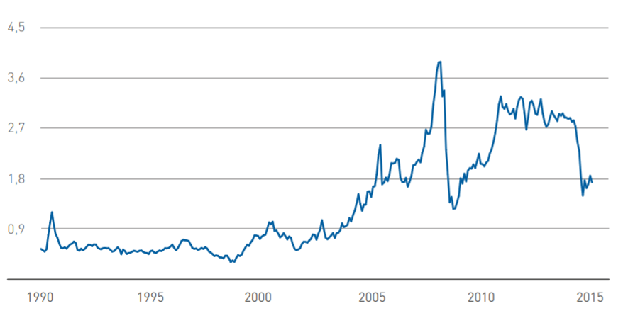
Fig.3-1 The graph of the global dynamics of aviation fuel prices
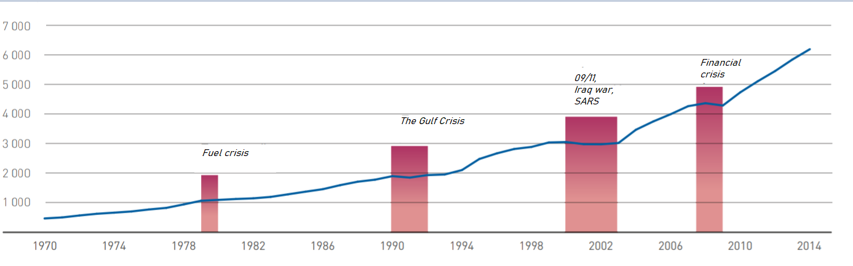
Fig.3-2 The global air traffic and dependence on political events in the world.

The economic and geopolitical situation in which the world air transportation market is currently located determines the directions of development in the medium term. One of the main trends remains the liberalization of the global air transportation market. Throughout the 2000s, the liberalization process intensified both in Europe and the USA, but also in Asia, which led to an increase in the number of airlines on the market, increased competition among them, and, as a result, lower ticket prices and increased passenger traffic. Air transportation.
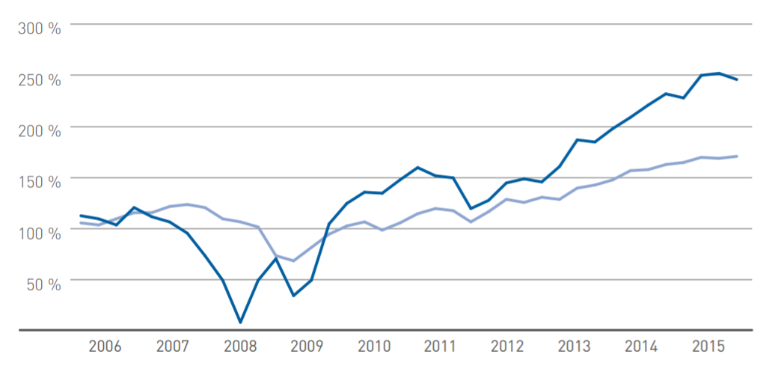
Against this background, an important trend is the globalization of aviation the market. Airlines are actively penetrating the markets of "not their" regions, the principle of "national" companies is being eroded, the process is being activated associations of the largest air carriers. Similar examples are the associations of the largest national air carriers in the United States, the acquisition of many European airlines by Lufthansa, the unification of a number of Russian players into the Aeroflot group, the active struggle of air carriers in the Middle East with the North American authorities to increase their role in the distribution of passenger traffic.
Fig.3-3 Financial stability of the airline industry.

Age more than 50% of PAS aircraft- The age structure of the fleet*of the Sazhir segment does not exceed 10 years old. Also, the world fleet is represented by a significant number of regional aircraft with a capacity of up to 60 chairs. However, aircraft with a capacity of up to 60 seats practically do not work in highly profitable directions, have fairly high
seat costs, and in a number of regions enter into direct competition with other modes of transport. The demand for aircraft with such a capacity has a cyclical form and significantly depends on the influence of external. A decrease in demand for air transportation or changes in the cost of jet fuel primarily affects this market segment.
The capital intensity of the narrow-body and wide-body segments significantly exceeds the performance of the segment with a capacity of up to 60 seats, although small narrow-body (with a capacity of 60-120 seats) and wide-body aircraft together make up no more than 30% of the current fleet. The fleet of wide-body aircraft has a fairly diverse age structure, but most major airlines prefer to operate a modern fleet. Age 49 % the fleet of wide-body aircraft does not exceed 10 years.
Thus, the global market is gradually becoming a single space for all playersod, GDP will grow by an average of 2.9%, and in the second by 2.7% per year. Growth over 20 years by 1.7 times.
It should be borne in mind that the rate of population growth in the world is slowing down. In the retrospective period (2001-2018), it amounted to 1.2% Now the population of the Earth is 7.6 billion. In 2038 it will be 9.1 billion. In 2018, approximately 4.3 billion passengers were transported; in 2038, about 10.4 billion.
The main measure of work in passenger traffic is the value of passenger turnover, measured in passenger-kilometres. Passenger turnover and GDP are interconnected and depend on the region, but everywhere passenger turnover is growing at a faster pace than GDP. As air travel develops, the lead is shrinking. In the retrospective period, the ratio between the rate of world passenger turnover and GDP was 1.9, in the first decade, it will decrease to 1.6, and in the second - 1.5. At the same time, in general, the passenger turnover will increase 2.4 times over 20 years (from 8.3 to 19.5 trillion passenger kilometres).
Air mobility (pkm / person) is increasing all the time, but the rate of its growth is decreasing. In the period 2001-2018 - 4.5%. In the first decade of the forecast period, they will decrease to 3.7% per year, and in the second decade - to 3.3%.
Narrow-body aircraft remain by far the most popular in the air transportation market, as they currently account for 52% of passenger traffic. The share of wide-body (WB) aircraft accounts for 44%. An important feature of the development of world transportation is the trend of an increase in the share of UV and a decrease in the share of WB aircraft (59% and 38% are expected in 2038, respectively).
The total share of traffic on regional aircraft in the world decreased from 8.3% in 2001 to 4.4% in 2018 and will continue to decline to 3.0% by 2038. The decline in the share of regional traffic and traffic on the WB is in no way equivalent to a reduction in the volume of these traffic.
In total, the commercial passenger fleet now has about 28 thousand vehicles. The largest share belongs to NB aircraft (single-aisle aircraft with a capacity of more than 110 seats) - 59%. Then there are WB aircrafts, their share is 17%. Regional aircraft in the world are 23% (9.5% of regional turboprop and 13.8% of regional jet aircraft).
The average calendar life of aircraft in the passenger commercial fleet at the beginning of 2019 was 11.1 years.
According to the average calendar service life, the most "old" are regional turboprop aircraft (16.4 years), followed by regional jet (12.3), then narrow-body (10.2) and the youngest are wide-body aircraft (10.1).
The distribution of the aircraft fleet by the average calendar service life within individual aircraft classes shows that long-haul aircraft are characterized by a reduction in their share as the age of the group increases.
It is expected that in 2038, the world park will remain approximately 10.5 thousand. Aircraft of the modern passenger fleet, that is, 38%. Most of all will remain NB aircrafts - about 7 thousand (42% of the current), least of all - regional turboprop and regional jet, 1 thousand each (27% and 39%), of the current WB in the ranks will be 1.5 thousand (32%).
The total demand for commercial passenger aircraft in 2019-2038 is estimated by us at 44.3 thousand or $ 6 351 billion in the catalogue prices of 2019. Of these, 13.4 thousand have already been ordered. Aircraft (30% of the estimated demand).
From the forecasts of the distribution of work between aircraft classes, it follows that narrow-body long-haul aircraft will be the most in demand. It is expected that the global demand for them will amount to approximately 31 thousand units in quantity and $ 3,736 billion in value terms, which is equivalent to 70% and 59%, respectively. 34% of the demand for NB aircrafts is already covered by existing orders. Thus, the free market is estimated at approximately 20,640 units.
If we talk about the distribution of demand for new NB aircraft by capacity groups, then the clear leader here is the group of 166-200 seats (20.5 thous. aircrafts), which accounts for 66% of the demand in the UV BC segment. 34% of the demand in the group will be satisfied by the existing orders, the free market - 13,550 aircraft or $ 1,625 billion.
In the group with a capacity of 201+ seats, orders cover 43% of the expected demand, and the demand itself is 3 times less than in the group 166-200 (23% of all NB). The free market for this group is estimated at 3,640 aircraft.
The demand for aircraft with a capacity of 135-165 and 111-134 is noticeably lower than in the groups listed above.
In the class of WB aircraft, the total world demand is estimated at about 7,550 aircraft, and the free market at about 5,610 aircraft (74%). The total demand in the group with a capacity of up to 300 seats (this group includes CR929-500 / 600) is 3,560 aircraft, not occupied by orders - 2,830 aircraft (21% coverage). In the 301+ capacity group (which includes CR929-700), the total demand is slightly higher - 3,990, but the uncontracted demand is less - 2,780 (30% coverage).
The total demand for regional jet aircraft is 3,610 aircraft, the free market is 2,830 (79%). The greatest demand will be in the group with a capacity of 61-90 seats (2,000 aircraft), but of which 1,370 (68%) are in North America. In the 91-110 group (to which the Superjet 100 belongs), the total demand is less (1,380 aircraft), but the group itself is also smaller in terms of the capacity range (delta is 20 seats, and in the 61-90 group it is 30 seats). In the group with a capacity of 30-60 seats, the demand is extremely low (about 230 aircraft).
The total demand for regional turboprop aircraft for 20 years will amount to 2,120 aircraft, of which 14% are covered by orders. The 61+ capacity group is more attractive as it accounts for 74% of the expected demand in quantity and 80% in value terms.
Russian civil aviation has already achieved results and is demonstrating double-digit growth rates in traffic. Our share in the global passenger turnover is 3.5%, and in the world population is 1.9%. Air mobility in Russia is 1.8 times the world average. Higher only in the Middle East (2.7), Europe (2.8) and North America (4.7). Note that these results do not seem unusual against the background of historical facts. At the time of the collapse of the USSR in 1991, Aeroflot was the largest airline in the world. In the same year, the share of the Russian Federation in terms of population was 2.7%, and in air transportation 8.1%, air mobility was 3 times higher than the world average. But then the crisis broke out. By 2000, the passenger turnover of Russian airlines decreased 2.8 times compared to 1991, and the global share decreased to 1.8% (the share in the population decreased to 2.4%, air mobility dropped to 0.7 of the world average). However, since 2001, the traffic of Russian airlines began to grow again and growth continued until 2014 with an average annual rate of 11.4%.
In the ICAO rating for passenger turnover performed in 2018, Russian airlines took the 7th position (after the USA, China, UAE, Great Britain, Germany and Canada). In terms of cargo turnover, it is also in 7th place.
The growth rate of GDP in the Russian Federation in the next 20 years is projected at 1.7%. The growth rates of passenger turnover in the forecast period will amount to 4.7% and will be higher than the world average (4.4%). By the end of the forecast period, the estimated air mobility of the population in relation to the world average will increase to 2.3, since here, in addition, the growth in the world population and the reduction in the Russian Federation will affect.
In total, the commercial passenger fleet of Russia now has 1,026 aircraft, the average calendar service life of aircraft in the fleet at the beginning of 2019 was 14.3, which is noticeably higher than the world average (11.1). The most "elderly" is the regional turboprop class (33.5 years) and its group of 30-60 seats (96 aircrafts with an average age of 39.4 years), since there are 76 An-24 in it, with the average calendar service life from 40 to 48 years. Moreover, 60 of them have the “In Service” status. In 2038, 326 aircraft will remain on the wing.
The demand for new aircraft is estimated at approximately 1,470 aircraft worth $ 182 billion, which is equivalent to a share of 3.3% of world demand in quantitative terms and 2.9% in value terms. 527 aircraft were ordered (36% of the quantitative demand). In the NB aircraft class, the expected demand will be 1,040 aircraft, of which 43% have already been ordered. At the same time, 59% of the projected demand has already been ordered in the NB 166-200 group, but there is still a demand potential for 260 aircraft. The second most popular group will be NB 201+. It is possible to purchase 210 liners here, 180 (86%) are not covered by firm orders. In the segment of regional jet aircraft, the delivery of about 200 aircraft is expected, 135 of which will be in the group with a capacity of 91-110 seats. Note that this is 10% of the world quantitative demand. Of the 135 aircraft, 32 have already been ordered. The demand for WB aircraft is forecasted in the amount of 140 aircraft, 45% of them (63 units) belong to the group of up to 300 seats. Orders covered 36% of the estimated demand for WB aircraft. The demand for turboprop aircraft is estimated at 94 aircraft. There are no firm orders yet [26].

3.3 PBL based technical maintenance risk analysis
Airline safety managers would like to have a simple and reliable tool for quantifying and predicting risk when flying with an airline.
The ICAO Safety Management Manual describes three safety management strategies: The reactive (response) method reacts to aviation events that have already occurred; The preventive method actively identifies hazards by analysing the activities of the organization; The predictive (warning) method analyses the characteristics of the system in its forthcoming production activities.
Depending on the intended aspect, the concept of flight safety may have different interpretations, for example:
- zero level of aviation accidents or serious incidents is a widely held opinion among passengers;
- the absence of hazard factors, i.e. such factors that cause or may cause damage;
- attitude of employees of aviation organizations to unsafe actions or conditions;
- avoiding errors;
- compliance with regulations.
Regardless of interpretation, they are based on one common premise - the possibility of absolute control. Zero level of accidents, absence of risk factors, etc. imply that it is possible (through the introduced system or measures) to put under control in the aviation operational context all variables that can lead to negative or damaging consequences. However, although the elimination of accidents and/or serious incidents and the achievement of absolute control are undoubtedly very desirable tasks, in an open and dynamic operational context they are unattainable. Hazard factors are integral components of the aviation operational context. Failures and operational errors will occur in aviation, despite the most effective and carefully designed measures applied to prevent them. No human activity or system created by him is guaranteed against the complete absence of hazard factors and operational errors.
Therefore, safety is a concept that should include relative rather than absolute concepts, which is why, in an inherently safe system, the presence of flight safety risk factors arising as a consequence of hazard factors in the operational context should be allowed. The main issue is still control, but control is relative, not absolute. As long as safety risks and operational errors are reasonably controlled, an open and dynamic system such as a commercial civil aviation system is considered safe. In other words, flight safety risk factors and operational errors that are under reasonable control are permissible in an inherently safe system.
Safety is increasingly viewed as a result of the management of certain organizational processes aimed at keeping under control the risk factors for flight safety that arise as a consequence of hazard factors in the operational context. Thus, for the purposes of this guide, safety means the following:
Safety assurance is a situation in which the risk of harm to people or property is reduced to an acceptable amount and also remains at this or a lower level due to continuous processes for identifying hazards and managing risk factors affecting flight safety.
Analytical risk expresses the frequency of the implementation of hazards in
relation to their possible number. In general:
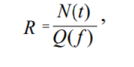
Where:
R is the risk;
N is a quantitative indicator of the number of undesirable events per unit of time t;
Q is the number of objects exposed to a certain risk factor а f.
The concept of "risk" includes another aspect – it is a quantitative characteristic of the action of hazards formed by a specific human activity.

3.4 PBL based technical maintenance external condition analysis
The main factors determining the demand for new aircraft are the development of air transportation and the disposal or replacement of the existing fleet. The demand for passenger air transportation, in turn, depends on many factors, but, first of all, on the size and rate of development of the gross domestic product (GDP), population and the level of development of the air transportation industry and alternative modes of transport.
Industry enterprises develop (as a rule, jointly with foreign companies) a number of promising civil aircraft and aircraft engines. first of all, this is a Russian regional aircraft (Russian regional aircraft, RYE) of the Sukhoi joint-stock holding corporation with the participation of companies such as Boeing (USA), Alenia Aeronautica (Italy), as well as the SaM146 aircraft engine, an aircraft engine designed to be installed in this aircraft, developed as part of cooperation between the French by the company Snecma on Moteur and the Russian JSC NPO Saturn. More promising is the short- and medium-haul MS-21 aircraft (Yakovlev Design Bureau, Ilyushin Design Bureau and Tupolev Design Bureau) and PS-12 aircraft engines, which are intended for installation on this aircraft (under development).
Perm design Bureau and D-436T12 (created by Ukrainian enterprises "Motor- Sich" in cooperation with a number of Russian enterprises).
The amount of expenses for the development and development of numerous products of new aircraft and aircraft engines is usually about several billion dollars, therefore, in order for the project to pay for itself, it is important to introduce at least several hundred, or even thousands of products.
Thus, manufacturers of aircraft of the MS-21 family predict sales on the Russian market exclusively in the period from 2011 to 2026. It is in the volume of 220-400 copies [4-5], and in the specified period it is planned to export up to 310 aircraft of this type (about 4% of the total demand of world airlines for short-haul and medium-haul aircraft in the period up to 2026, according to the company's forecasts).
The developers of the IEL aircraft hope to sell at least 800-1000 copies for the period from 2008 to 2023 (more than 2/3 of them for export), the total capacity of the global market for regional aircraft is approximately 5.0-5.5 thousand units.
At the same time, it should be recognized that demand forecasts for them vary significantly even among cooperation partners, not to mention competitors, airline representatives, and independent economists.
Due to the high cost of R&D, a reliable forecast of future demand volumes is necessary before the start of full-scale project development. Forecasting the demand for promising products of the aviation complex is hindered by its long-term nature: the pre-production stage of the aircraft life cycle (R& D, technological process of pre-production) is 5-10 years, and the stage of serial production is 20 years or more.
In the case when the forecast for sales volumes did not materialize, the market failure of the project can lead not only to the bankruptcy of enterprises, losses for the state budget, as well as to the loss of scientific, technical and personnel potential of the industry, as well as to negative social consequences.
In this regard, the improvement of demand forecasting methods in the aviation industry is considered the most urgent and complex scientific task.
In [6], some methodological problems of forecasting demand for aviation industry products are considered. Firstly, it is shown that in an unstable economy, an accurate forecast of demand for aircraft in competitive markets is achievable only with the selection of groups of rational potential customers. This point of view is shared by some other researchers (see, for example, [5]). In turn, such a choice is determined by the economic efficiency of products offered by competing manufacturers. Those customers for whom the economic efficiency of the products of this enterprise is higher than the efficiency of competitors' products will make up a lot of likely customers of the enterprise. At the same time, the demand of airlines for aircraft and aircraft engines consists in the main part of three important purchases: to replace aircraft that have exhausted their resource; to increase the carrying capacity (in order to meet the increasing demand for air transportation in the most holistic way); to replace obsolete (although, perhaps, not completely used up their resource) aviation facilities at the expense of new generation products.
The specifics of the current situation in both Russian and global civil aviation is the predominance of the third of the listed components of demand for aircraft, which is due to a significant excess of carrying capacity. In the early 1990s, due to a sharp decline in the purchasing power of most of the population in Russia, there was a multiple decrease in the volume of air traffic compared to the pre-reform level. A large number of serviceable aircraft were decommissioned. Thus, in 2004, the operated fleet of aircraft in Russian civil aviation was only 54%
The registered number [7]. At the same time, the intensity of aircraft operation, recorded by the average annual flight per aircraft, is 1.6-2.1 times lower in Russia than abroad (1600-2100 flight hours per year compared with 2900-4600 leading foreign airlines). By the beginning of 2006, the pre-crisis volume of traffic has not yet been restored, although the recovery growth has been observed since the early 2000s. Thus, the carrying capacity and resource of the existing fleet of aircraft are far from being exhausted. A similar situation is observed abroad, where (after the tragic events in the USA on 11.09.2001) hundreds of serviceable aircraft were put into temporary storage. The tendency of Russian airlines to upgrade their fleet, which has been observed in recent years, is mainly caused by the moral aging of the aircraft (this is low fuel economy, or complete non-compliance with new environmental standards, etc.), and not by the development of its resource. Thus, according to the source [7], only 42% of 700 decommissioned in 1991-2003. mainline and regional passenger aircraft have exhausted their resource, 14% of 440 cargo aircraft, 22% of 1,180 helicopters.
Consequently, for the next few years, the most important factor determining the demand for new aircraft and aircraft engines on the Russian and world markets will remain the readiness of airlines to upgrade their fleet of aircraft qualitatively, to equip with more modern and efficient aircraft. Therefore, in the economic analysis of innovations on their basis, there are several options for determining the indicator of the effectiveness of the introduction of innovations E, which can be represented as:
$$E=\frac{L}{(K_{IC}+K_{CC})},$$ | [13]
where L is the economic result of the innovation for the billing period;
K_{IC} - innovation costs;
K_{CC} - investment (capital) costs.
$$E_{CC}=\frac{L}{K_{CC}},$$ |  | [14]
$$E_{IC}=\frac{C_{P}}{K_{IC}},$$ | [15]
where C_{P} is the market price of the innovation.
In turn, the economic effect of the innovations U_{IC} can be written as:
$$U_{IC}=C_{P}-K_{IC},$$ | [16]
$$U_{IC}=L-K_{CC},$$ | [17]
In cases where it is necessary to compare innovations in terms of their profitability, ranking can be carried out using the profitability coefficient K_{P}:
$$K_{P}=\frac{S_{ð}}{S_{p}},$$ | [18]
where Sð - the sum of the reduced income;
Sp - the sum of the reduced cash costs.
The given cash incomes are the future profits from the innovation, which are added not in the absolute amounts that are expected in the future, but adjusted for the discount coefficient (different for each future year) [37].
The technical and economic level of aircraft engine production after the introduction of technological innovations can be characterized through the indicator of unit reduced costs K:
$$K=\frac{(C_{P}+E_{IC}F)}{N_{E}},$$ | [19]
where C is the cost of production of an aircraft engine;
Е_{IC} - standard efficiency coefficient (0.1–0.12);
F is the average annual cost of fixed assets;
N_{E} is the number of aircraft engines produced per year.
Thus, the economic analysis of technological innovations consists of defining a number of expected indicators that can be systematized into three groups:
The first group of indicators characterizes the expected economic results from the introduction of technological innovations (C_{P}, L).
The second group of indicators characterizes the expected innovation and investment costs associated with the introduction of technological innovations (K_{IC}, K_{CC}).
The third group of indicators characterizes the effectiveness of the introduction of technological innovations (E, E_{CC}, E_{IC}, K_{P}, K).
The problem of assessing innovations can be divided into two independent tasks: assessing the consequences (positive and negative) of the implementation of a particular direction of development and measuring the corresponding costs of their implementation. The choice of directions will be carried out by comparing alternative projects, which is carried out in two main directions: social assessments and economic (monetary) measurements [38].
Thus, the third chapter proposes a model of the conceptual and functional relationship between the development of technological innovations with a block of indicators for assessing the economic effect at the early stages of the aircraft life cycle. This model reveals the essence of assessing the economic effect of technological innovations at various stages of the aircraft life cycle and is based on quantitative changes in the technical and operational systems of the aircraft.
An in-depth analysis of economic efficiency indicators was also carried out, namely: an analysis of the aviation equipment market in the medium-haul aircraft segment, an analysis of the cost, supply and demand for aviation equipment, three methods of flight safety management were considered, an analysis of macroeconomic conditions affecting the implementation of technological innovations was carried out.
Section 3.3 describes a number of expected indicators in the economic analysis of technological innovations using the example of an aircraft engine. This product is proposed to be regarded as a breakthrough, the appearance of which on sale can cause a voluntary refusal in its favor, at least for some operated structures due to the operation of their existing aircraft, despite the fact that the latter has not yet developed its resource.
Of course, this is a very strict criterion. Nevertheless, it has a logical justification and, as will be shown below, does not contradict the data on the change of generations of aircraft.
If the formulated criterion is not met, airlines will prefer to continue to operate the existing fleet, and only as its resource is developed to acquire new products. Even if we give preference to the products of a domestic enterprise, it is obvious that the demand for it per unit of time will be significantly small, since only two of the three components of demand listed above in aviation remain in force (replacement of equipment that has spent its entire resource and expansion of the assortment). i.e., at the moment they are not the most significant. In the absence of a radical advantage to the products of the previous generation, the purchase of modern aircraft will mainly be postponed by airlines for the future period, resulting in two competitive threats.
Firstly, during the years for which the purchase of new aircraft (and engines) has been postponed, competing manufacturers are likely to offer new samples by the time their old products are written off. At the same time, it should be taken into account that foreign competitors have significant financial opportunities for R&D, since they have already managed to earn significant income through the sale and maintenance of their products.
Secondly, using competitors' products, airlines strengthen relations with their manufacturers and repair companies, which leads to mutual training (during work and after-sales service) and, as a result, enhance the blocking effect.
So, it is proposed to consider a breakthrough product that (at least in certain market segments) is able to overcome the blocking effect. Using the conventions introduced earlier, we will build a simplified model of making a decision on the write-off of old-generation aircraft with a remaining resource. Let's assume for simplicity that the owner of an old-generation aircraft can take one of two alternative solutions. Either the old product is operated until the resource is fully exhausted, and only then it is replaced by a new generation product, or it is written off and replaced immediately when a new generation of aircraft appears on the market.

Chapter 4 Conclusion
A critical analysis of the current state and trends in aircraft maintenance management shows the following shortcomings of the existing system for maintaining the airworthiness of civil aviation aircraft, both in the Russian market and in the Asian market.
Departmental structure of the aircraft maintenance economy, virtually devoid of any economic or commercial relations between various enterprises, high labor intensity of maintenance; low productivity of technical personnel, poor organization of the maintenance process maintenance, insufficient quality of aircraft maintenance, the impact of the maintenance process itself on flight safety, the impact of the human factor on labor results. Hence, the goals and objectives of further research. first, it is necessary to analyze and provide the most advanced maintenance organizations from the point of view of economical production, optimize its structure, and also start with technical and economic indicators in order to consider the indicators of the maintenance process itself, excluding costly indicators, in order to improve economic mechanisms, to study the indicators of air transport activities of civil aviation, in order to perform aircraft maintenance works, in order to carry out work on air transport by air transport, to study various indicators of manufacturability, maintainability, controllability, indicators of the technical condition of the aircraft to introduce, instead, to introduce comprehensive performance indicators. Take into account quality and risk indicators, implement comprehensive reliability, safety indicators and indicators of timely maintenance work.
With the digitalization of design and working technical documentation, as well as an increase in the share in the production of a modern technological complex, there is a need to consider the issue of digital modification of the organization of production processes of technical operation of air transport and its components.

4.1 Main work and innovation
Summing up, we can say that the work considers well-known techniques that allow implementing generally accepted approaches to assessing the economic effect of the introduction of technological innovations at the stages of the aircraft life cycle by applying standard concepts for assessing the economic effect of the introduction of innovations.
Taking into account the repeatable process of implementing an effective PBL agreement, it is necessary to ensure consistent reporting, maintain regular contacts with all key stakeholders, and evaluate the effectiveness of the agreement on a regular basis, within the established time frame. The figure below summarizes the best practices related to PBL contract management.
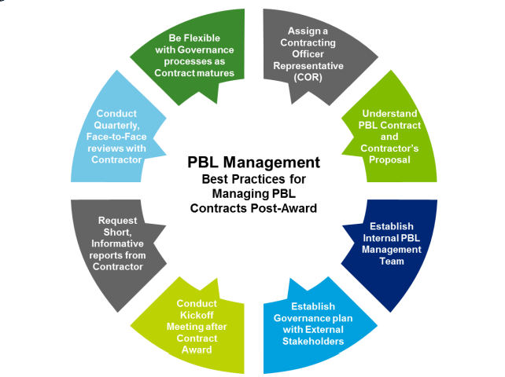
Fig.4-1 The main PBL principle

The master's study also looks at the theoretical basic principles of the study of the difficulty of assessing the financial result from the introduction of scientific and technical innovations at the stages of the current cycle of the aircraft unit, including the presentation of the essence of scientific and technical innovations, the difference between the judgments "innovation" and "innovation". Presented in detail: the current turnover of provisions, the boundaries of the current cycle of provisions, as well as the management of the current cycle of the product. The process of developing new technologies is almost always associated with the uncertainty of obtaining a successful result. This situation is especially typical for radical technologies with an intermittent development cycle. To reduce the degree of the technical and economic risk of creating technological innovations, the technology readiness level system can be recommended for use, and the return on investment can be assessed using well-known economic indicators, among which one of the most common is the indicator of net discounted income. These approaches, undoubtedly, are useful tools for managing investment and innovation projects and assessing their effectiveness, especially at later stages of the innovation process, for example, at the stage of manufacturing finished products. However, they lose their relevance at the early stages of the innovation process when developing radical discontinuous innovations, since in this case, there is an increased degree of uncertainty and it usually becomes impossible to give even an approximate forecast for the future regarding the success of creating an innovative product and draw up a plan for its implementation and commercialization. Therefore, in many respects, the degree of continuity of the process of its development will have a great influence on the ability to give an economic assessment of the effectiveness of creating high technologies. At the same time, the predictive methods used, the correct choice of strategy, risk assessment, technological routing, and technical and economic modelling are of great importance and value for the developer.
Summarizing the above, a model is proposed that presents the conceptual and functional relationship between the development of technological innovations with a block of indicators for assessing the economic effect at the early stages of the aircraft life cycle. This model reveals the essence of assessing the economic effect of technological innovations at various stages of the aircraft life cycle and is based on quantitative changes in the technical and operational systems of the aircraft. The model provides for the optimal (acceptable, acceptable or, in a negative sense, unacceptable, non-optimal) parameters of the technical and operational perfection of the aircraft within the technically achievable ranges. The model is built on the basis of a set of functional-cost (parametric) dependencies and includes taking into account the input (original) data - the requirements established in the technical specification for design, with the possibility of further clarification and coordination. The technical specification requirements for input establish the requirements for the basic (external) performance of aviation equipment and its technical and operational level.
In the third chapter, an in-depth analysis of economic efficiency indicators is carried out, namely: an analysis of the aviation market in the medium-haul aircraft segment, an analysis of the cost, supply and demand for aviation equipment. Three methods of flight safety management are considered, an analysis of macroeconomic conditions affecting the implementation of technological innovations is carried out.

4.2 The advantages and benefits of PBL based technical repair and maintenance
Innovations have a complex impact on both quantitative and qualitative parameters of economic growth. The impact of innovation on the pace of economic growth is manifested as a consequence of an increase in labor productivity and capital.
The high quality of economic growth presupposes the predominance of an innovative factor in its structure, which is reflected in the form of new goods, services, technologies, forms of organization, management methods, changes in the quality of labor.
The growth achieved at the expense of raw materials differs significantly from that which occurs on the basis of innovation.
The solution to the problem of the quality of economic growth is possible in 3 directions: economic, social and environmental. The economic direction includes two component blocks: factorial and structural.
When using the proposed innovative product, which is described in the master's thesis. We can finish off the totality of solving the set logistical problems in all 3 directions.
The economic direction will be developed in the direction of saving costs for logistics services. The social direction wins not only in the direction of creating new personnel, but also in the direction of reducing unnecessary personnel. Since the method of contacting intermediaries for certain logistics services will be applied. The ecological direction also wins, since we not only save fuel, kerasin, etc. And we also intentionally make less waste in the entire logical chain.
Innovation, being a direct growth factor, can revive demand in the long term. For Russia and China , the main domestic demand for aviation services in general is .In competition with other aviation giants, it is crucial to increase the competitiveness of goods and services, and this is possible only thanks to various innovations.
Performance-based mechanisms provide the industry with flexibility in determining how to provide quality services and performance results to its government partners with an acceptable level of profit and risk. on the basis of PBL contracts, the industry will "compete" within its own in order to reduce costs as well as increase profits, which is usually achieved by:
• Optimizing processes, reducing inefficiency and associated costs in order to meet
the demand for logistics;
• Improving product quality (for example, reliability), thereby reducing the overall demand and cost on the basis of PBL contracts, the industry will "compete" within its own framework in order to reduce costs and also increase profits, which is usually achieved by.
• Optimizing processes, reducing inefficiency and related support costs, * saving for
Ministry of Defence, * improving support capabilities for military fighters and increasing profits for the supplier.
on the basis of PBL contracts, the industry will "compete" within its own
framework in order to reduce costs as well as increase profits, which is usually achieved by:
• Optimization of processes, reducing inefficiency and associated costs to meet
the demand for logistics
• improvement of product quality (for example, reliability), which reduces the overall need and costs in order to achieve the desired performance.
All these approaches, with proper organization and management, will lead to lower support costs, as well as cost savings for
The Ministry of Defence, improving the capabilities of the military fighter support and increasing the supplier's profit.

4.3 Development and prospect of PBL for aviation industry
The problem of assessing innovations can be divided into two independent tasks: assessing the consequences (positive and negative) of the implementation of a particular direction of development and measuring the corresponding costs of their implementation. The choice of directions will be carried out by comparing alternative projects, which is carried out in two main directions: social assessments and economic (monetary) measurements
Process improvement is a structured or continuous improvement of production processes. The four-step method described in TQM, which ensures the effectiveness of improving business processes, consists of: selecting processes; preparing for improvements; analyzing and redesigning processes; implementing improvements.
The term Total Performance Maintenance is universal efficient maintenance." At the same time, the concept of "universal" means not just productive and economical maintenance, but also a complete system of efficient operation of equipment during its service life, and to include any particular employee and different departments in the process by involving individual operators in maintenance. Moreover, the application requires a trusted platform module, certain obligations on the part of the management of the enterprise. The management concept of Total Performance Maintenance (TPM) is the universal care of production equipment - aimed at improving the efficiency of maintenance. The technique of universal operation of equipment is based on the stabilization and continuous improvement of maintenance processes, a system of preventive maintenance, work on the principle of "zero defects" as well as the systematic elimination of all sources of losses.
The advantage of the process approach is the continuity of management, which it provides at the junction of individual processes within their system, as well as their combination and interaction. when applied in a quality management system, this approach emphasizes the importance of: 1) in understanding the requirements and their implementation; 2) the need to consider the processes from the side of the added value they create; 3) achieving the planned process indicators and guaranteeing their effectiveness; 4) continuous improvement of processes when applied in the quality management system, this approach emphasizes the importance of.
The PBL concept implies the provision of support services in the form of an integrated set of standardized optimized readiness indicators, the achievement of specified technical and tactical characteristics of the system and based on long-term service agreements with a clear division of powers and responsibilities between the parties. The purpose of the supply and application of complex high-tech products is not spare parts, materials or services, but standardized indicators of the final result: efficiency, reliability, time and costs of the buyer of these products.
Advantages of switching to PBL:
- Fully integrated supplier cooperation
- One integrator provider is responsible for the overall end result of all service support
- Radical reduction of formal barriers between the customer and the supplier
- Reduced operating costs
- Partnerships are long-term in nature
- The supplier is fully responsible for the dedicated subsystem
- The supplier provides certain types of heavy and medium forms of maintenance
- The PBL contract clearly outlines the roles and responsibilities of the parties.
The main advantage in applying the PBL concept is precisely that when signing a contract for the purchase of products and services, the product support manager identifies product support integrators who provide work results in accordance with the performance metric for the system or product. The integrator transfers the achieved level of support to lower prices or increases the amount of work for the same prices.
Payments to the service provider under the PBL contract are determined not by the prices of spare parts and the prices of such services, as with the traditional approach, but by the actual values of availability (availability) and reliability of products, operating costs and average downtime due to failures.
Disadvantages.
In Russia, PBL technologies are implemented most often within the framework of life cycle contracts and contracts for key performance indicators.
Their widespread distribution is limited primarily by the concerns of participants associated with insufficient legislative protection against the risks of such a business. Examples of mechanisms for applying PBL principles have not been developed in specific areas of the economy.
In particular, if there is experience and positive results in the field of military aviation, then in civil aviation such experience is not enough to use it. In addition, there are no scientific methodological developments both on the development of the logistics support system itself, and on its implementation and use.
With the help of this method, it is incomparably easier to solve any problems related to the radical improvement of technical operation and airworthiness maintenance systems.
When selling an aircraft, the manufacturer issues a MRO program and the corresponding requirements for the conditions of MRO (base, facilities, personnel, etc.).
Throughout the entire period of operation of the aircraft, the developer provides technical and technological support to operators, develops and improves the MRO program as well as all standard documentation.
It is important that all this be done under the auspices of the general designers, who are responsible for ensuring that the characteristics of flight safety and operational efficiency correspond to the declared ones.

References

- Denisov Y., Klubova M., Milshina Y. et al. Vehicles and systems: new technologies of aircraft construction. - 2016. - No. 9 (Higher School of Economics) / [Electronic resource].
Access mode: URL: https://issek.hse.ru/trendletter/news/192541548.html
- [Brovkin A.V. Vasilenko A.A. Stoimostnoy podkhod k upravleniyu kompaniyami / A.V. Brovkin A.A. Vasilenko [The cost approach to the management of companies / A.V. Brovkin A.A. Vasilenko]. Ekonomika i predprinimatel'stvo – Economy and Entrepreneurship, 2017, no. 5-2 (82-2), pp. 404-410.
- Brovkin A.V. Vzaimnoye strakhovaniye – istoriya zarozhdeniya i mirovogo razvitiya, kak aktual'nyy nauchno-prakticheskiy opyt dlya razvitiya nekommercheskikh finansovykh otnosheniy v Rossii / A.V. Brovkin [Mutual insurance is the story of the birth and world development, as actual scientific and practical experience for the development of noncommercial financial relations in Russia / A.V. Brovkin]. Rossiyskoye predprinimatel'stvo – Russian Entrepreneurship,2017, Tom 18, no. 20, pp. 3019-3030.
- Podkatilin, A.V. Problemy razvitiya TRIZ / A.V. Podkatilin [Elektronnyy resurs]. – Zagl. s ekrana. – Rezhim dostupa:
- [Problems of development of TRIZ / A.V. Podkatilin [Electronic resource]. - Title from the screen. - Access mode] http://www.metodolog.ru/01116/01116.html.
- Eremin M.Yu. (2019) Effektivnost' primeneniya strategii performance based logistics priosushchestvlenii servisnogo soprovozhdeniya voyennoy aviatsionnoy tekhniki [The effectiveness of the strategy performance based logistics in the implementation of service support of military aircraft]. Ekonomika: vchera, segodnya, zavtra [Economics: Yesterday, Today and Tomorrow], 9(1А), pp. 90-100.
- Potanina YU. M. Razrabotka sistemy pokazateley otsenki deyatel'nosti stoimostno-oriyentirovannykh kompaniy [Development of a system of indicators for evaluating the activities of value-oriented companies]. Bukhgalterskiy uchet, statistika i audit: vyzovy vremeni : Sbornik nauchnykh statey / Moskovskiy gosudarstvennyy institut mezhdunarodnykh otnosheniy (universitet) Ministerstva inostrannykh del Rossiyskoy Federatsii; Kafedra ucheta, statistiki i audita [Accounting, statistics and audit: challenges of time: Collection of scientific articles / Moscow State Institute of International Relations (University) of the Ministry of Foreign Affairs of the Russian Federation; Department of Accounting, Statistics and Audit]. Moscow: MGIMO-Universitet, 2017, pp. 196-213.
- Potanina YU.M. Analiz pokazateley finansovoy ustoychivosti i otsenka veroyatnosti bankrotstva kompaniy [Elektronnyy resurs] [Analysis of financial stability indicators and assessment of the probability of bankruptcy of companies [Electronic resource]]. Menedzhment i kontrolling v usloviyakh nestabil'nosti rynkov i vneshnikh ugroz : Sbornik nauchnykh trudov IV Mezhdunarodnoy nauchno-prakticheskoy konferentsii po kontrollingu (Ryazan'-Moskva, 8-9 oktyabrya 2015 g.) / NP «Ob"yedineniye kontrollerov» ; pod nauch. red. S.G.Fal'ko [Management and Controlling in the Conditions of Market Instability and External Threats: Collection of Scientific Works of the IV International Scientific and Practical Conference on Controlling (Ryazan-Moscow, October 8-9, 2015) / NP "Combining Controllers"; under the scientific ed. S. Propulsion Falco]. Moscow, 2015.
- Khorin A.N., Brovkin A.V. Klyuchevyye indikatory otcheta ob ustoychivom razvitii organizatsii / Khorin A.N., Brovkin | A.V. [Key indicators of the organization's sustainable development report / Khorin A.N., Brovkin A.V.].
- Teoreticheskaya i prikladnaya ekonomika – Theoretical and applied economics, 2018, no. 1, pp. 1-12.
- Chumakova O.V. Kontsessionnyye soglasheniya i soglasheniya gosudarstvenno-chastnogo partnerstva, munitsi pal'nochastnogo partnerstva kak pravovyye formy developmenta infrastrukturnykh ob"yektov [Concession agreements and agreements of public-private partnership, municipal-private partnership as legal forms of development of infrastructure facilities]. Ekonomika i predprinimatel'stvo – Economy and Entrepreneurship, 2017, no. 2-1 (79), pp. 1129-1135.
- Chumakova O.V. Rossiyskoye zakonodatel'stvo ob investitsionno-stroitel'noy deyatel'nosti: osnovnyye cherty i tendentsii razvitiya [Russian legislation on investment and construction activities: the main features and development trends]. Ekonomika i predprinimatel'stvo – Economy and Entrepreneurship, 2017, no. 2-1 (79), pp. 1170-1173.
- LSAR – The missing link for performance-based logistics [Elektronnyy resurs]. –
- https://www.plm.automation.siemens.com/zh_cn/Images/lsar%20wp%20W%201_tcm78-5601.pdf.
- Performance Based Lifecycle Support [Elektronnyy resurs]. – Zagl. s ekrana. – Rezhim dostupa [Performance Based
- Lifecycle Support [Electronic resource]. - Title from the screen. - Access mode]: https://www.sdcexec.com/
- warehousing/event/10722458/performance-based-lifecycle-suppor
- Methodological recommendations for evaluating the effectiveness of investment projects: Second edition / Official publication of 21.06.99 - M.: Economics, 2000.
- Product Support: A Program Manager’s Guide to Buying Performance, published in November 2001,
- “The PBL Guide.” USA/ 2001

Appendix

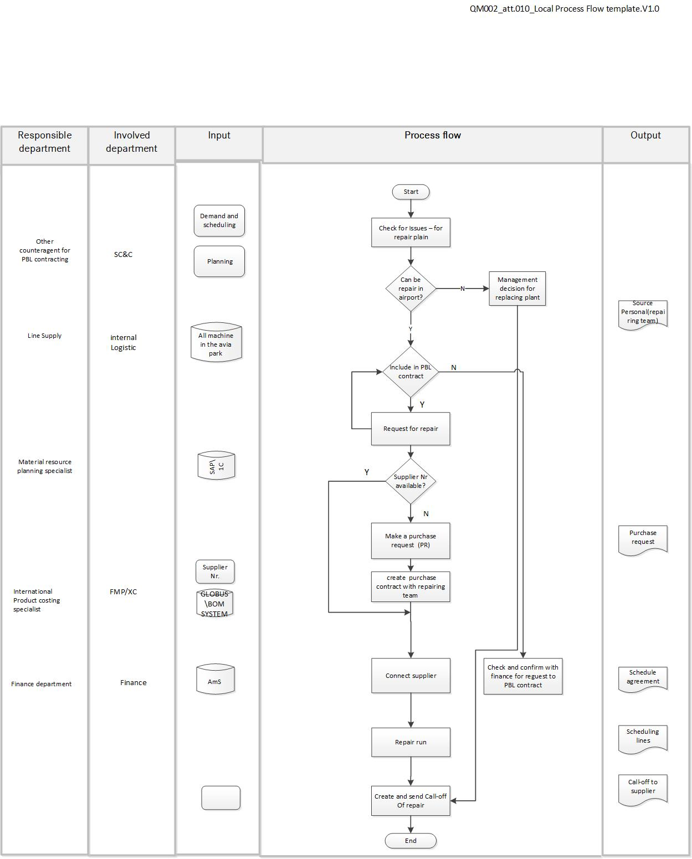

The concept of the streaming process and organizational structure, interaction in PBL logistics services has been developed.

With the application of this concept, we can notice how the expenses for the repair and maintenance of the aircraft have been reduced.

Aircraft maintenance cost schedule.

Acknowledgements

I express my great gratitude to my supervisor, my teacher Nikolai Laznikov, my Chinese professor Guoqing Wang. Without them, this work simply could not exist. I also say thank you to all my classmates and the university SJTU.

Papers published or accepted during the master's degree

[1] Adomavichyute M.E., Sergienko V.I., Yazovskih A.L, Laznikov N.M., 19th International Conference “Aviation and Cosmonautics” (AviaSpace-2021)
№ 4, 252-254 p. Development of MRO system based on Performance-Based Logistics in aircraft design

