Miss Valeriia Sergienko, there are still some places need to revise as following:

- Content
Here need to back two Spaces

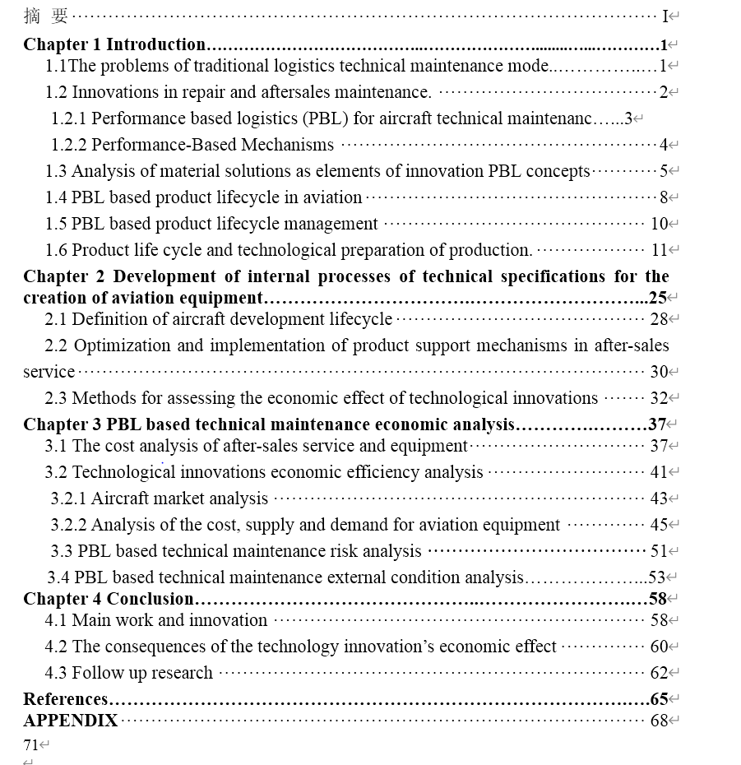
Here need to delete
Here need to back two Spaces

- Title format
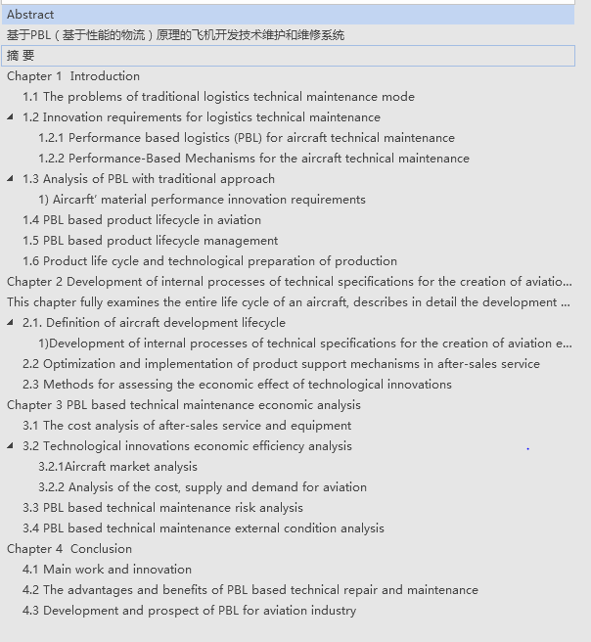
Here need to revise title attribute

