Miss Valeriia Sergienko, Your new version of dissertation still exist lot of problems. I have list it as following. I hope this time, you must revise it correctly.

- Figure title in Catalog is inconsistent with the figure title in the paper.
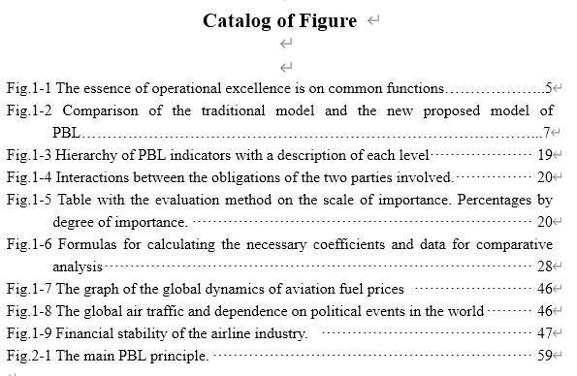

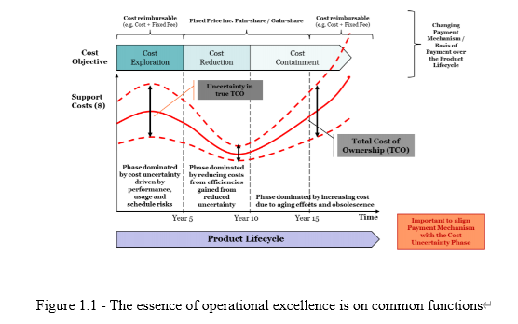

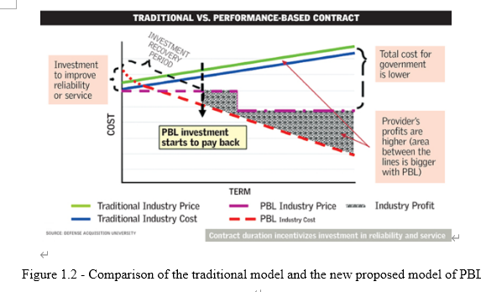

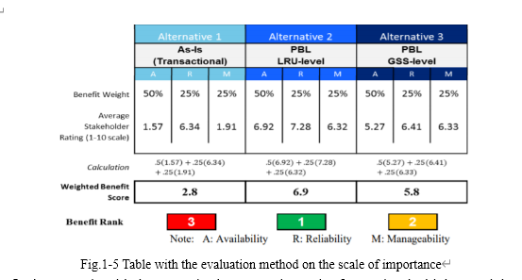

- Fig.1-6 does not found in the paper

- The Figure number in the paper is inconsistent with the chapter number
It should be: Fig.3-1, Fig.3-2, Fig.3-3, Fig.4-1

- Table’s title and page number in the Catalog of Table is inconsistent with those in the paper

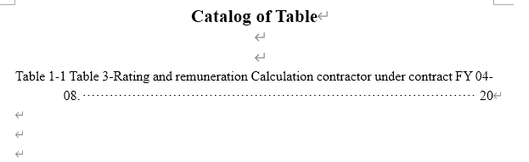
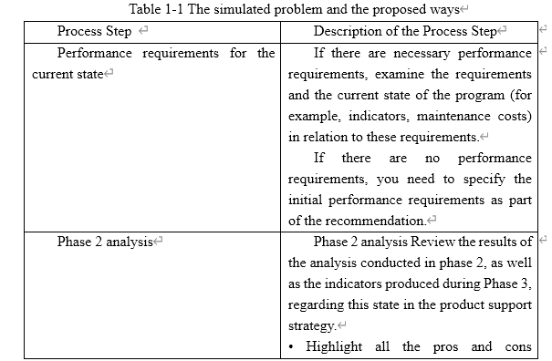

- Table 1-2 was not found in the paper

- Table 1-3 in the Catalog of Table was not found in the paper

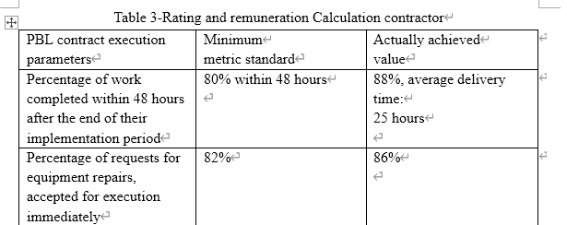

- The format of the view catalog is not correctly
Usually experts review papers using the view catalog mode,. Your paper the view catalog mode is showed as bellow. The red circle is not in the right format

