Контрольная работа.
Complete the conditional sentences with the correct forms of the verb.
- My neighbor wouldn’t have lost his parrot if he _________(leave) the cage open.
- If I hadn’t walked for a long time in the rain I__________(catch ) a cold.
- She would have paid for the meal if she_____( not lose) her purse in the train.
- If he finished the University he _________( become) a scientist.
- I would have painted a picture if I_________(not have) my arm broken.
is studying, graduated, handed in, do, attend.

Complete the sentences with the word from the box.

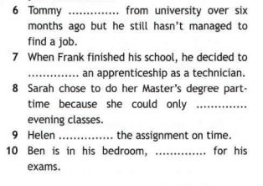
Choose the correct propositions: off, on, out, through.
11.
12.
13.
14.
15.

Choose the correct response.
16. How’s student life?
17. How are your courses going?
18. I’ve decided to do a Master’s degree in History.
19. It’s really hard work.
20. Have you made any plans for next year?

