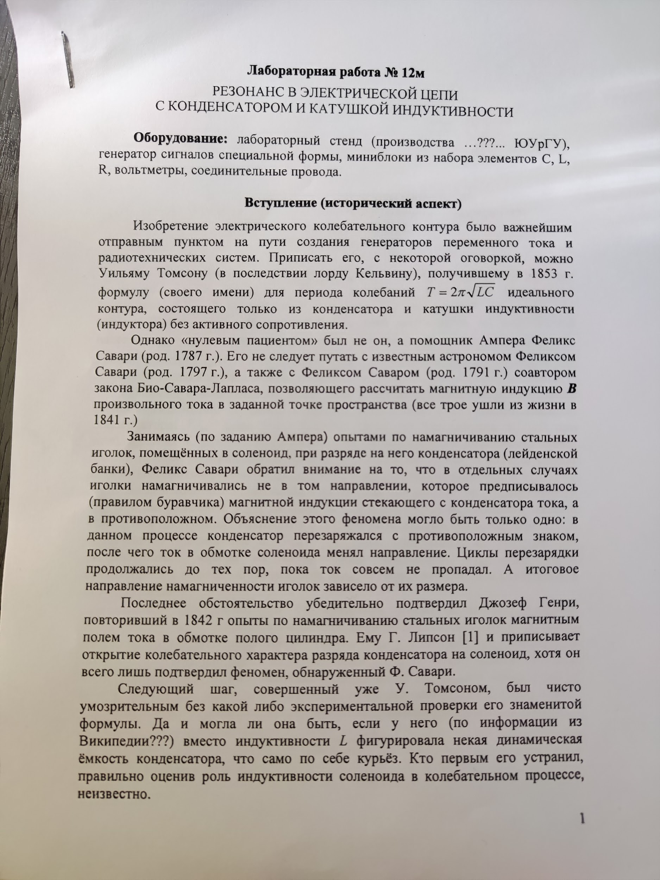

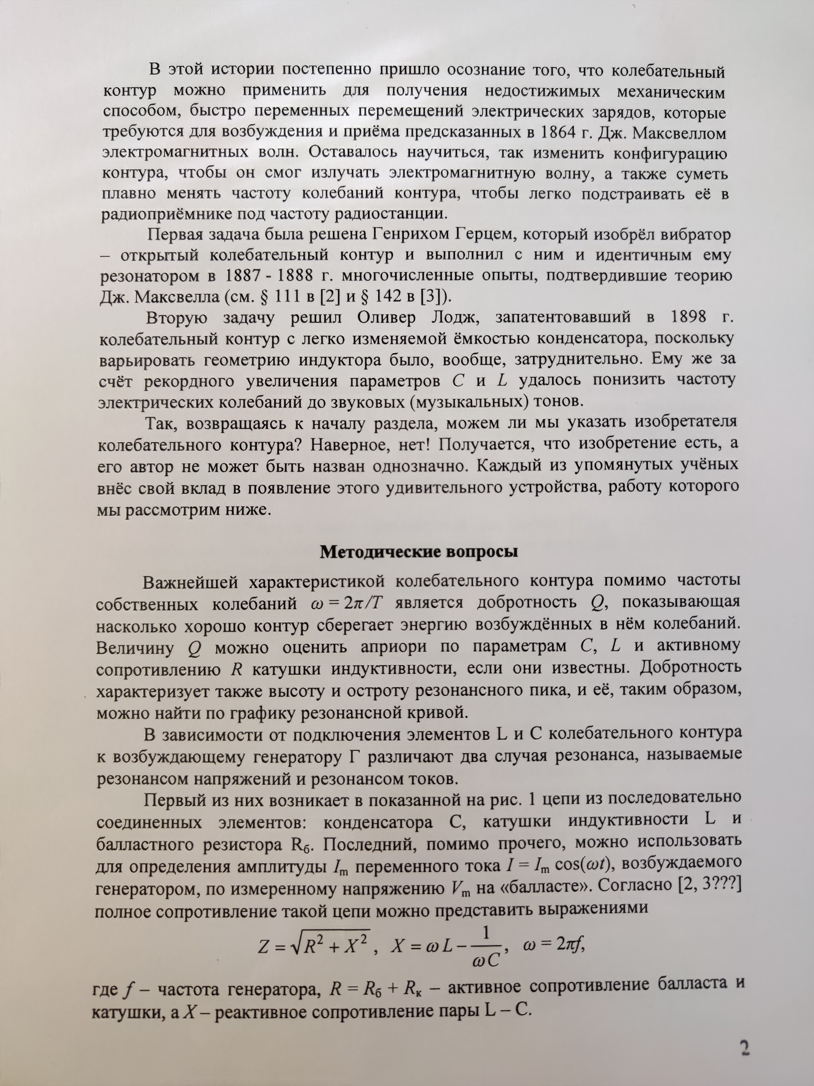

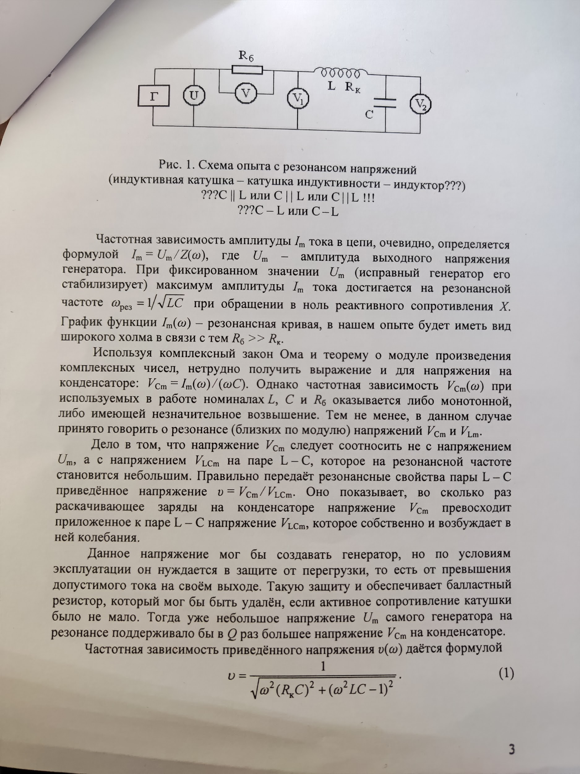

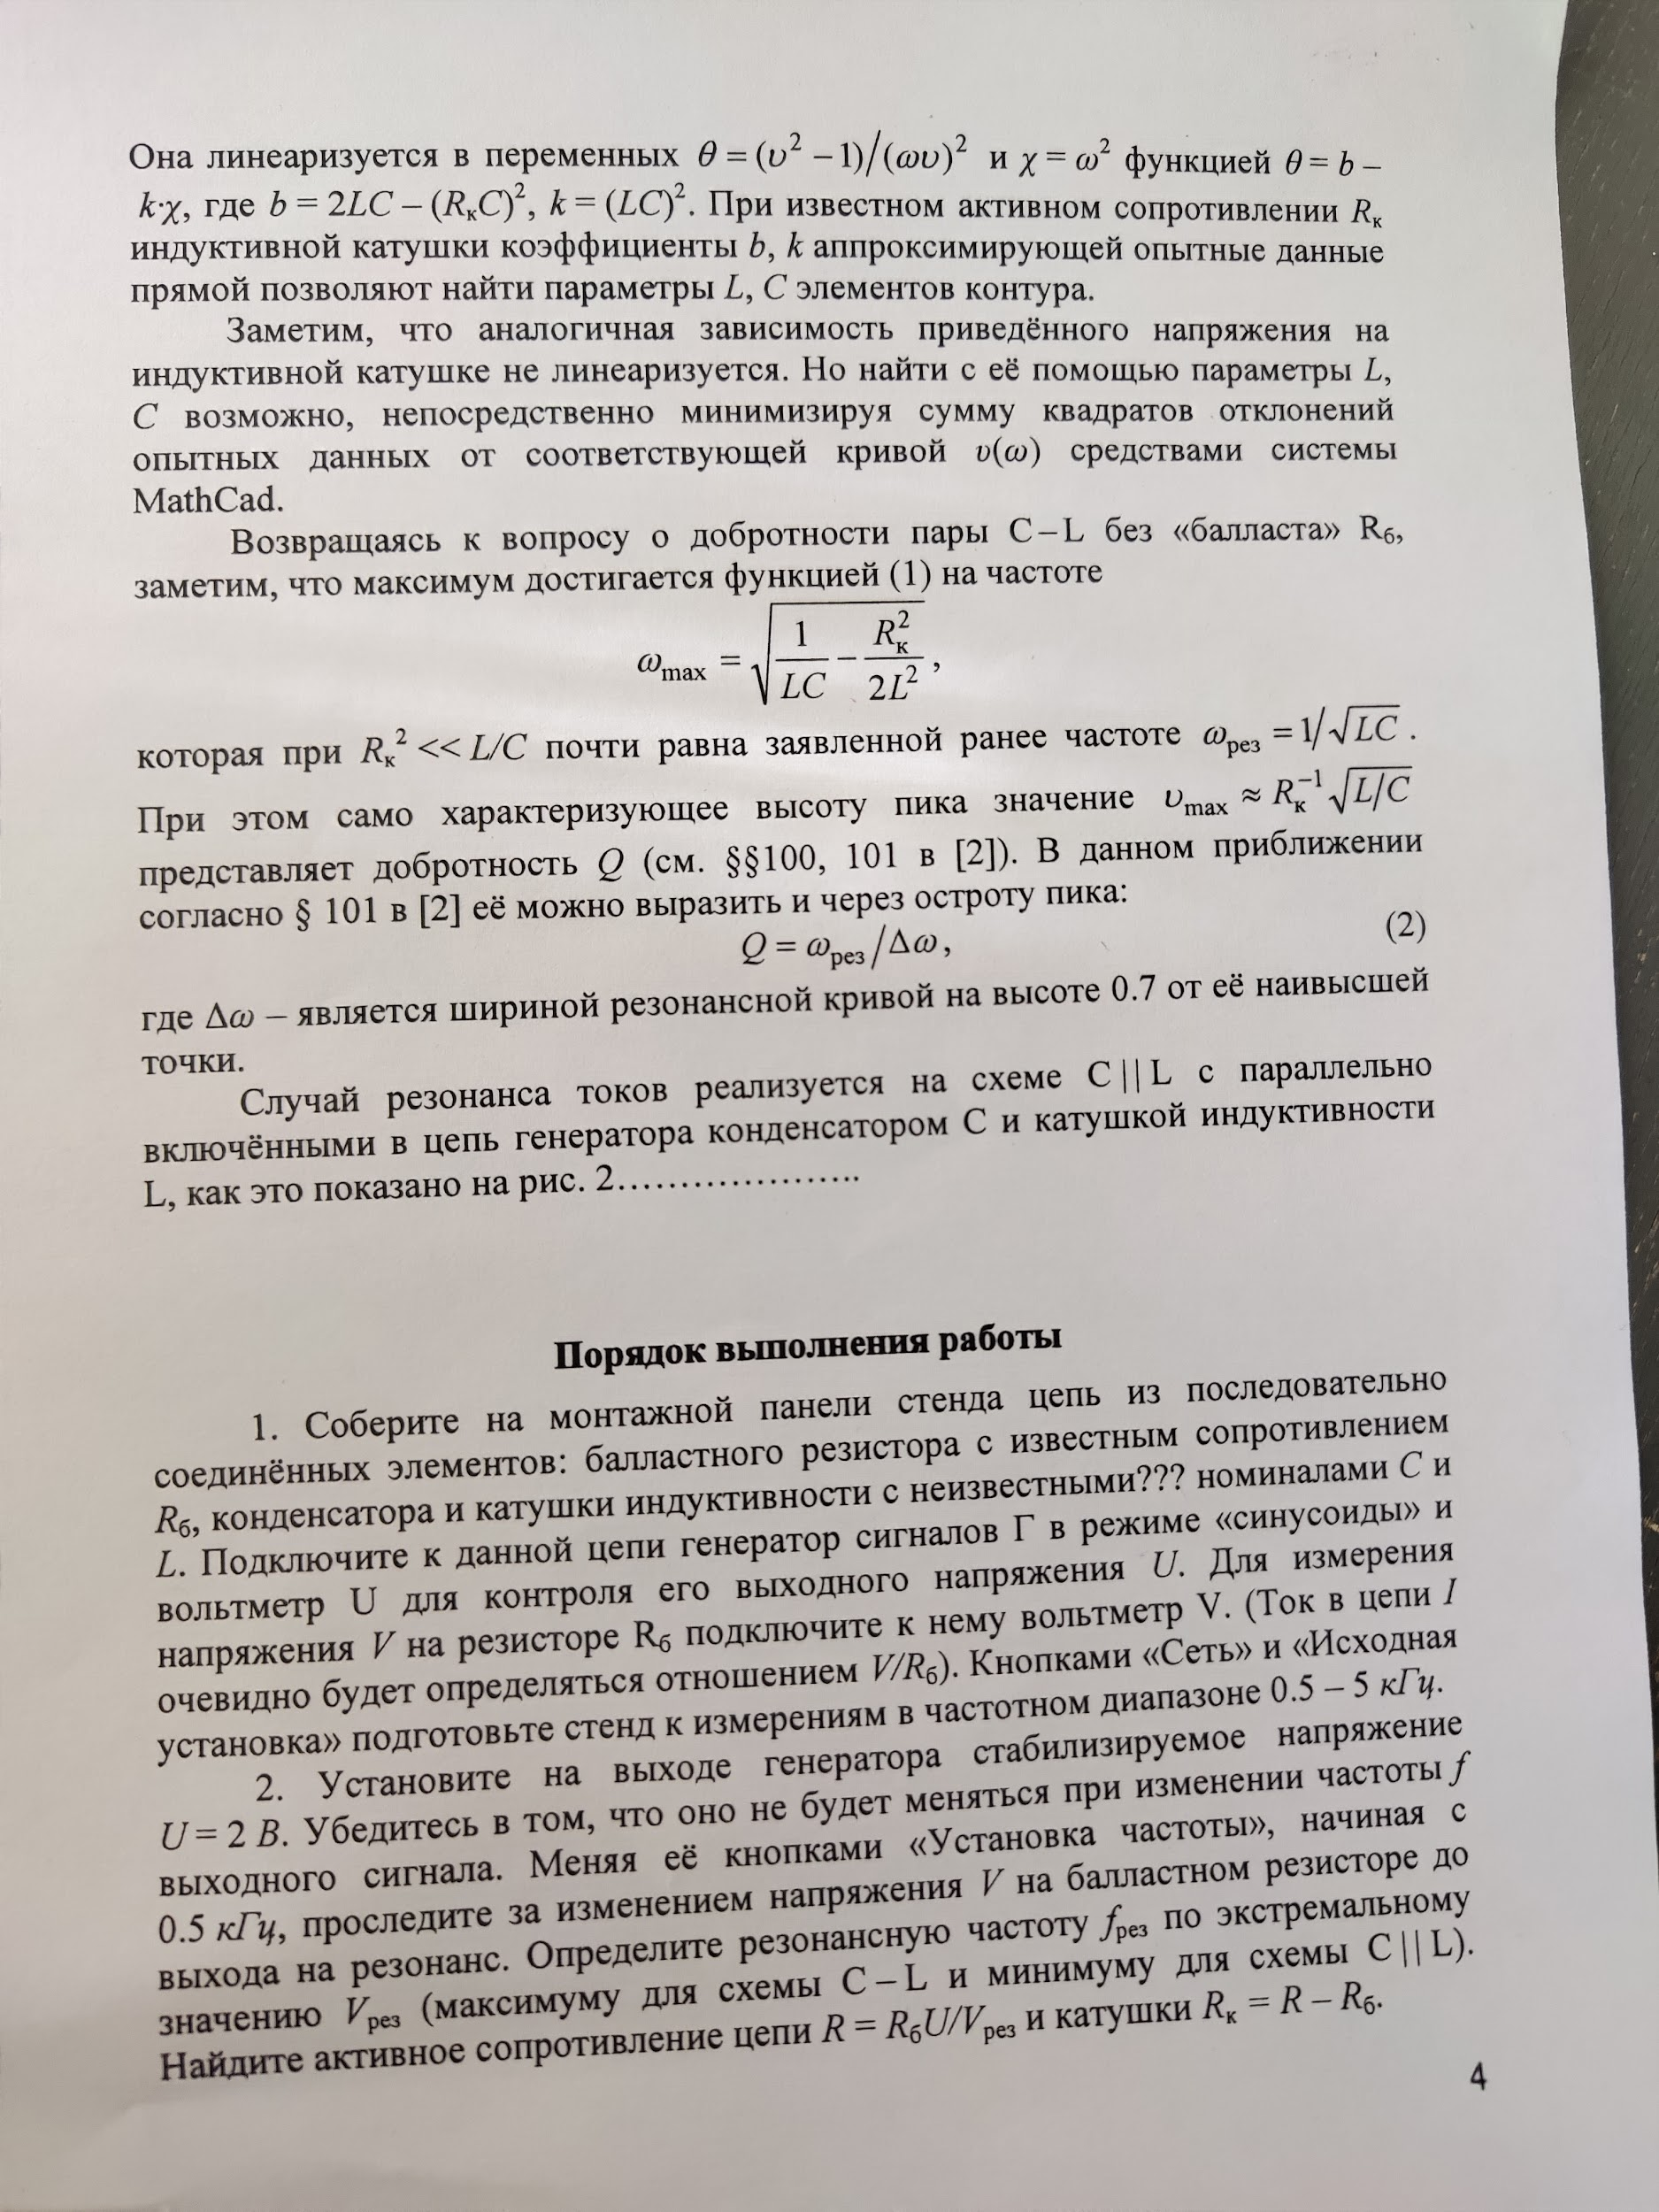

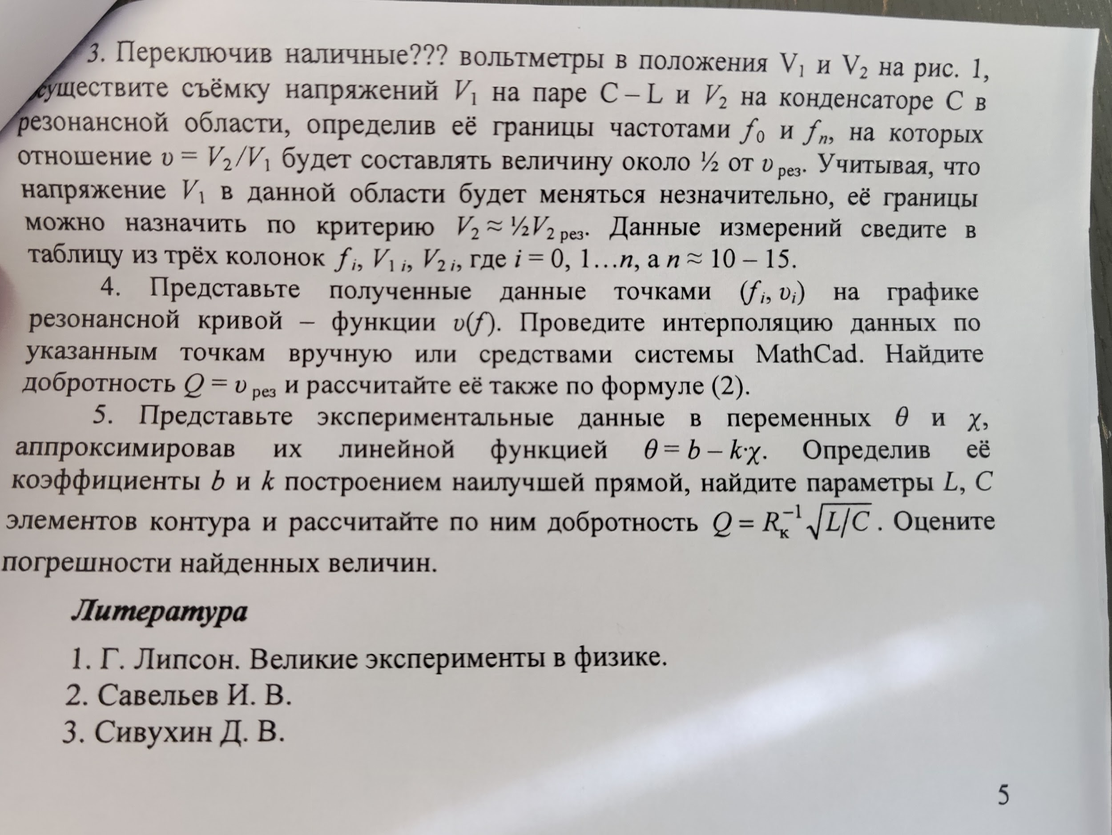

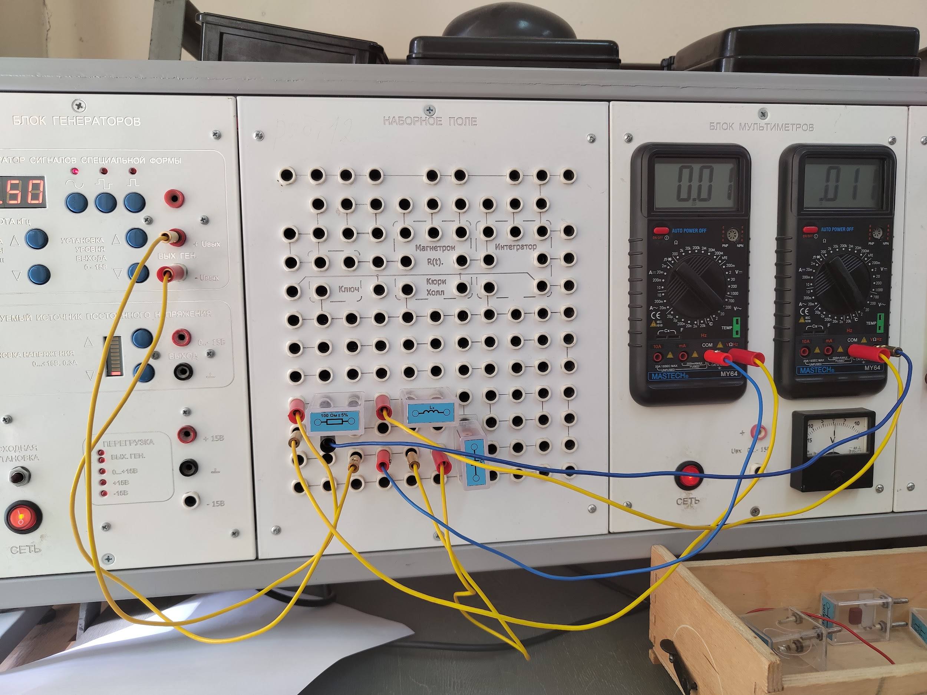

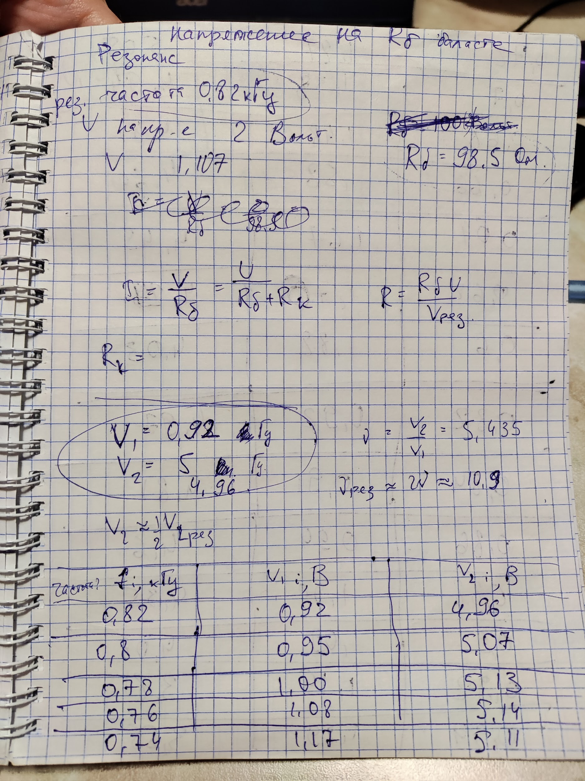

Продолжение таблицы

| 0.72 | 1.27 | 5.05 |
| --- | --- | --- |
| 0.7 | 1.38 | 4.94 |
| 0.68 | 1.48 | 4.81 |
| 0.66 | 1.58 | 4.64 |
| 0.64 | 1.67 | 4.45 |
| 0.62 | 1.76 | 4.24 |
| 0.6 | 1.82 | 4.03 |
| 0.82 | 0.92 | 4.97 |
| 0.84 | 0.91 | 4.81 |
| 0.86 | 0.94 | 4.6 |
| 0.88 | 1.00 | 4.35 |
| 0.9 | 1.09 | 4.08 |
| 0.92 | 1.19 | 3.81 |
| 0.94 | 1.29 | 3.55 |
| 0.96 | 1.38 | 3.32 |
| 0.98 | 1.45 | 3.10 |
| 1 | 1.52 | 2.9 |

Оформление:

